Interview Techniques 3

Elevator 3

Experiences 3

Project Portfolio 3

Personal Effectiveness: Attitude-Ability + Alliances-Assignments 3

Dialogue General 4

Strengths 4

Weaknesses 4

8 behaviors in team and individual assessments 4

How to succeed? 4

Conflict with a co-worker 4

1 How do you rescue program/projects? 4

2-1 Senior stakeholders with different opinion 4

2-2 Handle conflicts 4

2-3 Negotiation techniques 4

2-4 Building blocks for Stakeholder management 4

3-1 What is your management style? 4

3-2 What makes you a world-class leader? 4

4 Challenges of migration projects, e.g. M&A projects? 4

5 How do you hold team members accountable? 4

6 How do you handle unhappy stakeholders or clients? 4

7 How do you handle excessive work demand for your group? 4

8 What do you think would challenge you in this position? 4

9 How do you handle very poorly performing project staff? 4

10 Your top 3 recommendations to manage world class PMO? 4

11 How do you motivate? 5

12 How do you negotiate? 5

13 Leading organizational change management 5

14 How do you resolve personal conflict? 5

15 How do you create alignment among partners? 5

16 How do you manage stakeholders? 5

17 How I support new staff? 5

18 What I did when I screwed up? 5

19 What did you do when the project is behind schedule? 5

20 What did you do when the project is over budget? 5

21 Basic Requirements for controlling project 5

22 Auditing Projects 5

23 SDLC 6

36 Deliverables subject to Change Control 6

24 Project Management Transition 6

25 Project Management and ITIL 6

26 Program Management 6

27 Portfolio Management 6

28 Contract Management 6

29 Architecture 6

30 DATA management 6

31 Best Practices and Standards 6

32 RFI/RFP 6

33 Service Management, ITIL, IT Governance 6

40 Other PM topics in this document 7

41 Techniques to manage timelines 7

42 Techniques in conducting project meetings 7

43 Techniques to conduct technical reviews 7

Issues & Risk Management 7

44 Quality assurance 7

45 Quality Management 7

46 Quality processes in SDLC Phases 7

47 Communication Plan 7

48 Project charter 7

49 Techniques to estimate change requests 7

Fighting Resistances to Changes 7

1 Resistance - Initiative significant change for external customers 8

2 Resistance - Rationale difficult to understand & communicate 8

3 Resistance - Employees must change their behavior to succeed 8

4 Resistance Significant knowledge & skill development required 8

5 Resistance - Expected resistance from affected employees 8

6 Sponsorship - Accountable managers not supporting change 8

7 Sponsorship - Implementation involves many people 8

8-1 Sponsorship - Sponsors not understand time, $, HR requirements 8

8-2 Sponsorship - Sponsors not providing resources 8

9 Sponsorship – How to coordinate various business groups 8

Further questions to ask interviewer 8

Closing 8

CASE STUDY 8

CIBC Financial Risk 8

BCBS 239 (BASEL III) Requirements 9

Other Financial Risk War Stories 9

PMO Set up 10

Earned Value 10

SWIFT 11

STAR Skills 11

Business requirements 11

Risk Management 11

Schedule Management 12

Budget Planning & Management 12

Earned Value 12

Earned Value Management System (EVMS) 12

Project Benefits 12

Program Management 13

Project Management Office 14

INTAKE 15

Lean Management and Six Sigma 15

Enterprise Architecture 15

Change Management 15

RUP Rational Unified Process 15

UML Diagram 16

OO Analysis & Design 16

AGILE 16

Rapid Application Development (RAD) 17

SDLC and Payment 17

Microsoft Excel 18

Microsoft Visio 18

Microsoft Access 18

Microsoft Sharepoint 18

Microsoft Project 18

CA Clarity 18

CIBC PLANVIEW 18

On ERP Implementation Methodology 18

On MICROSOFT ERP 18

On Microsoft Dynamics SURE STEP Methodology 18

On SCOTIA RLP Retail Loan, Adjudication 18

On SCOTIA Credit Card generic platform 19

On SCOTIA Pre-paid Card 19

On SCOTIA Collection System 19

On Retail Banking 20

On Lending Systems 20

On Loan types 20

On Retail Strategy Planning and Analysis 21

On Front Office 21

On Back Office 21

On Treasury 21

SWIFT 21

On HOOPP Middle Office 21

On HOOPP Treasury 21

On workflow Equity, Derivatives, Fixed Income, FX 22

STAR Assignments 23

LITCOM SR. Consultant IT BEST PRACTICES/ PM (Jul14 – Now) 23

EVOQ PROJECT ENGAGEMENT (Apr14 – Now) 23

SCOTIA Backfilling NFF (oct13-apr14) 23

SCOTIA Collections (jan14-feb14) 23

SCOTIA Retail Loan (jan14-feb14) 23

SCOTIA Family of Cards (nov13-feb14) 23

AGNICO-EAGLE JD Edward (may13-oct13) 23

AGNICO-EAGLE C3 (may13-oct13) 23

HOOPP Back office Product Backlog (nov10-dec12) 23

HOOPP Fair Value Continuity (jan11-jun12) 23

HOOPP Upgrade (jan11-dec11) 23

CIBC RSI (jun09-oct10) 24

CIBC OSFI Initiatives (nov09-jun10) 24

CIBC Control (jan08-nov08), (jan05 – dec06) 24

MANULIFE Derivatives Accounting (jan09-jun09) 24

CIBC SOX Secure End User Computing SEUC (jan08-dec08) 24

🕮CIBC Mellon (ERP, Vendor) (jan07-dec07) 24

AIG/AIA (sep96-apr00) 24

AIDC (oct93-aug96) 24

PWC (oct90-aug93) 24

SIERRA Rescue (jan07-may09) 24

CIBC RSI 25

RSI Overview Deliverables 25

Risk Model & Sensitivities 25

Interest Rate Risk 25

Credit Spread Risk 25

Analytics 25

Analytics OLSM 25

Market Risk 25

Market Risk Data 25

Incremental Risk Charge (IRC) 25

Regulatory changes 25

Metrics to calculate regulatory capital for market risks 25

TOUGH INTERVIEW QUESTIONS 26

PROJECT Contact Names 27

KELLOGG SCHOOL OF MANAGEMENT 27

Great Tips 27

STAR Techniques 27

Crucial Conversations 27

Make Ideas Stick 27

How to succeed in life 27

NASA Shared Voyage 28

## Interview Techniques

**REMEMBER** SMILE - EYE CONTACT - CONNECT - CLARIFY - REFLECT - REPEAT - BE SILENT - EMPATHISE - PHYS. DISTANCE - I-STATEMENT - HOWEVER, MY FORMER - THANK YOU “I hope we'll have the opportunity to work together in the future”

**SAR** •Situation •Action required to find solution •Share Result  **STAR** (Interview) = Situation, Task, Action, Result *- what is the problem, what did i do, who did i talk to, how did i do that, how do i know that it was well done – focus on last 3 good projects* - **RAID** (Risk) = Risk, assumption, issue, dependency -**BOSCARD** (Charter) = Background, opportunity, scope, constraints, assumptions, risks, deliverables - **BATNA** – **INVEST** (change request) = independent, negotiable, valuable, estimatable, small, testable **–** **SMART** (goals) = specific, measurable, attainable, relevant, timely

## Elevator

I am a **proactive** and **successful** Program/Project manager with background in management consulting. I have over **20 years of experiences** in financial services, capital markets, retail and insurance. I held **managerial roles** at SCOTIA, CIBC, Sierra, AIG (Hong Kong), Price Waterhouse (Australia) and most recently a **delivery manager** at SCOTIA, HOOPP, **project manager/ controller** CIBC and Sierra, **PMO head** at AIG (Hong Kong) and manager at PW (Australia). I specialize in the **realization of organizational strategies** by implementing **best practices in project and finance management** to deliver portfolios, programs and projects. I developed a reputation as somebody **who creates value** by bridging **business** and **technology** considerations into a **holistic view** of the process at hand. I delivered **complex business solutions** through partnership with stakeholders from multiple disciplines – from front office to risk, treasury, accounting, operations and technology.

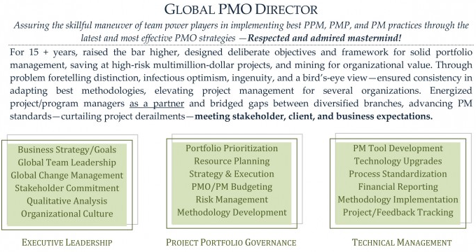

#### Experiences

|  |  |
| --- | --- |
| •**15 yrs** in portfolio management; **$100M portfolio of 100** programs and projects.  •**20 yrs** of program/ project management + developing/ deploying project management standards, processes, tools for project delivery and **budget** and **benefits**, **system integration**  •Manage/ report scope, time, cost, risk, resources, quality in programs exceeding **$50M** of **$15M** with **10** concurrent projects and teams **120** resources and **20** vendors  •Formulated corporate IT strategy for **CIBC**: $80M 3-yr upgrade financial risk system for $2B reduced Regulatory Capital; **CIBC Mellon**: $6M 2-yr integration financial system for revenue of $350M and 1,300 employees; and **AIG** $10B in revenues 120% explosive expansion into China, India, VN •Delivered AIG’s **4 strategic objectives** at $70M in costs per objectives, inventory of 9 regional initiatives; prepared business cases and effective ranking, prioritizing, approving and executing projects  •Created an inventory of **9 i**nitiatives supporting **4 x** **$70M** strategic objectives; established rigorous financial procedures for business cases and project ranking, prioritizing, approving and execution  •Strategy **for e-services** for 10 Australian industrials combined export of $50M to 20 countries in Asia and Middle East  •**Tier-1 consulting** projects for business transformation, process reengineering, compliance, infrastructure, development  •**Projects rescue** (Capital Markets, Credit Cards, Retail Loan, ***Wealth***, ***Treasury***, Payment, Business Intelligence, Insurance) and public services (BColumbia Corporate Accounting Services, MTO, Australia HCS)  •Implemented **Governance Methodologies** (Sarbanes-Oxley Act, COSO, COBIT, ValIT, CMM, RiskIT, ISO, ITIL); re-designed mgt processes for 5 departments (operations, middle office, back office, finance, IT) 200 members/ staff and established more than 4,000 process controls (SOX) at CIBC  •Business process transformations, enterprise risk, change management: assessed current state, defined target state, implemented gaps for org. changes | **5 business units and 7 stakeholders financial/compliance** standards: IFRS (HOOPP), GAAP (MANULIFE), BASEL II&III (CIBC), SOX (CIBC, AGNICO)  •Built consensus with senior leaders, management and staff. Team motivation, mobilization, building complex relationships among business lines, internal staff and vendors. Expert in identifying stakeholders expectations, and aligning them optimally  •Set up **Project Management Office** at AIG, CIBC (Financial Risk), [CIBC Mellon](#_(CIBC_Mellon_(ERP,), SIERRA, HOOPP, CBOC •Portfolio management, **Program management**  •Within PMO, mentored and managed **15 program and project managers**  •Engaged various business units for adoption and maturity of program and project management disciplines  •Defined **PMO policies and procedures** with the focus on transparency and alignment with strategic objectives for all programs and projects in the portfolio  •Defined **governance processes** around Portfolio and Project Management tools then evaluated, deployed and institutionalized **CA Clarity** and **PLANVIEW** systems  •Established policies, procedures, processes, tools & templates for portfolios, programs, and projects Metrics, **estimation**, **Balanced Scorecards**, **Strategy Maps,** **Activity-Based Costing (ABC)** and **Earned Value Management**. Developed project accounting practices and managed Project Financials using Scotia Bank SMARTSTREAM, Project Reporting Facility  •Expert with Program, Project Management methodologies including PMI’s Standard for Portfolio/ Program/ Project Management; Ontario Public Service Unified Project Management Methodology, Oracle Application Implementation Methodology, others (Scotia, CIBC, AIG, PwC), **AGILE****,** **RUP**, **SDLC****,** **SIMCORP**  •**Project rescue missions** •**project auditing** •scope management •**vendor selection** • **vendor management** (RFQ, RFP, contract negotiation, SLA, performance monitoring) •Project governance •Business requirements |
| •Work with clients to define/ **manage scope, strategy, and requirements** of projects  •Work with clients to manage **implementation** of projects  •Develop **cost benefit** analysis  •**Complete** projects within budget/ timelines while meeting client business objectives | •Identify and analyze project **risks**  •Mitigate, document, control project **risks**  •Develop and deliver **budgets**  •Identify **resource** needs for project  •Establish **roles, expectations, and goals** for team members  •**MS PROJECT**, **SHAREPOINT**, **EXCEL**, **ACCESS** |

Hands-on with technology, budgeting, planning, system design, testing - Fast learning and Effective on day one (PWU Consultant) - Consciously seek to comprehend people - process - technology – goals - Stay alert thru self-challenges and by stepping out of own comfort zone - Versatile in mgmt, technology and finance - International management consulting with senior mgmt exposure - Thoughtful, well-researched actions

**ANECDOTES** Fred Kavli, NTH Physics, Kavli foundation for astrophysics, nano-sciences, neurosciences – CDS of AIDC more +ve than BHP**PROJECT Contacts**

#### Project Portfolio

**12+** strategy process change projects at CIBC, SCOTIA, AIG and for Price Waterhouse: **5** vendor-solution implementation + **5** outsourcing + **2** development projects (from vendor)

**Jul14:** IT Best Practices & Mentoring CBOC LITCOM

**Apr14**: [Lead Engagement](#_PROJECT_ENGAGEMENT_(Apr14) ALGORITHMICS, NCB EVOQ

**Oct13:** [Scotia Bank NFF](#_SCOTIA_NFF_(oct13-apr14)), [Collection System Replacement](#_SCOTIA_Collections_(jan14-feb14)), Retail loan, Family of Cards

**May13**: Control Solutions AGNICO-Eagles Mines JD Edward, [IT Ops consolidation](#_AGNICO-EAGLE_C3_(may13-oct13))

**Nov10**: HOOPP Back office automation, [Upgrade](#_HOOPP_Upgrade_(jan11-dec11)), Methodology

**Jun09**: CIBC Risk Strategic Initiatives RSI (CAD 80M)

**Jan07:** SIERRA

Jan09: (Sierra) [MANULIFE](#_(MANULIFE_Derivatives_Accounting) Der. Actng GAAP "Other Than Temporary Impaired" (OTTI)

Jun08: (Sierra) CIBC – SOX Secure End User Computing SEUC (Middle, ***Wealth***)

Jan07: (Sierra) CIBC Mellon Fin Sys Renewal Project FSRP Treasury, BI/MIS/DW

Oct07: (Rescue) Balanced Scorecard/BI BC Corp Acctng Services (public sector),

Jan08: (Rescue) Russell-Mellon Enterprise Investment Platform (***Wealth***),

Mar08: (Rescue) MTO Road User Safety Revenue Mgt System (public sector),

Jan09: (Rescue) Travel Insurance Coordinators TIC merges Trent Health

**Mar05**: CIBC – Internal Control Repository (CAD 20M)

**Nov00**: XEG - SME, State organizations

**Jun96**: AIG – PMO set up, Harvester, India, VN, China (USD 100M)

**Oct93**: AIDC - Treasury system, financial repository (AUD 5M fee income)

**Oct90**: PWU WESTPAC DCPK Front/back office for FOREX (AUD 3M)

**Aug86**: ND COMTEC - integrated graphic system revenue (CAD 2M)

**Aug84**: ESSO Exploration (DB of 20 North Sea fields 200K barrels oil equivalent per day)

#### Personal Effectiveness: Attitude-Ability + Alliances-Assignments

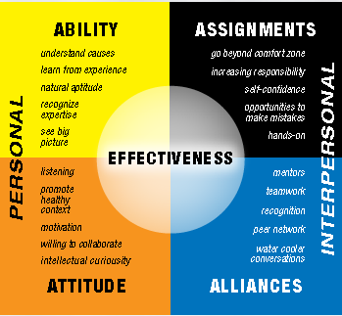

##### Top 5 things in next job

➊Satisfaction ➋Advancement ➌Location ➍Management Culture ➎Pay

##### Action Verbs

Refreshed the **PMO engagement model** - Designed and deployed - Led oversight and execution - Designed new processes - Provided a foundational baseline of - Developed cross-functional change management governance models - Set expectations, facilitated initial knowledge transfer and managed on day to day basis efforts - Managed Mutual Funds Project, resulting in updates to 100% of procedures (**80 existing procedures, 130 new procedures**), and in updates to more than **40 mutual fund products**- Defined I&IT **Project Portfolio**; Defined I&IT **Portfolio and Project Management policy**; Established I&IT **PMO strategy, guiding principles, functions, org structure, staffing and career paths, Checkpoint and Gating guidelines**, Established resource management process and supporting tools, Created a set of **43 Project Management artifacts**, including **process maps, document templates**, guidelines and process guides for **Initiation, Planning, Execution and Closeout** phases defined in the methodology. The artifacts covered Project Management (**Project Tailoring Guidelines, Project Charter, Project Schedule, Project WBS, Project Management Plan, Project Estimation Guidelines, standardized rates**, others), **Business Analysis, Solution Architecture, Quality Management** and other areas; Facilitated implementation of the **Project Intake Process** to standardize assessment / ranking of 6 new project and program requests per month

## Dialogue General

#### Strengths

**ABILITY** ➊Learn from experience ➋Big picture ➌Recognize expertise **ATTITUDE** ➊Collaborative ➋Intellectual curiosity ➌Promote healthy context **ASSIGNMENT** ➊Beyond comfort zone ➋Hands On ➌Value/Impact **ALLIANCE** ➊teamwork ➋Recognition ➌Communicative

#### Weaknesses

➊**Numerical** insist in examining every angle of Rubik's cube -> can be distracted. Now start a day with clear objectives, agenda. Think in perspectives, future ➋**Perfectionist** Expected top performance. Now take into account people perspectives. Develop empathy to better motivate. Develop plan to account for deviations. Slow/Fast thinker. Learn to appoint the right person for the job instead of the best all-rounder

#### 8 behaviors in team and individual assessments

➊Express authentic appreciation ➋Address shared interest ➌Appropriately include others ➍Keep all your agreements ➎Express reality-based optimism ➏Be 100% committed ➐Avoid blaming and complaining ➑Clarify roles, accountability and authority

#### How to succeed?

Define using other party's languages -Communicate understanding -Get confirmation -State objectives -Set communication channels: steering committee, forum, email, telephone, project plan -Dedicated team with specific/strategic tasks –Plan, allocate resources (20% high potential, 40% strategic, 30% core, 10% support) -Customer feedback –SLA

#### Conflict with a co-worker

**STAR=Situation**– Continuity report for finance report due for end of the year Reluctant co-worker **Task** Feasibility Budget **Action** Clarify requirements, work schedule **Result** Split report, Off-load analysis, testing - *I sat down with my co-worker at company x and asked what her issues were. Then I stated my concerns. We both discussed our most important issues and the ones we could compromise on. Once we identified and prioritized common goals, we decided together what to give up and what to keep. Both of us felt like we were gaining something and were instrumental in the compromise*

#### 1 How do you rescue program/projects?

**The first steps I took** ➊**Management level assessment** ⬩Sponsor, internal stakeholders and management say about the situation (**Diligence of eliciting requirements** Establish communication update plan for assessment period ➋**On the ground assessment** Unwind where the project is vs. where it should be - Ask for people thoughts on what is wrong ➌**Update stakeholders** ➍**Present plan based on assessment Project failure causes** **❶Poor Change Management** scope creep ❷**Poor Communications** 🡪 Communication plan ❸**Inadequate Resources** not committed resources, lack of support, no analysis and documentation of skill sets, conflicting resource delegation, turnover, dependence on heroes ❹**Poor Requirements** ambiguous priorities, imprecise information ❺**Poor Planning** Inaccurate Estimates, unrealistic timetable, missing key processes, poor estimates/ data ❻**Poor Risk Management** ❼**Poorly Defined Deliverables** ❽**Over Optimism** ❾**No Time for Project Management** ❿**Poor PM skill Rescue steps** ➊Improve stakeholder’s communications (what to expect) ➋Re-evaluate resources ➌Refine project & scope ➍Use right technology ➎Replace PM

🕮**Project Audit**🕮**Risk Management**

#### 2-1 Senior stakeholders with different opinion

➊Know senior management requirements (put themselves in boss’s shoes, be sympathetic to challenges, problems, and pressures of senior managers) ➋Analyze boss’s thinking patterns, act in ways that are consistent with that pattern (analytically or intuitively) ➌Listen, look for verbal and nonverbal components of boss’s message, just as a project ➍Take solutions as well as problems to boss & explore alternatives & make recommendations ➎Keep boss informed of progress and plans ⇨ boss can act as a mentor, give support ➏**Consult boss on policy procedures & criteria** help clarify management philosophy & establish boundaries related to administrative issues (to protect oneself) ➐**Avoid steamrolling** boss; be patient, allow time for thinking & evaluation will lead to better relationships and results

**Managing Up** ⬩Maintain Energy And Maximize Efficiency ⬩Being fully effective springs from building a reputation for being a *team player*, demonstrating a willingness to *accept responsibility*, bringing *new ideas to the job*, and being *productive* ⬩Managing is not the exclusive property of MBA graduates ⬩At times we are all managers, and we are all support staff ⬩Those who manage up have to think - and act -like managers ⬩A good manager is a student of cause and effect ⬩It's not good enough to be aware of what's happening around you; you must also know why it is happening ⬩If you are not helping, you are hindering ⬩Ask yourself: Did the work I performed today help achieve a goal?

**Meetings** Project meetings ⬩COBIT Governance & Management ⬩

#### 2-2 Handle conflicts

⬩**Set framework** (*stakeholder map*, *roles & responsibilities*, *communication plan*, *issue resolution*, *change management*, *risk management*) to communicate the options, the pre-requisites and the implications in a simple, structured and clear in order to reach a consensus-based pragmatic solution ⬩**3 types of conflicts** ➀**Goal-oriented conflicts** (associated with end results, performance specifications & criteria, priorities, objectives) CIBC-M Finance-Treasury, SCOTIA BA/Architect ➁**Administrative conflicts** (management structure, roles & reporting relationships, responsibilities & authority for tasks, functions, decisions, budget & cost, hr, schedule) CIBC RSI Staffing, Budget, Requirements, SOX Performance ➂**Interpersonal conflicts** (differences in work ethics, styles, egos, personalities of participants) ⬩**Resolutions** Conflict over ➊**Project priorities** (sequence of activities & tasks, goals incompatibility & differences in long-term/short-term) ⇨ Master plan compatible with long-term strategies ➋**Administration procedures** ⇨ Clarify roles, responsibilities, reporting relationships at project start ➌**Technical opinions & performance trade-offs** ⇨ Peer review & steering committees to review specifications & design ➍**Human resources, staffing, allocation/hiring project personnel)** ⇨ Work breakdown structure 🞧 responsibility matrix ➎**Cost & budget** ⇨ Budgets supported by detailed budget and cost estimates of subproject tasks & activities ➏**Schedules** ⇨ schedule integrating schedules for subprojects with staffing & other life constraints ➐**Personality** ⇨ Emphasize team building, create environment emphasizing respect, diversity, and equality See 14. *How do you resolve*

#### 2-3 Negotiation techniques

**⬩BATNA** (both parties alternatives & resistance point) - Prepare & plan, Subject knowledge, Patience & Listen ⬩**Principled negotiation** •**Positions**: one party’s (usually self-serving) solution to problem •**Issues**: elements/ subject matter of dispute to be negotiated •**Interest**: factors motivating parties to reach respective positions and underlying foundation for positions, including desires and concerns

#### 2-4 Building blocks for Stakeholder management

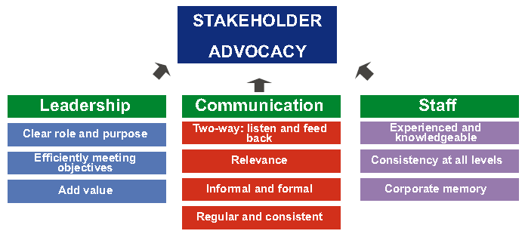

#### 3-1 What is your management style?

#### 3-2 What makes you a world-class leader?

Consultative, professional, respectual, hands-on, persistent

#### 4 Challenges of migration projects, e.g. M&A projects?

➊Familiarize with new environment ➋Determine correct migration, upgrade path ➌Determine new environment requirements (resources, system) ➍Plan testing ➎Allow time for performance tuning ➏Set up training environment ➐Plan for backup & recovery

#### 5 How do you hold team members accountable?

➊Handbook (scope, procedures) ➋Clear role ➌Measurable performance criteria ➍Meeting, communication

#### 6 How do you handle unhappy stakeholders or clients?

➊Involve stakeholder in prioritization of requirements ➋Ensure business sign-off of charter and requirements ➌Ensure minimum weekly face-to-face meeting on progress ➍Invite business to (some) project status meeting

#### 7 How do you handle excessive work demand for your group?

➊Acknowledge team extra effort ➋Inform business of related risk ➌Review risk log and approach to remedy ➍Review plan/workflow to identify bottleneck

#### 8 What do you think would challenge you in this position?

➊Engage stakeholder ➋Optimize team performance ➌Detect/ correct problems on time

#### 9 How do you handle very poorly performing project staff?

➊Diagnose poor performance ➋Enhance ability (Resupply, Retrain, Refit, Reassign, Release) ➌Improve motivation (performance goals, assistance, feedback)

#### 10 Your top 3 recommendations to manage world class PMO?

➊Engage stakeholder ➋Optimize team performance ➌Continuous improvement

#### 11 How do you motivate?

➊Be realistic and specific ➋Create a safe environment (shield from org politics) ➌Be a role model ➍Know the team members ➎Recognize effort, progress, contributions ➏Celebrate ➐Empower ➑Link project success to corporate strategy – Get recognition from senior management

#### 12 How do you negotiate?

➊Know your opponent ➋Know the subject to negotiate ➌Know your BATNA

#### 13 Leading organizational change management

…on projects whose benefits relied significantly on high degree of behavioral changes

##### Change Management

➊Shared understanding of reality of change ➋Formulate the change ➌Plan the change ➍Implement the change ➎Manage change transition ➏Sustain change

##### Promoting Behavior Changes

➊Increase benefits ➋Decrease costs ➌Decrease the desirability of competing alternatives ➍Socially Desirable ➎Easily Done ➏Seek Sr. Management blessing

##### Types of Resistance to changes

➊**Technical resistance** ➀**Habit & Inertia** (bureaucratic traditions vs. new ways) ➁**Fear of the Unknown** ➂**Prior investment** (fear of waste)

➋**Political resistance** ➀**Resource allocation** (doing more with less) ➁**Leaders indictment** (full responsibility over the overloading of market risk system) ➂**Threats to powerful coalitions** (C-M Operations & IT)

➌**Cultural resistance** ➀**Old cultural mindsets** (CIBC/HOOPP gung-ho trading, AIG dominance) ➁**Sense of security** ➂**Climate for change** (pension not in the crosshairs)

🕮**Fighting Resistances to Changes**🕮**Change Management in Portfolio, Program, Project** 🕮**Organizational Project Management (OPM3)** 🕮**Change Management at Portfolio Level** 🕮**Change Management at Program Level** 🕮**Change Management at Project Level**

#### 14 How do you resolve personal conflict?

➊Be neutral third party ➋Establish rules of conduct ➌Meet both parties in calm & controlled setting ➍Control discussion ➎Understand perspectives ➏Reach working solution ➐Status Quo unacceptable

#### 15 How do you create alignment among partners?

➊Create stakeholder matrix ➋Seek common understanding of project objectives (Project Charter) ➌Define detailed RACI chart ➍Ensure representation within the team ➎Ensure adequate communication plan

#### 16 How do you manage stakeholders?

➊Identify ➋Prioritize ➌Understand their needs ➍Engage ➎Monitor engagement - Report project health

#### 17 How I support new staff?

**Program/project handbook** ➊Program Scope ➋Program Approach ➌Program Management, Control Process ➍High Level Program Plan ➎Project Governance ➏Change Management ➐Roles & Responsibilities ➑Weekly Status Report Process ➒Centralized Issues Log ➓Project Control Mechanism

#### 18 What I did when I screwed up?

➊Assess the damage ➋Admit your mistake immediately ➌Be direct and unambiguous ➍Take responsibility with humility ➎Take a step back and breathe ➏Don’t throw others under the bus ➐Devise an action plan ➑Do everything in your control to make it right ➒Prepare yourself for the consequences ➓Don’t be too hard on yourself

#### 19 What did you do when the project is behind schedule?

➊Work overtime➋Reallocate resources (critical path) ➌Double-check dependencies ➍Check time-constrained activities (sign-off, training) ➎Swap resources ➏Crash schedule (increase resources) ➐Fast track it (make sequential partially or totally parallel) ➑Prevent all scope change ➒Improve processes ➓Scale back the scope of work

#### 20 What did you do when the project is over budget?

➊Work unpaid overtime ➋Swap human resources ➌Eliminate or replace non-labor costs ➍"Zero tolerance" scope change ➎Use budget contingency ➏Scope back the work

#### 21 Basic Requirements for controlling project

➊**Plan** (realistic, credible, detailed enough to be executed, acceptable to those who must execute it, approved by those who are accountable (SRO/ Project Board) ➋**Process for monitoring/ managing** progress & resource usage ➌**PM organisation** (skilled people with sufficient authority & time to plan, monitor, report, take decisions & deal with exceptions ➍**Process for minor corrections & adjustments** (minor deviations & omissions) ➎**Commitment** to provide resources (SRO, Project Board, Stakeholders, resource ‘owners’) ➏**Explicit authority** to proceed by accountable (SRO/ Project Board)

#### 22 Auditing Projects

###### Software architecture audit model

|  |  |  |
| --- | --- | --- |
| **Architecture** | **Security** | **Tools** |
| ⬩Application architecture  ⬩Database architecture  ⬩Overall architecture | ⬩Application security  ⬩Web service security  ⬩Database security | ⬩NET framework  ⬩Visual Studio  ⬩3rd party |
| **Process** | **Efficiency** | **Performance** |
| ⬩Code management  ⬩Quality control  ⬩Methodology | ⬩Libraries  ⬩Frameworks  ⬩Factories | ⬩Availability  ⬩Maintainability  ⬩Scalability |

###### Project Lifecycle Documents (10)

➊**Feasibility Study** ➋**Specification** ➌**Cost effectiveness Analysis** ➍**Project Integration** ➎**Requirements** ➏**Internal Control** ➐**Testing** ➑**User Acceptance** ➒**Final Assessment** ➓**Project Context**

|  |  |  |  |  |
| --- | --- | --- | --- | --- |
| **Feasibility Study (5)** | **Specifications (7)** | **Cost Effectiveness Analysis (4)** | **Project Integration (5)** | **Requirements (4)** |
| ➊**Objectives** ➋**Solutions** ➀System demands ➁Solutions (variants) ➂Costs, risks, advantages ➌**Resources/ Funding** (demands on project & organisation) ➍**Feasibility** ➎**Readiness** (can concept phase begin/ project commissioning) | ➊**Objectives** ➋**Expectations** (users, stakeholders) ➌**Functionalities** ➍**As-Is** (what available) ➎**Project size** ➏**Project constraints** ➐**Technology requirements** | ➊**Total costs** (e.g. operational costs of data migration, capacity, training ➋**Assessed use for quantity, quality** ➌**Project cost effectiveness** | ➊**Integration** (corporate strategy + IT structures) ➋**Project overlap** ➌**Synergy** ➍**Conform to standards** ➎**Automatic/ manual interfaces** | ➊**Internal** (agreements, procedures, quality norms) ➋**External** (laws, regulations, directives, contracts) ➌**Specificity** (data protection, publication, procurement procedures, banks, best practices) ➍**Effect on processes/ infrastructure** (architecture, security) |
| **Internal Control (4)** | **Testing (5)** | **User Acceptance (5)** | **Final Assessment (5)** | **Project Context (4)** |
| ➊**Automatic controls** (data input validity check, automatic comparisons, error lists) ➋**Functions to be separated/ access permission** ➌**Measures to control** ➍**Measures for continuity in operations** (emergency plan)/ **preservation of data** (archive plan) | ➊**Purpose** ➋**Plan** (methods, tools, criteria, case studies) ➌**Resources** (availability, time constraints ➍**Test methods** ➎**Test results** | ➊**Acceptance definition** ➋**Data/ application ownership** ➌**UAT signoff** ➍**Test cases** ➎**Acceptance conditions** | ➊**Objectives achieved & requirements fulfilled** ➋**Final cost & variances** ➌**Cost effectiveness calculation** ➍**Post-implementation risk** ➎**Lessons learned** | ➊**Extensive user involvement** ➋**Performance appraisal** ➌**Extent of standardisation** ➍**Quality assurance systems & procedures** |

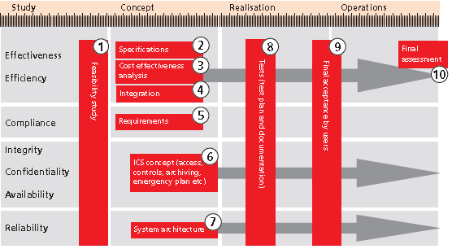

###### Project Survival Test

|  |  |  |  |  |
| --- | --- | --- | --- | --- |
| **REQUIREMENTS** | **PLANNING** | **PROJECT CONTROL** | **RISK MANAGEMENT** | **PERSONNEL** |
| ➊Clear, unambiguous **vision/ mission statement** ➋Realistic vision ➌**Business case** with business benefit and benefit metrics  ➍**User interface prototype** to demonstrate functionality ➎Detailed, written **specification** ➏Did the project team interview people who will actually use the software (end users) early in the project and continue to involve them throughout the project? | ➊Detailed, written **Software Development Plan**  ➋**Project task list** include creation of an installation program, conversion of data from previous versions of the system, integration with third-party software, meetings with the customer, and other "minor" tasks  ➌**Schedule and budget** estimates officially updated ➍Detailed, written **architecture and design** documents ➎Detailed, written Quality Assurance Plan that requires design and code reviews in addition to system testing ➏Detailed **Staged Delivery Plan** for implementation & delivery  ➐**Project plan** include time for holidays, vacation days, sick days, and ongoing training, and are resources allocated at less than 100% ➑**Project plan & schedule** approved by development, quality assurance, technical writing | ➊Single key **executive** with decision-making authority  ➋Project manager's **workload** adequate ➌Well-defined, detailed **milestones** ("binary milestones" 100% done or not done)  ➍Published **milestones** with status ➎**Feedback channel** for anonymous report of problems  ➏**Change management plan** ➐**Change Control Board** with authority to accept or reject proposed changes ➑Published **planning materials, status information** including effort, schedule estimates, task assignments, progress compared to the plan thus far available to every team member ➒Automated **revision control**  ➓Defect tracking software, source code control, PM software | ➊List of current risks to project  ➋List updated frequently  ➌**Project risk officer** to identify emerging risks  ➍Plan for managing subcontractors | ➊Team technical expertise  ➋Expertise with business environment in which the software will operate ➌Technical leader capable of leading project successfully ➍Enough people to do all the work required ➎Everyone work well together  ➏Each person committed to the project |

#### 23 SDLC

❶**Preliminary Analysis** organization's objectives, nature & scope of problem under study - alternative solutions - costs & benefits - preliminary plan with recommendations ❷**Systems analysis**, **requirements definition** project goals defined into functions/ operation of application - end-user information needs ❸**Systems design** features & operations in detail (screen layouts, business rules, process diagrams, pseudo-code, etc.) ❹**Development** Code writing, Integration & testing ❺**Acceptance, Installation, Deployment** ❻**Maintenance** changes, correction, additions, moves to different platforms, etc.

**DELIVERABLES** ➊**Requirements Management** change control ➋**Development Approach** SW development plan/project charter, development case/process plan, iteration plan/phase ➌**Issue Management/ Change Control** effort 🞧 cost impact of change 🞧 recommended solution ➍**Risk Management** identify, analyze, prioritize, identify risks (mitigate/retire early high risks, use requirements confirmation to mitigate scope/functional risk, architectural POC to eliminate technology risk) ➎**Quality Management** quality planning, assurance & control ➏**Configuration Management** evaluate, coordinate, approve/disapprove, implement changes in artifacts used to construct & maintain SW ⇨ define •set of artifacts (configuration items) under CM jurisdiction •naming of artifacts •entry/exit of controlled set •change rule •availability for use rule •CM tools➐**Test Management** test strategy & plan ➑**Project Acceptance** user acceptance process & sign-off ➒**Project Closeout**

#### 36 Deliverables subject to Change Control

|  |  |  |  |  |
| --- | --- | --- | --- | --- |
| ➊Change Control Plan ➋Change Proposals ➌Vision statement ➍Top 10 Risks ➎SW Development Plan (project cost, schedule estimates) | ➏User Interface Prototype ➐User Interface Style Guide  ➑User Manual/ Requirements Specification ➒Quality Assurance Plan ➓SW Architecture | ➊SW Integration Procedure ➋Staged Delivery Plan ➌Individual Stage Plans (miniature milestone schedules) ➍Coding Standard ➎SW test cases | ➏Source code ➐Media (graphics, sound, video) ➑SW build instructions make files ➒Detailed Design Document per stage ➓SW Construction Plan for each stage | ➊Install program ➋Deployment (Cutover Handbook) ➌Release Checklist ➍Release Sign-Off Form ➎SW Project Log ➏SW Project History Document |

🕮**ESTIMATION**🕮**CIBC EDF**🕮**SDLC Survival Test** 🕮**RUP**

🕮**14 System Integration Best Practices**

#### 24 Project Management Transition

➊**Project kick-off presentation** **deck** review ➋**Project schedule** deep dive ➌**Project finance** deep dive ➍**Project Culture** ➎**Project Staffing** ➏**Project stakeholders & interests** ➐**Assistance** (further)

#### 25 Project Management and ITIL

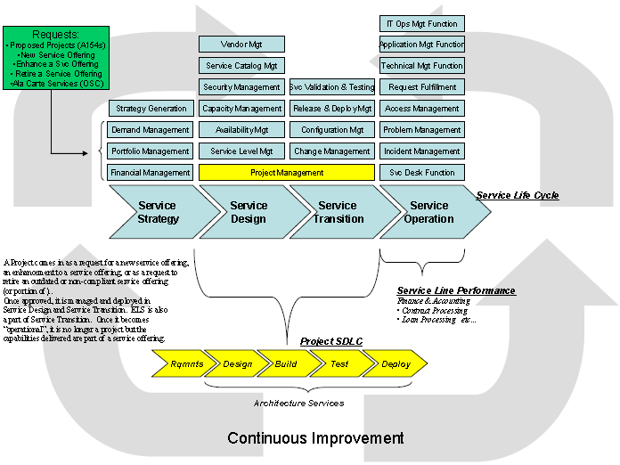

⬩**PM = Service offering** ⬩**Project = service request** (ITIL *Change Management*) ⇨ ***approved, designed, managed, deployed*** (ITIL *Service Design, Transition*) 🕮**ITIL Change Management** (➊Record RFC ➋Review RFC ➌Assess & Evaluate RFC ➍Authorize RFC ➎Plan ➏Implement & Coordinate ➐Review & Close) 🕮**ITIL Service Design** (➊Service Catalogue Management ➋Service Level Management ➌Capacity Management ➍Availability Management ➎IT Service Continuity Management ➏Information Security Management ➐Supplier Management) 🕮[**ITIL Service Transition**](#_Service_Transition_(ST)) (➊Change Management ➋Service Asset & Configuration Management ➌Release & Deployment Management ➍Minor Service Transition Processes)

#### 26 Program Management

🕮**Program Management Process (Ricardo Vargas**) **DEFINITION** – **BENEFITS** **DELIVERY** – **CLOSURE** and **9 Competencies** ➊Communication ➋Financial ➌Integration ➍Procurement ➎Quality ➏ Resource ➐Risk ➑Schedule ➒Scope

🕮[**Program Life Cycle (5)**](#_Program_Lifecycle_(5)) ➊Pre-program setup ➋Program setup ➌Program Mgt & Technical I/F ➍Benefit delivery ➎Program closure

🕮**Project Selection Criteria (9)** ➊Strategic alignment ➋ROI ➌Expected benefits ➍Urgency/ market reactive ➎Project type (new, maintenance) ➏Dependency with major project/program ➐Risk factor ➑Time to complete ➒Complexity

#### 27 Portfolio Management

🕮**Portfolio Management principles & practices (10)**

➊Strategic focus ➋Strategic initiatives ➌Portfolio Components ➍Quantifiable Components ➎Time Horizon ➏Portfolio snapshot ➐Portfolio Management Activities ➑Alignment to Organization Strategy ➒Governance ➓Balancing of conflicting demands

🕮**Portfolio Management Process Groups (5)**

➊Strategic ➋Governance ➌Performance ➍Communication ➎Risk

🕮**Portfolio Management Tools & Techniques** **(4)**

➊Analysis ➋Selection ➌ Meeting ➍Communication

**Analysis (15)** ➊Strategic alignment ➋Prioritization ➌Scenario ➍Capability & Capacity ➎Interdependency ➏Cost/benefit ➐Stakeholder ➑Readiness ➒Portfolio Organizational Structure ➓Graphical Analytical Tools ➊Quantitative & Qualitative ➋Value Scoring & Measurement ➌Benefits Realization ➍Communication Requirements ➎Gap **Selection (4)** ➊Portfolio component inventory ➋ Portfolio component categorization ➌Weighted ranking & scoring ➍Portfolio authorization **Meeting (1)** ➊Portfolio review meetings **Communication (4)** ➊Communication methods ➋Elicitation techniques ➌Portfolio Management information system ➍Integration Portfolio Management

#### 28 Contract Management

**Areas (7)** ➊Authoring & negotiation ➋Baseline management ➌Commitment management ➍Communication management ➎Contract visibility & awareness ➏Document management ➐Growth **Contract Placement Stages (4)** ➊Requirements Analysis ➋Evaluation Plan ➌Invitation to Tender ➍Proposal Evaluation **Contract Management phases (5)** ➊Initial ➋Bid ➌Development ➍Manage ➎Maintenance

#### 29 Architecture

🕮[**TOGAF**](#_TOGAF_(Open_Group) 🕮**ZACHMAN** 🕮**NET** 🕮**Mobile** 🕮**Data Architecture**🕮**Service architecture** 🕮**LIFE architecture** 🕮**Risk Architecture** 🕮**SCOTIA NFF** 🕮**SCOTIA Direct Loan** 🕮**MTO Revenue**

#### 30 DATA management

🕮**BCBS 239 (BASEL III) Requirements** 🕮**Risk Data 7 Areas 400 Requirements** 🕮 **20 Key Risk Reports** 🕮**20 Conceptual Data Models** 🕮**20 Key Risk groups** **data feeds** 🕮**8 Key Risk groups Data** 🕮**Risk Case Studies** 🕮**Risk Architecture** 🕮**SUNGARD** 🕮**CVA data requirements** 🕮**CIBC Risk** 🕮**Risk Topics** 🕮**Lexicon Risk** 🕮**DARPA Data Management** **11 Knowledge Areas**

###### Data Issue resolution

⧫**Data integrity** (resulting in inefficiency/costly rework, concerns over data shared with/ received from 3rd parties, excessive customer complaints or disputes) ⧫**Management information** for effective decisions ⧫**Significant data conversion, integration/ data cleansing** activities ⧫Potential overpayments/ revenue leakage issues ⧫**Complex spreadsheet models** support key business decisions ⧫**End-User Computing (EUC)** not supported by IT ⧫**Lack of internal skill set / capacity** to perform electronic data analytics and testing of complex business logic on a periodic bases

###### Merits of ETL and ELT

**ETL extract-transform-load** means risk is always playing catch-up **ELT extract-load-transform** continuous change and adaptation, less needs to predict exactly how information is used in the future

###### Credit scorecard development

➊**Data cleansing** **a-**Missing values/ outliers **b-**Correlation of financial characteristics **c-**Determine strength of financial characteristics **d-**Intuitive application (business / operational considerations)) ➋**Variable selection** (final set of characteristics 5 to 10) apart from other information like borrower's name, default information (# days past due) ➌**Scorecard development** ➍**Validation**

###### Data Quality Management Project example

➊Establish DQM environment ➋Scope project & implementation plan ➌Implement DQM project (define, measure, analyze, improve) ➍Evaluate DQM project

#### 31 Best Practices and Standards

⬩Business Continuity COBIT, ISO 27002, Business Continuity Institute (BCI) ⬩IT Governance COBIT⬩Information security management system (ISMS) ISO 27000, SANS Top 20 security controls

#### 32 RFI/RFP

10+ years selecting / managing vendors, issuing RFP, conducting Proof-of-Concept and negotiating contract for 4 enterprise initiatives of up to $80M at CIBC, CIBC Mellon and AIG

RFQ, RFP, contract negotiation, SLA, Statement of Work, vendor performance monitoring (in development and production) - **CIBC RSI 2009** ($80M project $35M annual, Industry Scan, RFP, POC, Contract) [**CIBC EUC 2008**](#_(CIBC_Control_(jan08-nov08),) ($3M, Industry Scan, RFI, POC, Contract) [**CIBC Mellon 2007**](#_(CIBC_Mellon_(ERP,) ($3M, Industry Scan, RFP) [**AIG India Vietnam 1999**](#_AIG/AIA_(sep96-apr00))

**Phases** **(6-8 months)** Scope (1 month) Preparation (1 month) RFP (2.3 months - Vendor contact 3 weeks, Vendor demo 2 weeks, Vendor Follow-up 2 weeks, Scoring/selection 2 weeks) Contract (2 months) 🕮**Vendor Selection Toolkit**

#### 33 Service Management, ITIL, IT Governance

**ITIL, COBIT capabilities** ⬩Implement KPIs with Balanced Scorecard (financial, customer, learning & growth, internal operations) ⬩Continual improvement ⬩Incident mgt ⬩Problem mgt ⬩Change mgt ⬩Configuration management ⬩Operational governance **🕮** (COBIT) ⬩**🕮**[SLA](#_SLR_(requirements),_SLA,) ⬩OLA ⬩Change advisory board ⬩Steering committee ⬩Known error database

⬩AGNICO (May – Oct13) ⬩HOOPP (Dec10 – Feb11) **🕮**ITIL Service Delivery processes **🕮**ITIL Infrastructure **🕮**ITIL Strategic questions **🕮**Lifecycle of Service Continuity Management **🕮**Resource Management Infrastructure **🕮**COBIT 4 domains **🕮**COBIT Components **🕮**COBIT Domains and Processes

#### 40 Other PM topics in this document

⮚Leading and mentoring ⮚Estimation techniques ⮚Gathering business requirements ⮚Process analysis ⮚Managing timelines ⮚Conducting technical reviews ⮚Development of Quality Management, Change Management, Issues & Risk Management plans, Communication plan, Project Charter ⮚Change requests ⮚Gating ⮚Project governance

#### 41 Techniques to manage timelines

➊**Detailed planning** (for 3-4 months ahead, up to 7-8 level deep of work breakdown structure) ➋Well-defined **milestones with ownerships** ➌Daily **review of risks and threats** ➍Visual **reports of project progress- challenges** ➎**Contingency planning** and **risk management planning**

#### 42 Techniques in conducting project meetings

**Agenda to plan project** ➊Welcome ➋Review Project Charter & Mission Statement ➌Project Scope ➍Major milestones ➎Task List and Dependencies ➏Risks and Mitigation Strategies ➐Project Communications ➑Information Repository ➒Action Plans

###### Various types of project meetings

🞟**Steering Committee for governance**, **project status** **Mthly** (HOOPP – CIBC) 🞟**Executive Committee for project status Wkly** (HOOPP – CIBC) 🞟**Project team meeting** for status, issue resolution – **Change management meeting** – all projects

#### 43 Techniques to conduct technical reviews

➊**Formulation of key questions** with the help of SMEs ➋Construction of “**evidence map**” to delimit areas for review ➌**Critical appraisal** with checklist, quality scales ➍**Audit trail** from business requirements to technical solutions ➎**Meetings and workshops management** with clear agendas, minutes and action plans

#### Issues & Risk Management

For each **risk type** (organization specific, project specific, policies and procedures, technology, etc.), Identify and document the risk description, mitigation approach, contingency plan, likelihood of occurring, potential impact ($ / schedule / quality etc)

**RAID** ➊**Risks** = combined likelihood the event will occur and impact on - includes description, full analysis and plan to manage➋**Assumptions** factors assumed to be in place that will contribute to the successful result of project - includes details of the assumption, the reason it is assumed and the action needed to confirm whether the assumption is valid ➌**Issues** something going wrong – includes description, impact, seriousness and actions needed to contain and remove ➍**Dependencies** event/ work dependent on result of project, or your project will depend on - captures who you are dependent on, what they should deliver and when, who is dependent on you

#### 44 Quality assurance

**Tools** benchmarking, benefit/cost analysis, walkthroughs, audits •**Reviews** process, objectives, schedule, board/ action team, responsibilities

#### 45 Quality Management

For each phase (*initiation, planning, control/ execution, closing*), define the quality requirements and activities for the related deliverables and activities

❶ **Quality Activities**

|  |  |  |
| --- | --- | --- |
| Deliverable/Activity | Quality Activity | Comments |
| Initiation & requirements, design, construction, testing, implementation | | |

❷ **Standards and Guidelines**

|  |  |  |  |
| --- | --- | --- | --- |
| Standard | Owner & Location | Description | Exemption |

##### ⬩Data quality management ⬩AGILE quality

#### 46 Quality processes in SDLC Phases

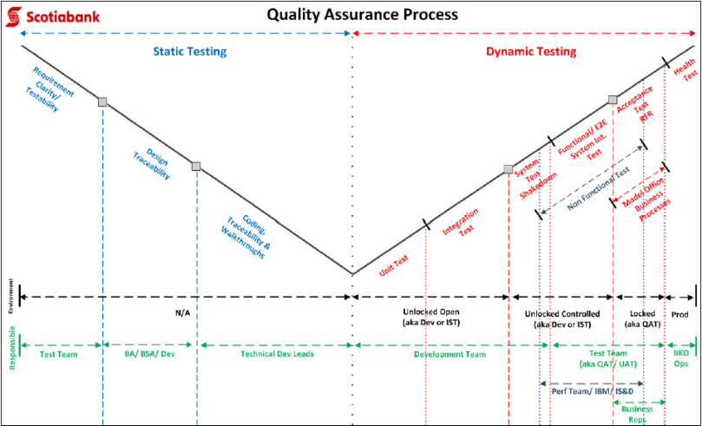

#### 47 Communication Plan

* I can get requirements for the communication Deliverable; identify the Producer, Receiver, Frequency and the Medium

🕮**Communication Plan**  🕮**Engagement/Communication Plan Structure**

#### 48 Project charter

* Key sections - project definition, business need and justification, in-scope, out-of-scope, key deliverables, tentative schedules, risks and challenges, project governance, project manager, key staff and stakeholders
* **BOSCARD** ➊**Background** (motivation, key stakeholders) ➋**Objectives** (goals linked to SMART objectives) ➌**Scope** (features/ functions of product, result) ➍**Constraints** (limits, conditions on scope) ➎**Assumptions** (for planning, to be validated) ➏**Risks** (with quick assessment of significance and mitigation) ➐**Deliverables**

#### 49 Techniques to estimate change requests

➊Itemized changes **INVEST** (Independent, Negotiable, Valuable, Estimatable, Small, Testable) ➋Inclusive of **all aspects of delivery** (analysis, design, implementation, testing, refactoring, deployment) ➌**Input from all concerned parties** including business, project team, IT ➍**Estimation methods**: affinity, wideband Delphi, ideal time, relative sizing based on experiences and history ➎**ITIL** Incident, problem, change

###### Techniques to negotiate change requests

🞟Itemized changes **INVEST** 🞟Min. 3 alternative choices of implementation 🞟Ranking based on business value and priority combined with Technology risk and difficulties 🞟Collective understanding of impact on project (time, resources and cost) 🞟**BATNA** (Best Alternative to Negotiated Agreement) 🞟Active listening 🞟Facilitation

###### RSI change control process

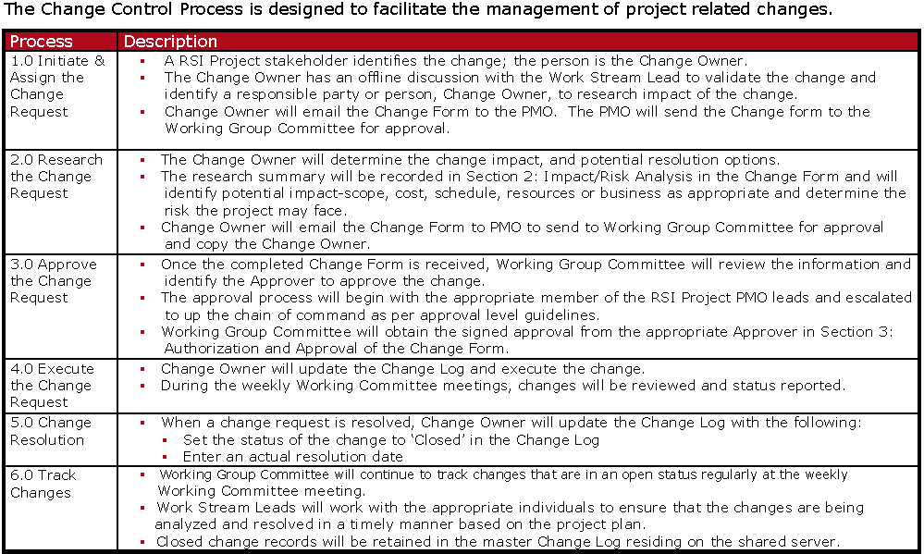

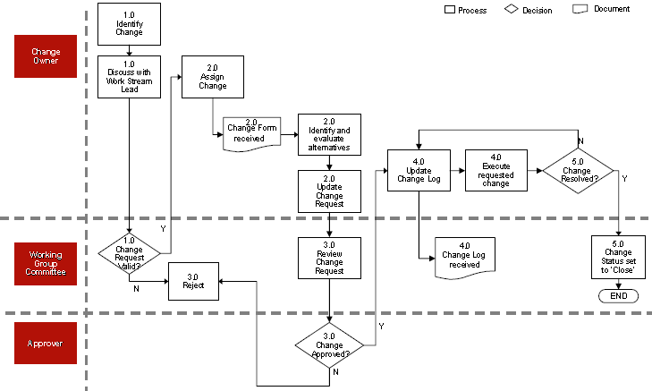

##### Selected change requests that I managed



**HOOPP (2012) Accounting Analytics**: prepared-get approved-implemented (added 2x3 man-months for analysis + coding efforts to incorporate analytics of asset-based income)

**CIBC (2009) Risk Initiatives**: prepared for vendor estimates, reviewed vendor submission, get approved by business changes request on new workflow for market risk stress testing (additional 600 hours vendor’s development effort)

**Analytics (300), Credit Risk (220), Market Risk (120), Operational Risk (20) Total: 700**

-**MANULIFE Derivatives Accounting (2009)**: added the quarterly process for portfolio manager to declare “Intent to hold” (additional 200 hours in development effort)

-**CIBC-Mellon (2007) Financial System Renewal Project FSRP**: added the business intelligence requirements for Balance Scorecard (additional 1 week analysis and coordination of vendors to submit RFPs)

-**CIBC Internal Control Repository ICR (2003)**: added the requirements to convert 3,000 MS Excel-based internal controls into OPENTEXT (additional 4x man-month to construct and execute data cleansing and reporting tools)

## Fighting Resistances to Changes

🕮**Types of Resistance** 🕮**Risk Management**

#### 1 Resistance - Initiative significant change for external customers

➊Understand the exact nature of the change for the customers, what they will have to do that is new or different (This refers to CIBC’s external customers) ➋Involve Marketing to create a ***communication strategy*** that includes both customers and customer-facing employees ➌Identify customer- facing employee knowledge/skill gaps and get Training involved to develop an action plan.

#### 2 Resistance - Rationale difficult to understand & communicate

➊Develop a ***Stakeholder Role Map*** to identify key audiences affected by the initiative ➋Develop a ***cascading communication strategy***, so that difficult to understand messages can be conveyed face-to-face by the one-up manager ➌Develop ***feedback mechanisms*** – Employees Hot Lines, Mailboxes and/or Town Hall Meetings or Workshops designed to convey the messages with time for Q&As

#### 3 Resistance - Employees must change their behavior to succeed

➊Develop a ***Stakeholder Role Map*** to identify key stakeholders ➋Identify the nature of the behaviour change – discuss with sponsor/steering committee and get agreement ➌Involve Training to develop a ***strategy/plan to shift behaviour*** ➍Involve HR to determine if/how to incorporate it into ***Performance Scorecards*** ➎Identify incentives that can be introduced ➏Develop a ***cascading communication strategy***. Ensure sustaining sponsors are fully engaged (they know, understand, communicate and are prepared to deliver consequences) ➐Develop a strategy to measure the behaviour change

#### 4 Resistance Significant knowledge & skill development required

➊➋➌➍➎➏➐Above ➑Assess capability against future skill, attribute requirements

#### 5 Resistance - Expected resistance from affected employees

➊Develop a ***Stakeholder Role Map*** to identify the different stakeholder groups who will be impacted by the initiative ➋Upon completion of the ***Resistance Assessments***, develop a strategy and action plans to mitigate and track the level of resistance among the various stakeholder groups.

#### 6 Sponsorship - Accountable managers not supporting change

➊Develop a ***Stakeholder Role Map*** and identify the critical ***Sustaining Sponsors*** of the key targets of the change ➋Determine whether the Sustaining Sponsors are also targets of the initiative ➌Develop a strategy and action plans to mitigate and track the level of sponsorship among the various Sustaining Sponsors.

#### 7 Sponsorship - Implementation involves many people

➊Develop a ***Stakeholder Role Map*** to identify the different stakeholder groups who will be involved in the initiative. Include all relevant areas e.g. Risk Management, HR, Security, Compliance, Finance etc. as well as outside suppliers, labour unions ➋Determine the nature of their involvement ➌Identify ***critical Sustaining Sponsors*** for each of the areas identified ➍Identify ***critical change agents*** you need to enlist in those areas ➎Develop an ***advocacy strategy*** to gain and track sponsorship in the respective areas so that you can work effectively with required change agents

#### 8-1 Sponsorship - Sponsors not understand time, $, HR requirements

#### 8-2 Sponsorship - Sponsors not providing resources

➊Develop a ***Stakeholder Role Map*** and identify the ***critical Sponsor / Sustaining Sponsors*** of the key targets of the change ➋Develop a strategy to communicate critical resource requirements to the Sponsors. The ***Project Charter*** is an effective vehicle to use to discuss these issues ➌Revise the scope of the project to reflect the resource commitment that can be made by the Sponsor/Steering Committee ➍Develop an ***effective working contract*** with the Sponsor/Steering Committee to ensure these issues can continually be addressed through the ***Phase Transfer*** or between as required.

#### 9 Sponsorship – How to coordinate various business groups

➊➋➌➍As in 8 ➎Develop an ***advocacy strategy*** to gain and track sponsorship in the respective areas so that you can work effectively with required change agents. (The Initiating Sponsor of the initiative and the Project Steering Committee will need to play an active role in enlisting the co-operation of the various business groups)

#### Further questions to ask interviewer

Is this a new position? How long has this position existed? What significant changes do you foresee in the near future? How is your organization structured? How many portfolios? How many professionals? How is information shared? How is performance measured? What are my main responsibilities? Who will I report to? Who will report to me? How do I fit in the department? What is the organization's main goal? What are the organization's long term plans? What provisions are there for skills acquisition? What career progressions within the organization does this job entail? How does this organization differ from its competitors? What does a typical day in the post entail? What additional information can I provide about my qualifications? What are the next steps in the selection process?

#### Closing

Would you like a list of references? - What are the next steps? - When can I expect to hear from you? - Are there any other questions I can answer for you? Thank you again for having me here today. From the information that you have been sharing with me, I am even more excited over this opportunity at … As you can see, my experience has been with finance, and my skills risk management, financial instruments, business analysis, quantitative modeling and IT architecture.

## CASE STUDY

#### CIBC Financial Risk

##### Data Stream activities

|  |  |  |
| --- | --- | --- |
|  | **Artifacts /**  **Deliverables** | **Target Date** |
| **Current State Overview** | ⬩Business Goals & Objectives ⬩Inventory of Market Data Feeds & Data Flows ⬩Market Data Feed Assessment ⬩Market Data Usage & Use Map | 6/2 |
| ⬩Data Distribution Process Flows ⬩Market Data Processing Quality Processes ⬩Technology Platforms & Components | 6/2 |
| **High Level Business Requirements** | ⬩Future State Requirements | 6/2( |
| ⬩Opportunities for Improvement | 6/2 |
| **Phase I Tollgate** | ⬩Management Presentation/Report -Current State Deliverables contingent upon workshop results from period of 6/1-6/4 | 6/2 |
| **Market Data Management Analysis** | ⬩Industry Comparative + IM Maturity Analysis ⬩Pro-forma [1]End State Market Data Model ⬩Architecture & Components ⬩Gap Analysis: End State Transition | 6/23 |
| ⬩Future State Vision ⬩RSI related recommendations & findings | 6/23 |
| **Phase II Tollgate** | ⬩Management Presentation | 6/30 |
| **Architecture and Recommendation** | ⬩Future State Architecture Models ⬩Process, systems, organizational capabilities | 7/9 |
| ⬩Preferred Software Solutions and Platforms | 7/9 |
| **Implementation Planning and Roadmap** | ⬩Implementation Roadmap and Transition Strategy | 7/9 |
| ⬩Measurement Process and Metrics | 7/9 |
| **Phase III Tollgate** | ⬩Management Presentation | 7/9 |
| **Final Report and Presentation** | | |
| 🕮**Risk data Management** 🕮**DARPA BI/Data warehouse** | | |

###### Interview Schedules

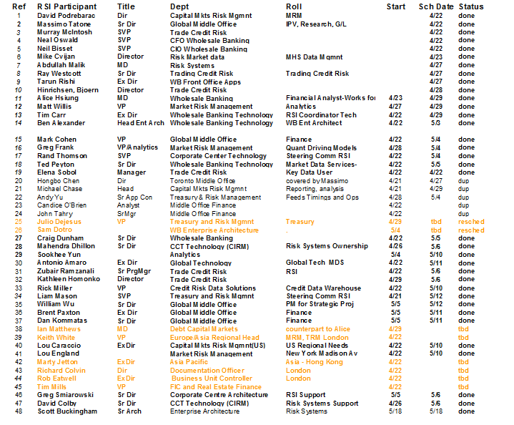

###### Issues

|  |  |
| --- | --- |
| **Issue** | **Follow-Up Actions / Decisions** |
| Schedule interviews to use time effectively and efficiently- group them together. | Reduce volume of interviews by eliminating redundant meetings. Identify additional interviewees to extend detail of our understanding. Get cooperation from participants. |
| Getting the documentation request filled in a reasonable time | Time constraints; Information around TRACS and Voyager @ high level. Meet with Mahendra Dhillon to address. Fact Finding artifact collection |
| Gaining confirmation of our observations and future state | Workshops to communicate & confirm business understanding |
| Unavailable documentation ADAPTIV deployment, e.g. gap analysis, market data requirements | Request from vendors + research + develop template documentation |
| Required low level detail on data management ⇨ understand existing & planned applications: **Adaptiv** (Implementation plan, gap analysis, data requirements), **Xtrader, Wall Street** architecture, transformation, data management strategy, **MHS Data Adapters**, **Voyager/Tracs** (process flows, data usage, conversion strategy) | Clarify scope of market data - Get WB/ Technology lower level documentation or technical SME – Classification of source per date, completeness – Document **project risk log**  🕮**CIBC Key Applications**🕮**CIBC 5 Asset Classes by 29 Systems**🕮**Data Integration** 🕮**LIFE Integration**🕮**System Integration** |

##### Data Stream deliverables

➊Business Requirements ➋RFP Requirements ➌Data Requirements ➍Data Dictionary ➎Conceptual Data Models ➏Current State Architecture ➐End State Architecture ➑Technical Considerations - Pros & Cons ➒Point-to-Point Data Flows ➓Feed Timings

**Preparation** ➊Data Questionnaire ➋Gap Analysis

🕮**Risk Data Facility (RDF) Requirements**

**Data Structure/Data Schema (8)** ➊Trade data ➋Market data ➌Scenarios ➍Issuer/Issue Data ➎Reporting hierarchy structure ➏Market model parameters ➐Result data mart & cube ➑Limits **Data Process (8)** ➊Source data mapping ➋Calibrating market model parameters ➌Exporting market data ➍Exporting trade data ➎Building result data mart and cube ➏Data adjustment & correction ➐Run session ➑End of day (EOD) run, incremental run & rerun

##### Risk Data 7 Areas 400 Requirements

➊Data Quality ➋Capital Calculations ➌Simulation & Monitoring - Monte Carlo/Non Monte Carlo Stress Testing - What-If ➍Workflow & Reporting ➎User Access ➏Operational Controls ➐Systems Architecture

##### 19 Key Risk reports

➊Deal Structure Detail ➋Security Price Override Expiry Warning ➌Product term limit ➍Adjudication Reports ➎CCIS Reports ➏Country Exposure & Limits ➐Deal Violation ➑Documentation Reports ➒Exposure & Limit ➓Exposure Detail ➊Guarantee ➋History ➌Issuer Risk ➍Limit Excess Breaches/ Violations ➎Month-end Regulatory & Economic Capital ➏Override Reports Pledging ➐Exposure ➑Reconciliation ➒Stress Test

##### 20 Conceptual Data Models

➊Transaction/ Position Data Sub-System ➋Market Data ➌Reference/ Static Data ➍Netting/ Collateral ➎Aggregation ➏Pricing/ Simulation ➐Credit Risk ➑Calculation (**a**-Market Risk **b**-Credit Exposure **c**-Sensitivity Analysis **d**-P&L decomposition **e**-Economic & Regulatory Capital **f**-What-If **g**-Results, Reporting, Reconciliation) ➒Limits ➓Other (**a**-Debt Specific Risk **b**-Incremental Risk **c**-Liquidity Risk **d**-Operational Risk)

##### 20 Groups of Risk Data feeds

|  |  |
| --- | --- |
| **Data types covered by real-time feeds**  ⬩Static data ⬩Deal Data ⬩Pre-deal checks ⬩Counterparty Exposure updates  **Planned real-time feeds**  ⬩Counterparty updates from **Risk Data Facility (RDF)** ⬩Master Agreements updates from RDF ⬩Confirmed deals (WSS, X-Trader, OPtex) ⬩Pending deals (WSS, OPtex) ⬩Pre-deal trial checks (X-Trader) Data Feeds Schedule | **Output (ADAPTIV to RDF)**  ⬩Market risk end-of-day exposures (max 0.5GB)  ⬩Market risk IRC exposures (1 file)  ⬩Credit Risk EOD limits & exposures (max 4GB)  ⬩Credit Risk KMV exposures (1 file)  ⬩Credit Risk CVSA exposures (1 file)  ⬩MDS extracts (10 files)  ⬩Wall Street (FXIS) feed (outgoing exposure profiles/ availability)  ⬩Other |

###### Static Data

➊**Customers** hierarchy of trading clients ➋**Agreements** list of netting & collateral agreements for risk mitigation ➌**Organizations** hierarchy of bank’s branches and legal entities ➍**Industries** hierarchy of client industries ➎**Locations** Countries, cities, political groups ➏**Ratings** “credit worthiness” of static data entity ➐**Assets** physical or notional assets, including currencies, precious metals ➑**Asset Securities** fixed income & Equity securities (listed or private) ➒**Products** types of products dealt by bank ➓**Checks** Entities allowing exposure or deals in the system to be controlled

###### Dynamic Data

➊**Deals** individual trades conducted with a customer ➋**Excesses** entities created when exposure exceeds the value of a limit ➌**Violations** creation/ increase of excess during trading activity ➍**Portfolios** collections of deals with manageable aggregate exposure

##### Risk Measures

|  |  |
| --- | --- |
|  |  |

##### 8 Groups of Key Risk data

➊**Yield Curves** feed in Par Rates or Zero Rates ➋**Spread Curves** feed in Spreads per Tenor ➌**FX Grid** feed in Spot FX rates ➍**Cap Volatility Surface** supply Volatility, Premium & Strike ➎**SWAPTION Volatility Surface** supply volatility & premium ➏**FX Volatility** Delta & Strike Volatility ➐**Equity** Spot Price & Volatility Surface ➑**Credit Curve** need CDS Prices

##### On Risk feed experiences

###### Critical path in feed development

**4 activities**: design, development, system test, UAT

➊**Bus requirements** report/ process, data, operations, security, reconciliation, test plan definition ➋**Analysis** data feed rqmts, report/ process data model, operations, security & reuse domains/libraries ➌**Design** a) ***Data*** (logical/physical model of data sources, staging, destination tables) b) ***ETL process*** (extraction-transformation-loading, ETL maps, lookups and sessions) c) ***DBA Optimization /Security*** ➍**Development** + **Unit Test** (programs, stored procedures) ➎**System Test** including QA and performance ➏**User Acceptance Test**: users test data, security, performance, function ➐**Deployment & Production**

Information to calculate counterparty credit risk (new IR derivative feed)

➊Counterparty’s overall ***netting agreement*** ➋***Collateral requirements*** (⇨ evaluate counterparty’s collateral requirements) ➌***Default correlation*** (***counterparty,*** ***investor***) ➍***Correlation*** between ***underlying (interest rates)*** and ***counterparty/investor credit spread*** ➎Other attributes of IR derivative a.k.a ***vanilla Interest Rate Swap***: Principal, Currency, Discount rate, Reset type, Swap rate, Pay rate type, Floating Margin, Effective date, Maturity date, Pay (Receive) frequency – day count – first coupon date

###### Regular IR fix / float swap versus XCCY swap

**Vanilla IR swap**: No exchange of principal amount (notional amount), which is used mainly for determining the size of cash flows to be exchanged **XCCY swaps**: exchange of the principal amounts upon entering into the contract and at maturity. The amounts to be exchanged at maturity are fixed at the inception of the cross-currency swap and based on the FX spot rate at the time. Since the magnitude of that final set of cash flows far outweighs any other cash flows that might exist in the swap, the ***credit risk of XCCY swap*** often is more significant than that of a vanilla interest swap

###### On Credit Risk feeds

Daily loan (agent, principal), Counterparty, Facility (limit, drawdown), Greeks, Ratings, Collateral, Netting, Haircuts, Market data (yields, spots, FRA, volatility)

#### BCBS 239 (BASEL III) Requirements

##### Portfolio Data

**Assets & liabilities (12)** ➊Client, creditor, counterparty identifier ➋Product identifier ➌Currency & country information ➍Contractual terms (maturity, interest rate, seniority of claim, maximum line, covenants, netting-agreement) ➎Value (current, historical; accounting definition) ➏Exposure/ Net exposure (current & historical) ➐Profitability data (costs of liquidity, funding, capital) ➑Ratings (internal/ external rating; current & historical) ➒Probability of default (PD), loss given default (LGD), value at risk (VAR) ➓Liquidity information (liquidity coverage ratio (LCR) weight, days needed for sale, outflow likelihood within given period of time) ➊Hedges & funding linked to asset/ liability ➋Assigned collateral **Clients, creditors, counterparties (10)** ➊Unique identifier ➋Affiliation/ relationship with other clients/ creditors/ counterparties (subsidiary/ parent) ➌Demographic data for private individuals ➍Industry/company information for corporate counterparties, including financial ratios ➎Delinquency history & status (missed payments, current default status, restructuring status) ➏Risk limits (per product, per country) ➐Limit utilization ➑Exposures (total, per product, over time, etc) ➒Posted collateral ➓Rating, PD **Collateral (4)** ➊Unique identifier ➋Type (securities, real estate, cash, guarantee) ➌Value estimate (for real estate, last appraised value/ date) ➍Links to exposure & counterparty

##### Basel III Risk KPI

➊New capital definitions & target ratios ➋Net stable funding ratio (NSFR) ➌Liquidity coverage ratio (LCR) ➍Further liquidity/funding monitoring metrics (Contractual maturity mismatch, Concentration of funding, Available unencumbered assets) ➎Credit-valuation adjustments (CVA) ➏Stressed VaR ➐Incremental risk charge (IRC) ➑Comprehensive risk measure (CRM) – IRC for correlation activities ➒Wrong-way risk ➓Leverage ratio

##### Risk Data Director

**Responsibilities** ⬩Work with VP Risk Data, lead design & execution of risk specific initiatives (governance, sourcing, storage, flow and analytics of risk data) ⬩Work with Initiative partners to determine optimal strategy to source data across clusters of risk types with common data, e.g. trading vs. banking book ⬩Execute multiple initiatives, coordinate development of deliverables, execute against established timelines ⬩Coordinate with peers on simultaneous execution of entire set of initiatives ⬩Develop scope & tasks for initiative execution including assessment, acquisition, allocation of resource requirements (time, cost and skill set) ⬩Align deliverables with industry better practice + evolving regulatory expectation ⬩Execution compliance testing of initiative requirements **Authorities, Impact, Risk** ⬩Compliance with **BCBS 239 – Risk Data Aggregation and Risk Reporting (RDARR)** (non-compliance entails regulatory penalties e.g. capital add-ons & restriction on banking activities) ⬩Failure results in uncompetitive position with sub-optimal capabilities relative to Peers ⬩Expenditure in aggregate approximately **$70 – 100mm** spread across **27 initiatives** led by the Risk Initiative Leads

#### Other Financial Risk War Stories

##### Coordinated data management for Regulatory

**Requirements** ⬩Recovery & Resolution Planning (RRP) ⬩Capital Requirements Directive (CRD) IV ⬩European Market Infrastructure Directive (EMIR) ⇨Set up **Chief Data Office (CDO) function** - Group-wide mandate to define, coordinate approach to data management **Approach** ➊Define **target** **operating model**for Chief Data Office (CDO), emphasis - *delivery capabilities of change* / robust *Business as Usual (BAU)* ➋Define **Data Management Framework (DMF)** ➌Review existing & upcoming regulation for data related requirements & provide impact assessment on various businesses within client portfolio ➍Scope major programs of work across organizations, work with Divisions and Functions to break into practical portfolios of change, establish business benefits & associated costs

##### Derivatives Excess Management

**Requirements** ⬩Division CB provides structured lending products, e.g. foreign currency + IRS derivatives ⬩Division IB process/manage derivative trades ⬩CB responsible for ensuring that IB trades remain within approved limits ⬩IB Risk Control responsible for identifying/ reporting excesses of individual limits ⬩Excess management process hampered by granularity & accuracy of information available to credit officers + relationship managers to understand causes and recommend remediation **Approach** ➊***Build reporting tool & analytical tool*** reflecting existing data quality and constraints to source, process and reconcile data from various sources to establish a ‘true picture’ of all existing excesses ➋***Remedial work with credit officers & relationship managers*** to understand causes of excess and agree a course of action, requiring in-depth analysis to quantify exposure, drill-down at level of trades, understand movements caused by market and/or recent changes to exposure measurement models ➌***Identify root causes of high level of excesses*** and make recommendations for process improvement

##### Collateral Management

**Requirements** ⬩Collateral management functions in line with Basel II standard AIRB **Approach** Streams ➊**Policy** Ensure policies ⬩complete/ compliant with Basel regulations ⬩aligned with industry best practice ➋**Data** ⬩Meet Basel data requirements ⬩Timeliness and availability ⬩Quality of available data ➌**Valuation** ⬩Construction of valuation models (Liquidity, MtM, MtModel) ⬩Valuation frequency (timeliness) ⬩Mitigated Regulatory & Economic Capital impact ⬩Collateral coverage of portfolio ➍**Systems** suitability to meet Basel requirements (Scalability + Interfaces to other systems) ➎**Process** Assess ⬩fit of current processes with Basel operating model ⬩against industry best practice

##### Teacher’s Data Warehouse

###### Operational Excellence

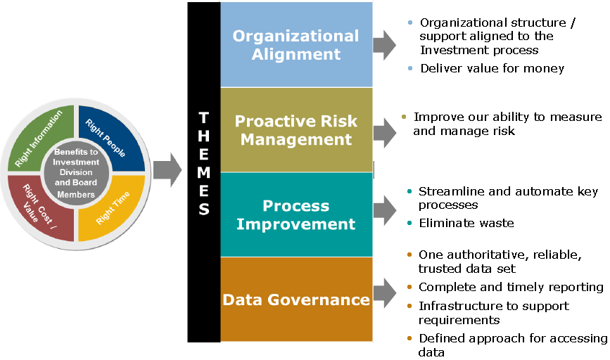

###### Effective Risk Management Challenges & Benefits

⬩**Challenges** –Cost –Change Management –Organizational Alignment

⬩**Benefits** –Business agility & integrated data –Efficient operations that are ‘less risky’ –Improved decision making –Supports future growth and risk reduction

***Operational Excellence program supports risk appetite (risk/ reward) objectives***

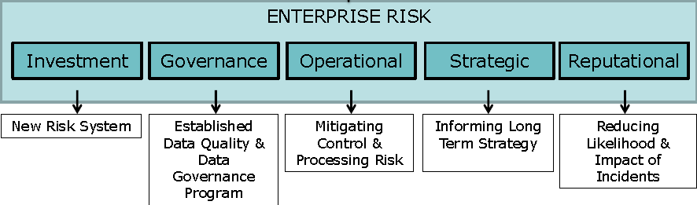

###### Architecture

***Architecture = plan with organizing principles & design objectives***

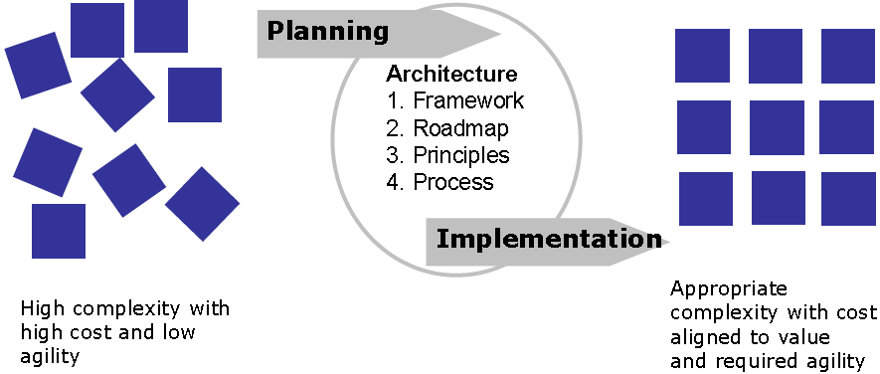

###### Data Governance

⬩“Single source of the truth” ⬩Availability of high quality, complete data ⬩Simplification of data access ⬩Defined data support

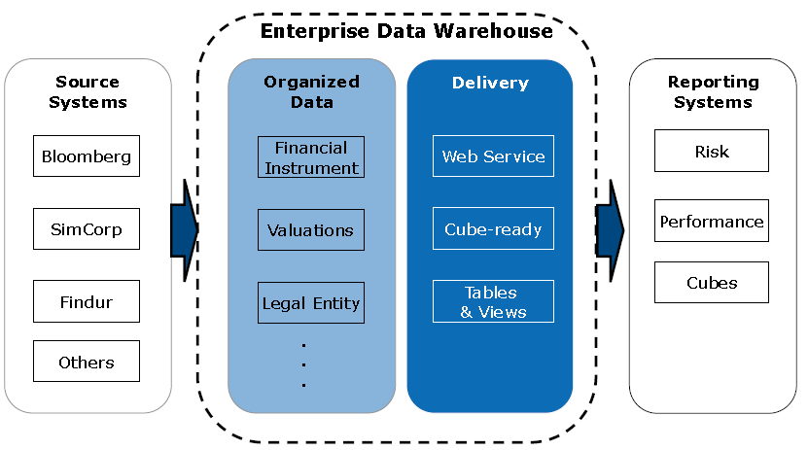

###### Journey

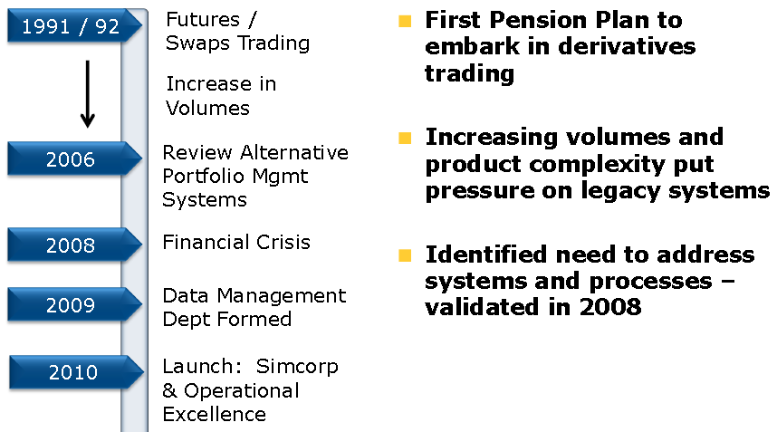

#### PMO Set up

**STEP 1 (1-3 months)** ⬩Meet with Governance or Project Steering Committee to craft PMO Director or PMO Manager job description ⬩Hire right people **STEP 2 (3-5 days)** ⬩Hold PMO Planning session to discuss PMO Roles, assign committee chairs, discuss deliverables, timeframes **STEP 3 (10 weeks)** **Project Inventory Focus (or Committee)**

⬩Initiate a review of current projects by segmentation: by Division, by PMO, by Initiative, by department or division **Gather** ⬩Project Number ⬩Project Name ⬩Project Description ⬩Business Initiative Alignment ⬩Internal/ External ⬩Division/ Department ⬩Project Type (Application Development, Infrastructure, etc.) ⬩Project Manager ⬩Project Sponsor, Requestor & Internal Priority ⬩Start Date, Estimated End Date, Actual End Date, Percent Complete to date ⬩Estimated Budget (Planned Value/ Cost Forecast), Actual Cost (AC) to date ⬩Estimated Risk (H, M, L) ⬩Customer Impact/Benefit ⬩Investment Type (Expense, Capital) **Calculate** Estimated ROI or Revenue, Schedule Variance, Cost Variance **Determine** ⬩Project Health or Status ⬩Portfolio Alignment (by Initiative, Goal, LOB, Department, Division) ⬩Project Variances (Costs, Resources, Scope, Change, Schedule) **Project Development/Training Focus (or Committee)** ⬩Define Roles & Responsibilities (Project Review Boards, Project Governance Committee, Project Office Personnel, Project Managers, Project Coordinators) ⬩Create Job Descriptions ⬩Create Career Paths ⬩Designate individuals per identified roles ⬩Create PM Methodology, Templates, and Toolkits by project phases **Project Tools Focus (or Committee)** ⬩PM Tool ⬩Project Portfolio Management Tool ⬩Project Portfolio Scorecard ⬩Evaluate tools & make recommendations for solutions **STEP 4 (6 Weeks) Project Inventory & Governance Focus (or Committees)** ⬩Make recommendations for retaining, consolidating, shifting project resources, or killing projects based on metrics, duplications, alignment with corporate initiatives, revenue, project resource availability **Project Development/Training Focus (or Committee)** ⬩Create training plan with outlined courses & course progression toward PM training and certification ⬩Ensure PM has Development Plan in place for including PM certification training ⬩Create PM certification training tracking system to track and communicate training progression ⬩Develop feedback system to assess training effectiveness **STEP 5 – Implementation (3 months)** **Development / Training** ⬩Initiate PM certification training ⬩Initiate PM Tool(s) training ⬩Bi-Weekly Report on training progress & student feedback ⬩Communicate PM Career path and post any open positions **Tools** ⬩Execute PM Tool(s) installation ⬩Communicate installation progress & tools strategy **PMO** ⬩Track active projects for PPM updates ⬩Offer coaching & mentoring for PMOs and projects without PMO coverage ⬩Offer PM Consulting with available resources

#### Earned Value

➊Rudimentary **EVMS**, ***gross % complete*** 🞬 **BAC** (Budget @ Completion) **=** **BCWP** (Budgeted Cost Work Performed) per project summed up to program level - BCWS, BCWP and ACWP in man-hours ➋Sr Mgr trained in PM and EVMS; mthly status reviews earned value centered; pressure to adhere to master plan; improve performance measurement system/ performance measurement system baseline; integrated delivery (design before detailed planning + material ordering); collocated PM, planners, estimators ➌FY baseline based on detailed planning with EV in mind; smart resource management, functional management agreement to baseline; **BCWS** (Budgeted Cost Work Scheduled) from baseline, **ACWP** (Actual Cost Work Performed) from management system, **BCWP** (Budgeted Cost Work Performed) from project managers**, variance classification scheme** (“green” variance < $1K, “yellow” if 10-15% unfavorable, “red” if > 15% unfavorable or > $20K applied to cumulative data at project level – “red” addressed at project status reviews); projects share same resources; **classification of hi-level causes** of “yellow” and “red” manpower availability, outside contracts, requirements definition; **PARETO chart by systemic cause** indicating schedule variance ($) by cause (e.g. funding delay caused negative variance) ⇨**resource management office** ⇨ better base-lining

#### SWIFT

##### SWIFT Case Study (INTEL 2005)

**Challenges** •Banks different levels of expertise in SWIFT Corporate Access •If not support **SCORE** model [2]⇨ set up MA-CUG [3]•Cannot send MT202 messages (used by FI) ⇨ work around by insert BEI code into BIC code tag but not supported by bank ⇨ use MT103 message no longer supported from 2009-11 through SCORE.

##### SWIFT Case Study (Citi 2004)

•Migrate to SWIFT ISO15022 platform 🞧 SWIFTNet FIN

•**SWIFT FIN to SWIFTNet FIN** - SWIFT FIN network (store-and-forward financial messaging service access over an X.25 connection) ⇨ SWIFTNet FIN (Internet type network); all current users must migrate by 2004-12; primarily a technological migration because no need to dovetail readiness to individual client – unlike Securities MT 500 series migration to 15022 and Cash migration of the MT100 to the MT103,

•**SWIFTNet Facilities** *FileAct* (automated file exchange, interactive & optional store-and-forward, suited for bulk payments, securities value-added information & reporting, central bank reporting & intra-institution reporting) *InterAct* (real-time, interactive messages exchange by sending request message to application & receiving response message) *Closed User Group* (ability to establish private networks within SWIFT community or external to it; for local market IF, those not eligible for direct SWIFT participation; SWIFT-like security + STP to non-SWIFT eligible corporate business community) *Browse* (secure browser access to service providers; direct access to secure messaging features of InterAct & FileAct offering authentication, encryption & non-repudiation) - *FileAct* for high volume SWIFTeligible, *Closed User Group* lower volume corporate client

•**Testing & Implementation** - Connectivity to Market Infrastructures (CLS®, the Bank of England, BIREL); local market, Closed User Group •**RosettaNet** defines supply chain activity standards for ITT, 500 members@ $1Trevenues

## STAR Skills

|  |  |  |  |
| --- | --- | --- | --- |
| Situation | Task | Action | Result |

#### Business requirements

|  |  |
| --- | --- |
|  | **McKinsey way**  **MECE** = Mutually Exclusive, Collectively Exhaustive  **80/20 rule** |

**🕮****Requirement Management Life Cycle**

##### Requirement types

❶**Business Requirements** enterprise goals, objectives, needs (why a project is initiated, what will achieve metrics to measure success) ❷**User Requirements** statements of stakeholder needs, how stakeholder will interact with a solution, bridge <Business Requirements> to other requirements classes ❸**Functional Requirements** behavior/ information/ capabilities to perform ❹**Quality of Service Requirements** (non-functional, supplementary requirements) ❺**Assumptions/ constraints** aspects of problem domain limiting/ impacting design but not functional requirements ❻**Implementation requirements** to transition from current to desired future state (once off) ➐**Project requirements** ➑**Quality requirements**

##### Elicitation Importance

➊**Support executive decision making** ➋**Apply influence to finish work** (backed by information that supports the goals) ➌**Assist in negotiation/ mediation** ➍**Resolve conflicts** ➎**Define real problems**

##### Requirements Elicitation

**❶**Brainstorming **❷**Document analysis **❸**Focus group **❹**Interface analysis **❺**Observation **❻**Prototyping **❼**Requirements workshop **❽**Reverse Engineering **❾**Survey/Questionnaire

##### Requirements Communication

**❶**Requirements communication plan **❷**Requirements format **❸**Requirements package **❹**Requirements presentation **❺**Conduct a formal requirements review **❻**Get signoff

##### Requirements planning and management

**PLANNING** ⬩key planning impact areas ⬩SDLC ⬩project life cycle methodology ⬩project risk, expectations & standards ⬩key stakeholder needs & location ⬩project type **REQUIREMENTS ACTIVITIES** ⬩requirements elicitation stakeholders/ activities ⬩requirements analysis/ documentation activities ⬩requirements communication activities ⬩requirements implementation activities **ESTIMATE REQUIREMENTS ACTIVITIES** ⬩milestones in requirements activities development/ delivery ⬩units of work ⬩effort per unit of work ⬩duration per unit of work ⬩identify assumptions ⬩identify risks **MANAGE REQUIREMENTS SCOPE** ⬩establish baseline ⬩structure for traceability ⬩identify impacts to external systems ⬩identify scope change resulting from requirement change (change management, maintain scope approval) **MEASURE/ REPORT ON REQUIREMENTS ACTIVITY** ⬩determine project / product metrics ⬩collect project / project metrics **MANAGE REQUIREMENTS CHANGE** ⬩plan requirements change ⬩understand requirements changes to ⬩document requirements changes ⬩analyze change requests

##### Techniques to analyze process

**1** Who owns process **2** Who has power to change it **3** What are its objectives **4** What are success metrics **5** Who are customers **6** Who participate **7** What are inputs **8** What analytical tools **9** What events and milestones drive this process **10** What kind of decisions does this process generate **11** What decision-making criteria **12** How are decisions communicated, and to whom **13** Link to other management systems

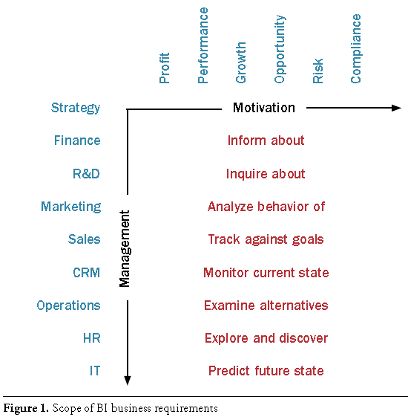

#### Risk Management

➊Identify ➋Analyze ➌Plan ➍Implement ➎Track & Control

**Step 1 – Identify**

**1-1** Identify and Collect **Candidate Risks 1-2** Identify & Provide Candidate Risk Input to Risk Manager/Analyst **1-3** Review Candidate Risks (**Table 1:** Criteria for Risk Identification - Risk? Impact? Likelihood? **Table 2:** *Risk Identification Components* – Originator, date, title, description, context) **1-4** Record Identified Risks in the Project Risk Database

**Step 2 – Analyze**

2-1 Verify/Determine **8** **Risk Classification** ➊Cost ➋Schedule ➌Scope ➍Quality ➎Human Resources ➏Communications ➐Procurement ➑Integration

**2-2** Verify/Determine **Risk Impact** (*High, Medium, Low*) **2-3** Verify/Determine **Risk Probability** (High >65% conf., Medium 35-65%, Low <35%) **2-4** Verify/Determine **Risk Timeframe** (*Short <120 days, Medium <360 days, Low*) **Risk Exposure** = Probability x Impact **2-6** Verify/Determine **Risk Severity** = *Exposure x Time Frame* **2-7** Recommended **Mitigations + Contingencies**: *Elimination, Reduction, Acceptance* **2-8** Review Risks with Project Director, Project Sponsors, and Stakeholders

**Step 3 – Plan**

**3-1** Assign **Risk Owner 3-2** Develop-Review-Approve Mitigations, Contingencies, Measurements **3-3** Develop Mitigation and **Contingency Action Plans 3-4** Update Project Risk Database

**Step 4 – Implement**

**4-1** Execute Mitigation and Contingency Action Plans **4-2** Update Project Risk Database

**Step 5 – Track and Control**

**5-1** Oversee Mitigation and Contingency Action Plan Execution **5-2** Track Action Plan Execution and Provide Feedback **5-3** Re-Assess Risks **5-4** Report Risk Status **5-5** Maintain the Project Risk Database **5-6** Escalation of Project Risk **5-7** Risk Retirement

**Table 8: Guide for Determination of Risk Escalation**

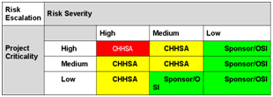

See PMI Practice Standard Risk Management

**Risk Statement** “Because of <1 or more causes>, <risk> may occur, which would lead to <1 or more effects>

###### PM Risk TOOLS

**Identify** ➊Brainstorm ➑Constraint analysis ➋Cause & Effect (Ishikawa) ➌DELPHI ➍FMEA Failure Modes Effect Analysis ➎Force Field ➏Influence diagram ➐Risk breakdown structure ➑Questionnaire ➒WBS review ➓SWOT

**Analyze** ➊Probability and Impact ➋Post-review ➌Analytic Hierarchy ➍Root-Cause ➎Decision Tree ➏Expected Monetary Value EMV ➐Monte Carlo

**Plan** ➊Brainstorm ➋Contingency planning ➌Contingency Reserve Estimation ➍Critical Chain Project Management CCPM ➎Prompt List ➏Scenario Analysis

**Track & Control** ➊ Critical Chain Project Management CCPM ➋Reserve Analysis ➌Risk Audit ➍Trend Analysis ➎Variance Analysis

**Risk Register** ➊**SUMMARY** ⬩Risk statement ⬩Risk owner ⬩Date last assessment ⬩Due date for update of risk assessment ⬩Risk category (Strategic, Project delivery, Operational) ⬩Risk classification (low, medium, high) ⬩Risk response ➋**DESCRIPTION** ⬩Title ⬩Scenario description (Actor, Threat type, Event, Asset/resource, Timing) ➌**ANALYSIS RESULTS** ⬩Frequency of scenario (# times per year) ⬩Impact on business (1 Productivity 2 Cost of response 3 Competitive advantage 4 Legal) ⬩Impact rating (average of 4 impact ratings) ⬩Rating of risk (frequency & impact ratings) ➍**RISK RESPONSE** ⬩Response (avoid, mitigate, transfer, accept) ⬩Response Justification ⬩Risk action plan status, issues ⬩Completed responses status, issues ➎**RISK INDICATORS**

🕮**CRISC IT Risk & Controls** **5 practice areas ➊**Risk Identification, Assessment, Evaluation ➋Risk Response ➌Risk Monitoring ➍IS Control Design & Implementation ➎IS Control Monitoring & Maintenance 🕮**IT Risk Scenario 5 Components** ➊Actor ➋Threat type ➌Event ➍Asset/Resource ➎Time 🕮**Risk Analysis and Response** **Risk Analysis** Top Down/ Bottom Up **5 Risk Factors** ➊External environment ➋Internal environment ➌Risk management capability ➍IT capability ➎IT-related Business Capability **4 Risk Response** ➊Avoid ➋Mitigate ➌Transfer ➍Accept **Risk response 5 parameters**➊Cost ➋Importance ➌Implementation capability ➍Response effectiveness ➎Response efficiency **36 Risk Scenarios** ➊IT program selection ➋New technologies ➌Technology selection ➍IT investment decision making ➎Accountability over IT ➏Integration of IT within business processes ➐State of I/F technology ➑Ageing of application SW ➒Architectural agility & flexibility ➓Regulatory compliance ➊SW implementation ➋IT project termination ➌IT project economics ➍Project delivery ➎Project quality ➏Selection/ performance of 3rd-party ➐IF theft ➑Destruction of IF ➒IT staff ➓IT expertise & skills ➊SW integrity ➋IF HW ➌SW performance ➍System capacity ➎Ageing of IF SW ➏Malware ➐Logical attacks ➑Information media ➒Utilities performance ➓Industrial action ➊Database integrity ➋Logical trespassing ➌Operational IT errors ➍Contractual compliance ➎Environmental ➏Acts of nature

#### Schedule Management

**Critique Schedule**: ⬩Critical Path(s) and Float (float report, reasonable total float (days), assigned predecessor and successor) ⬩Activities Level of Detail & Logic in Sequencing of Tasks ⬩Major Issues and Obstacles for the Project ⬩Organization of Tasks in Groups ⬩Contract Data ⬩Baseline ➊Include logical ties for activities ➋Include milestones + deliverables ➌Reflect agreed-to project baseline ➍Integrate cost baseline

**Create Schedule**: ⬩Identify Phases within Project ⬩Identify Areas within the Phases ⬩Identify Components within Areas ⬩Identify Activities within Components ⬩Identify Activity Codes for Reporting ⬩Identify Project Constraints, Materials & Methods, Contract Restraints ⬩Interview Team Members to Gather Missing Information ⬩Determine Best Delivery Method (ο Fast Track Scheduling ο Conventional Scheduling ο Phased Scheduling) ⬩Baseline Schedule Process

**Input Schedule Into Project**: ⬩Project Information & Phase Headers ⬩Area Headers in Phases ⬩Tasks ⬩Durations ⬩Activity Codes ⬩Assign *Dependencies* ⬩Calculate *Schedule*

#### Budget Planning & Management

##### Budget disciplines

⬩**Operating Budget** vs. **Capital Budget** ⬩**Accounting** ⬩**Contract Managem****ent** ⬩**Internal Control** ⬩**Audit**

##### Contract Baseline 8 elements

➊Total contract price ➋Total contract cost ➌Profit/fee ➍Contract budget base ➎Performance measurement baseline ➏Management reserve ➐Distributed budget ➑Undistributed budget

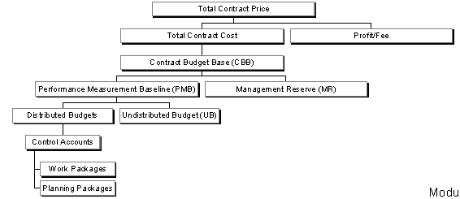

##### Capital Budget 12 best practices

➊**Assessment of Needs** to Meet Results-Oriented Goals & Objectives ➋**Identify Current Capabilities** (e.g. Use Inventory of Assets & their Condition) & **Determine Gap** (Current v. Needed Capabilities) ➌**Identify & Evaluate Alternative** (Including Non-Capital) Approaches to Meet Gap ➍Establish **Review & Approval Framework** ➎**Rank & Select Projects** Based on Established Criteria ➏Develop **Long-Term Capital Plan** for Capital Asset Decisions ➐Budget for **Projects in Useful Segments** ➑Approaches to Full ***Up-Front Funding*** ➒Monitor **Project Performance** & Establish Incentives for ***Accountability*** ➓**Cross-Functional Teams** to Plan & Manage Projects ➊**Evaluate Results** against Organization-Wide Goals ➋Evaluate **Decision-Making Process** - Re-Appraise & Update to Ensure Goals Met 🕮**Recourse planning Cost Management** 🕮**Activities and Scheduling** 🕮**Characteristics of Credible estimates**

•Budget = Integrated Scope, Schedule and Cost

#### Earned Value

|  |  |  |
| --- | --- | --- |
| Guessing project status; budget variance & gross % complete assessments, milestones/Gantt chart inconsistent quality and interpretation, cannot roll-up data and no audit trail, no time-phased budget; Earned Value used on larger projects | Harvester portfolio of $100M 15 countries, coordinated with Home Office New York  **BAC**= Budget at Completion, **BCWS**= Budgeted Cost Work Scheduled, **ACWP**= Actual Cost Work Performed, **BCWP**= Budgeted Cost Work Performed  **Earned Schedule** | Costs $50K **BENEFITS** Articulated status via common language; EV drive top-down planning & resource mgt, highlight systemic problems; sound management decisions wrt resource & funding ⇨ satisfied customers |
| Performance Measurement Baseline (PMB) characteristics: ➊accurately represents only authorized work ➋includes realistic network schedule baseline ➌includes realistic time phased spread of budget/resources to base lined schedule ➍management makes consistent commitment to enforce proper baseline change procedures and periodically review the remaining baseline to ensure that it remains executable ⮚Apply statistical techniques to predict project outcomes and historical data for planning | | |

🕮**Earned Value Formulas** 🕮**Earned Schedule** 🕮**MS Project Earned Value**

#### Earned Value Management System (EVMS)

**EVMS**= set of policies, procedures, and practices to support program and project management as a decision enhancing tool and a critical component of risk management

**Performance Report** ➊WBS ➋Organizational Categories ➌Baseline ➍Staffing ➎ Explanation and Problem Analyses **Input to EVMS** ➊WBS ➋OBS (org breakdown structure) ➌Schedule ➍Time-phased baseline budget ➎Cost/resource control plan ➏Change control plan **WBS** ➊Final project products to succeed? ➋Deliverables to succeed? ➌Requirements to manage + control? ➍Stakeholders review/ agree **WBS elements** ➊Phases imperfect tense (-ing) ➋Deliverables noun ➌Detail tasks verb ➍Milestones noun **WBS** **report levels** ➊Control Accounts (WBS L3) ➋Work Packages ➌Planning Packages **WBS Dictionary** ⇨ Statement of Work **OBS Org Breakdown Structure** by Responsible Department and then by Performing Department at the lowest level **OBS ʌ WBS = Responsibility Assignment Matrix**

**5 Industry Standard EV Management System** ➊Organization ➋Planning & Budgeting ➌Accounting ➍Analysis & Management Reports ➎Revisions & Data Maintenance

➊**Organization**

⇨Define ***Work Breakdown Structure (WBS)***

⇨Define ***Organizational Breakdown Structure (OBS)***

⇨Establish work authorization and cost accumulation processes

⇨Establish Cost and Schedule Integration Process

⇨Identify Indirect/Overhead Cost Structure

⇨Create ***Responsibility Assignment Matrix (RAM)***

➋**Planning and Budgeting**

⇨Create *Integrated Master Schedule*

⇨Identify Milestones, Key Events, Technical Performance Measures

⇨Establish and Maintain a Time-Phased Budget Baseline

⇨Identify Management Reserves and Undistributed Budget

⇨Reconcile ***Contract Budget Base (CBB)*** with ***Total Allocated Budget (TAB)***

➌A**ccounting**

⇨Record direct and indirect costs in accordance with company disclosure statement

⇨Provide summary and detail visibility of costs

⇨Establish process for reporting Material, Other Direct Costs, and Subcontractor Costs

⇨Provide full accounting of all material purchased for the project

➍**Analysis and Management Reports**

Monthly information @ Control Account Level for analysis and reporting using actual cost data that is reconcilable with the approved accounting system

⇨Report ***variance of Budget (BCWS)*****,** ***Earned Value (BCWP)*,** ***Actual (ACWP)***

⇨Provide explanation of indirect costs

⇨Implement recovery plans, management actions, and recommendations

⇨Develop revised estimates (EACs, LREs) = f(performance to date, estimated future perf.)

➎**Revisions and Data Maintenance**

Establish Change Management System - Provide Reconciliation and Revision Reports =

Control and Document changes

#### Project Benefits

##### 6 Benefit Types

➊Cost reduction ➋Cost avoidance ➌Revenue protection ➍Revenue generation ➎Operational improvement ➏Capital reduction

##### Benefits per Project Phase

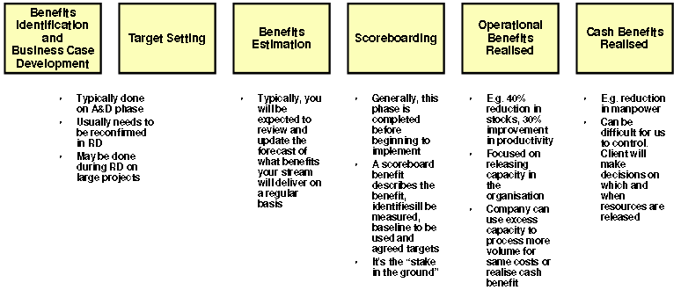

###### Benefits Stage 1: Identify Performance Measures

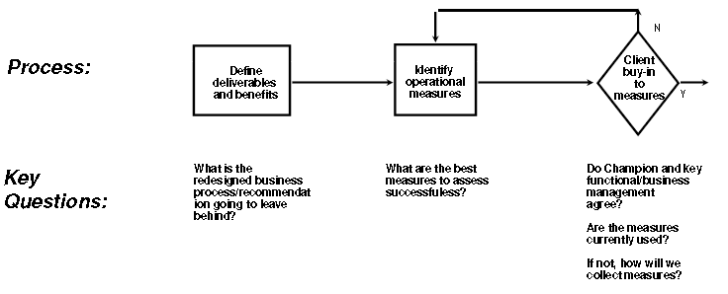

###### Benefits Stage 2: Operational Baselines & Targets

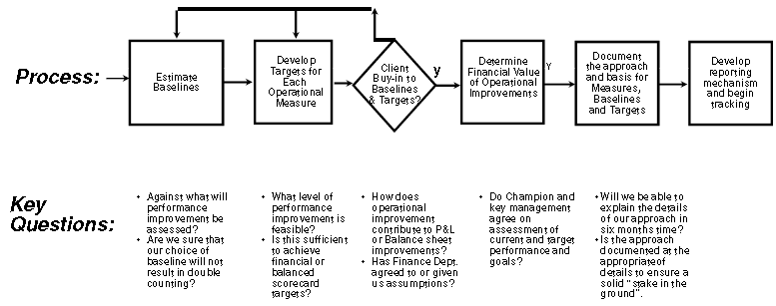

|  |  |
| --- | --- |
| **Benefit** | **Baseline** |
| **Cost avoidance or Capital** | Need to demonstrate that $ would have been spent e.g. $ allocated in Budget or Plan, Approved Business case, Project already spending $ |
| **Revenue enhancement** | Historical volumes, historical/ forecast prices  Forecast volumes, historical or forecast prices |
| **Cost savings** | Historical spend |
| **Working capital reduction e.g. reduction in A/R, debtors** | Ratios not absolute $ e.g. A/R ($)/ Sales ($) |

##### Logics of Benefits

⬩Delivery of MEASURABLE benefits is contractual ⬩**Intangibles** = “enabler” to achieve other MEASURABLE benefits ⬩**Benefits in annualized amounts** ⬩Buy-in from Finance ⬩Primarily project management & change management tool ⬩Translates ***operational improvement*** into ***financial benefit*** ≈ ***general ledger benefit*** ⬩Focuses on performance improvement and use of KPI’s 🕮**Earned Value Variance**🕮**Benefit Realize sample**

#### Program Management

***🕮*****Program Management Process** *🕮***Portfolio Management**

##### Program versus Project

|  |  |
| --- | --- |
| **Projects** | **Programs** |
| Have solutions that are known and describable | Know that a solution exists, but is often is initially unknowable |
| Are amenable to a structured process (“methodology”) | Less amenable to a structured management process |
| Specific details in charter (often indistinguishable from project plan) | Are chartered to reflect the strategic nature of an investment |
| Have an internal focus on tasks and project issues | Have an external focus on stakeholders politics and alliances |
| “**Risk**” = threat that will undermine performance. Project mangers focus on reducing uncertainty. | “**Risk**” = opportunity that brings with it threats and obstacles that will be managed. Program managers first manage ambiguity and then uncertainty. |
| Led by people knowledgeable of the technology and system | Led by people who appreciate the politics and culture as well as the technology |
| Are smaller in size and intended impact | Larger in size and intended impact, strategic and aligned with enterprise strategy |
| Are funded from a single funder | Funded by multiple stakeholders, and often self-generate their own funds |
| Have clearly distinguishable end points | End when the underlying technology platform obsolete / funding withdrawn |
| React to changes from specific customers | Changes from stakeholders, from strategic intent to strategy |
|  | PMI: 1) Program Stakeholder Mgt 2) Program Financial Mgt 3) Governance |

##### Program Roles & Responsibilities

|  |  |
| --- | --- |
| **Program**  **Sponsor(s)** | * Champion statewide support for the program * Provide sponsorship and support for program * Ensure program funding and resources * Establish and reinforce the vision for the program * Interpret federal requirements and regulations * Develop state regulations pertaining to the program * Point of Contact for state control agencies and federal partner agencies * Chair the Executive Steering Committee |
| **Executive Steering**  **Committee (ESC)** | * Assign authority to Program Director, PM Team, Project Directors * Provide leadership and support for the entire program * Support the program by communicating the vision and working to reduce barriers, and mitigating risk * Facilitate the interdepartmental collaboration of a statewide system * Provide issue resolution across agencies * Receive periodic briefings from the Program Director and Project Directors regarding program and project progress, resource needs, issues, risks, funding and expenditures |
| **Executive Advisory Committee (EAC)** | * At ESC direction, directs analysis effort, provides recommendations to ESC; * Sets long term goals and strategies in support of the strategic direction and vision established by the ESC; * Set priorities for funding, program changes, and technology initiatives * Ensures the availability of funds; * Ensures consistency and coordination across the component projects in support of the Program Director; * Resolves issues raised from Customer Impact+ Technology Advisory Committees * Provides guidance and direction on leveraging technology; * Provide guidance and direction on policy changes; and * Assists the ESC in managing fiscal and political issues. * Discusses and provides recommendations to the ESC and Program Director on critical program and cross-project issues and risks |
| **Program Director** | * Leads the program management team * Liaison to Legislature, State CIO, Governor’s Office, departments, agencies * Report project achievements and status to the ESC * Elevate issues to the ESC * Serve as a project spokesperson responsible for communicating project strategy, benefits, direction, status, and recommendations to stakeholders and the public * Approve final project deliverables * Approve risk mitigation strategy and action |
| **Customer**  **Impact**  **Committee**  **(CIC)** | * Represent the customer perspective based on knowledge of the program, existing business processes, and customer or client needs * Elect Chair (CIC representative to EAC and advisory member of ESC) * Bring forth significant project concerns to the Program Director * Escalation of project issues/concerns to the Executive Advisory Committee (EAC) * Advise EAC of impacts to stakeholders/departments of program and project approach, schedule, plans, and activities * Ensure departmental support and readiness for implementation * Assist in program and project planning, requirements development, and implementation activities |
| **Technical**  **Advisory**  **Committee** | * Elect a Chair (TAC representative to EAC and advisory member of ESC) * Bring forth significant program and project concerns to Program Director * Escalation of project issues/concerns to the Executive Advisory Committee (EAC) * Provide advice and counsel to technical staff of component projects or program * Advise and report to the EAC as requested * Assist in technical project planning, design, and configuration activities |
| **Project Director**  **(State Project**  **Manager)** | * Promotes the vision for the project * Provides leadership for the project * Provide Executive oversight for project and delivery of the solution * Provide project reports to the Program Director and the ESC * Approve final project deliverables * Approve risk mitigation strategy and action * Provide a centralized structure to coordinate and manage the project, its staff resources, teams, activities, facilities, communication, and outreach using structured project management methodologies including OSI Best Practices * Ensure overall project process and deliverable quality * Responsible for the delivery of the solution * Ensure solution implemented addresses project’s and program objectives * Serve as central point of communication and coordination for project * Ensure timely communication with program management + external stakeholders * Direct the activities of state and vendor personnel assigned to project * Monitor the planning, execution, and control of all activities necessary to support the implementation of a statewide enterprise <Insert project type) system * Provide leadership to state staff assigned to manage the multidisciplinary project teams including business process teams, technology teams, acquisition teams, change management teams, project administration teams, and training teams * Direct the development of project documentation required by control |
| **OSI Program Mgment Team** | * Provides support to the Program Director * Develop and maintain the Master Program Plan * Develop and maintain the Master Schedule * Provide program-level issue management * Provide program-level risk management * Prepare reports for ESC and other stakeholders * Manage the program-level change management process |
| **OSI Executive** | * Provides guidance/ support to the Program management leadership * Advocate for the program with the Health and Human Service Agency, control agencies, and the Legislature |
| **Program Budget Office** | * Lead the development and maintenance of the program budget * Leads the development of budget change documents on behalf of the program (e.g. BCP, SPR) * Coordinate budgets and budget changes with sponsors, partner agencies and departments which manage component project budgets |
| **Office of Technology Services** | * IT Federated Data Center services * Wide area network support * Provide technical counsel in areas associated with the service they provide to the program (e.g. network and interface design) |
| **Non-Govt Stakeholder** | * Provide input based on business, policy, or technical expertise * Provide advocacy for the program’s mission |
| **User Stakeholder** | * Provide input to the project teams and management based on business and/or policy expertise * Participate in joint application requirements sessions * Participate in user acceptance testing * Help the program and projects understand the impact of the proposed system/solution of upon end user business processes * Participate in the development of Service Level Agreements between the projects, program, and the user community |
| **Independent Validation & Verification** | * Provide independent quality assurance and quality control services to the program with an emphasis on the technical aspects of the program * Provide reports and recommendations to program management |
| **Independent Project Oversight Provider** | * Provide independent monitoring of the Program Office, Project Office, and Contractor's management efforts. The focus is generally on process and products from a management, process and quality perspective, not the in-depth technical reviews associated with IV&V. * Create and provide reports and recommendations to program management, Departments, Agency, and the California Technology Agency. |
| **Federal agency Stakeholder** | * Review / approve planning documents and federal funding - Advise state and program of upcoming federal changes which may potentially impact the program |

##### Program Lifecycle (5)

➊Pre-program setup ➋Program setup ➌Program Mgt & Technical I/F ➍Benefit delivery ➎Program closure

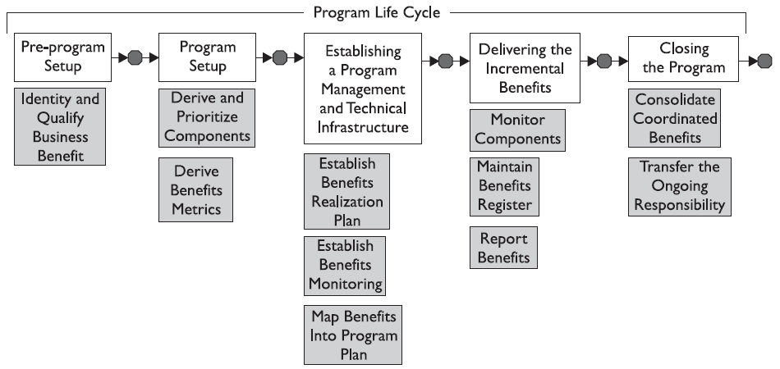

##### Project Portfolio Optimization (PPO)

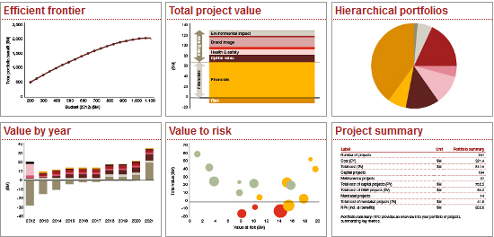

##### Project selection criteria

|  |  |  |
| --- | --- | --- |
| 14% ⬩Return on investment  9% ⬩Risk factor  6% ⬩Complexity of project  18% ⬩Strategic alignment | 10% ⬩Project type (new, maintenance)  9% ⬩Dependency with major project/ program | 13% ⬩Urgency/ market reactive  7% ⬩Time to complete  14% ⬩Expected benefits |

#### Project Management Office

##### Project Intake

➊Collaborate & analyze needs of functional areas ➋Oversees intake of requests, routing for scoring/prioritization & scheduling ➌Assists with business cases ➍IT project & resource managers for status updates and reports

##### PMO Organization

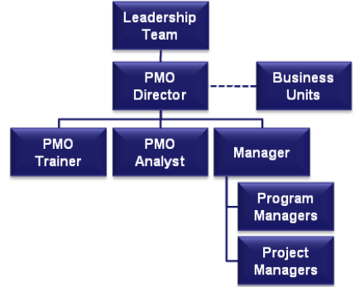

##### PMO Setup phases

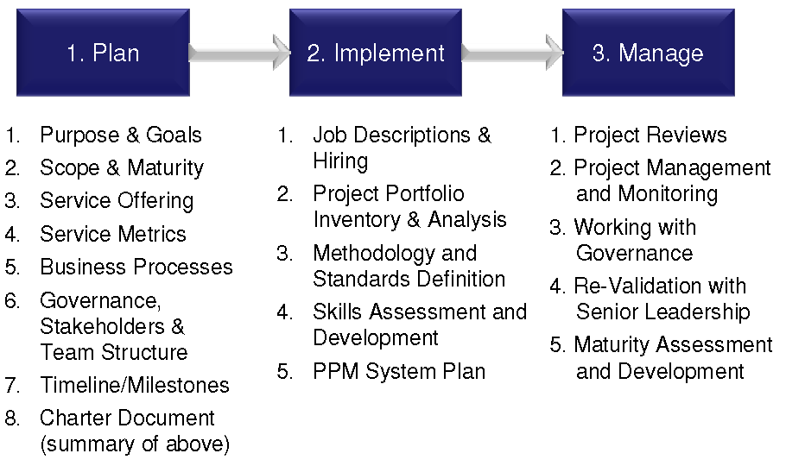

##### From “Initiative PMOs” to “PMO in a Box”

■What elements should go into a program charter and why they are important?

■Instructions and examples on how to create work breakdown structures

■Risk category examples and what constitutes a high, medium or low risk

■How program managers should handle dependencies in scheduling

■When program managers should use estimating, what techniques?

■When and how often the Program Manager should engage stakeholders

■The significance of escalation to senior management

■The importance of establishing change control at the start of a program

PMO 3 Scopes ➊Portfolio ➋Program ➌Project

##### PMO Maturity 5 levels

➊Reactive ➋Repeatable (defined processes) ➌Pro-active (document, standard) ➍Measured (KPI) ➎Continuously Improved (extension to external, collaboration)

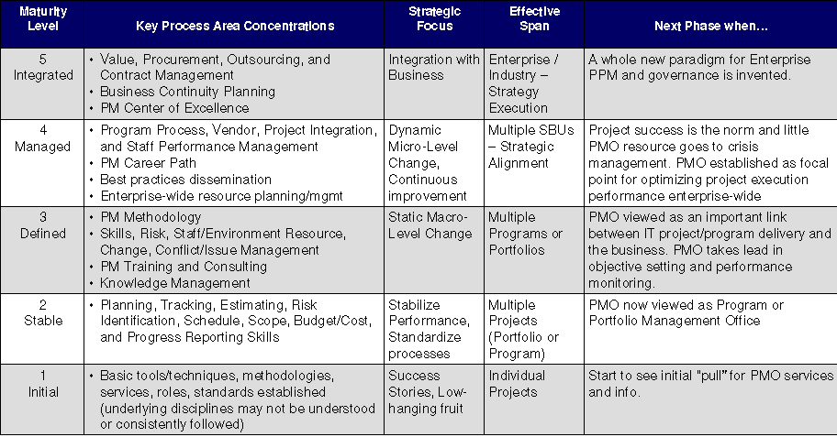

##### PMO Cores services

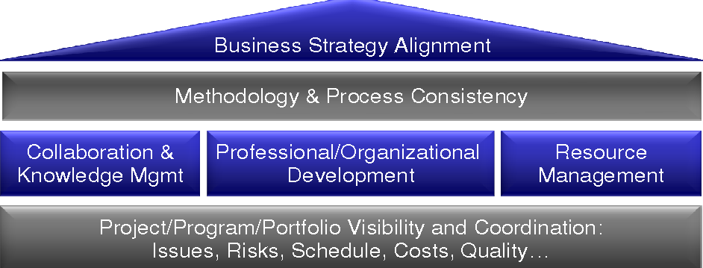

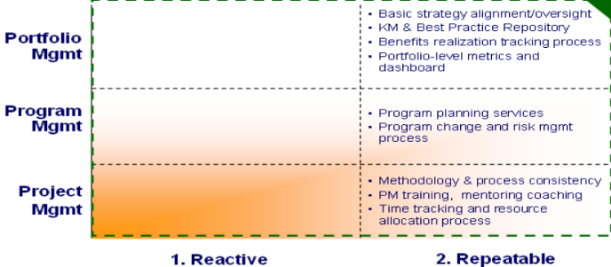

##### PMO implementation plan

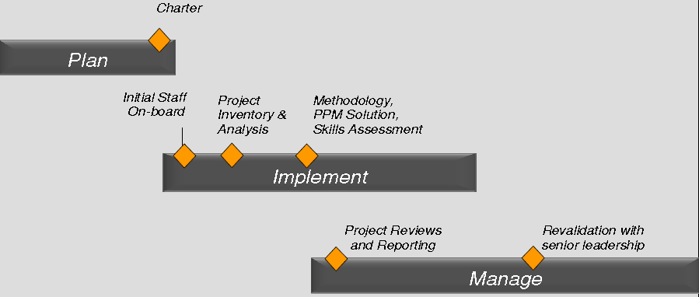

##### PMO Charter

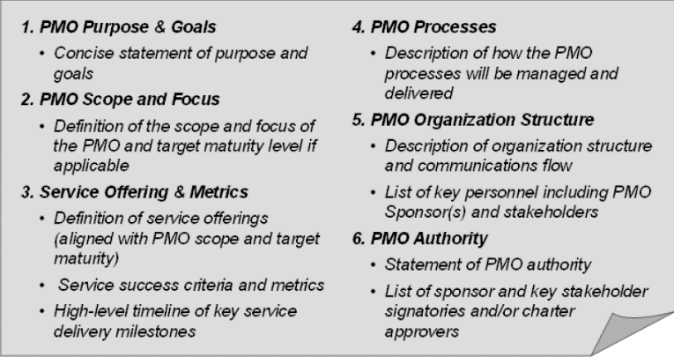

#### INTAKE

⬩Request for project evaluation ⬩Analyze project feasibility ⬩Develop project charter ⬩Approve project

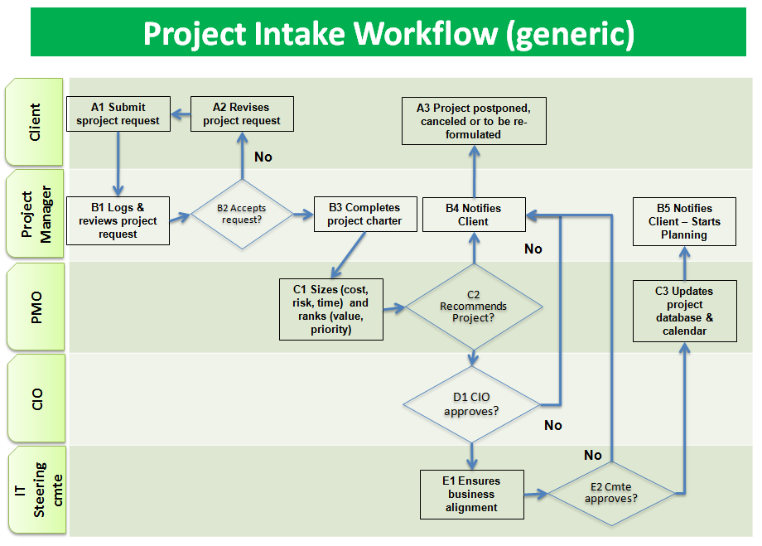

**Key factors to consider**:

⬩Intake triggered by “Client”; projects to improve IT services considered as internal IT projects and included in the IT operating budget ⬩Intake requires **Business case** + **Budget** “owned” by Client ⬩Project manager assigned to represent PMO to help Client; PM initial task = determine whether Intake is properly documented (e.g.. Which new capability is required by which organization in order to generate which new organizational value, etc.); include ***marketing report*** of current best practices and competitors’ achievements, ***FMEA*** (Failure Modes Effect Analysis) of current system or strategic analyses such as ***SWOT*** or ***PEST*** ⬩**Project Charter** (high-level requirements, scope, benefits, key project stakeholders, key project dates, high-level estimates of costs (order-of-magnitude) required to formally request service of a PM ⬩PMO to analyze the project from the perspectives of: alignment with business and IT strategy, tangible values, related costs (IT and non-IT related), risks (technology and non-technology related) and required delivery time; available resources (manpower, infrastructure, etc.)? need for external resources? ⬩PMO recommends to **Office of CIO** to review before forwarding to **IT Steering Committee** or **Governance Board** ⬩Review criteria = alignment with long- or near-term business strategy, available organizational resources, readiness of the project in terms of planning, risk assessment, etc. ⬩Once approved by the Steering Committee, the project may be registered to project database and cleared for **planning stage** (Business case, detailed Project budget, detailed Project plan and schedule)

#### Lean Management and Six Sigma

**Six Sigma** & Lean management; Tools: **SIPOC, Voice of Customer, Voice of Process, Process Map, ANOVA, Cause-Effect, Cost of poor quality CoPQ**

#### Enterprise Architecture

**⬩****TOGAF 9** **⬩Architecture Development Method (ADM)** •**9 phases** •**4 domains** BDAT (➊Business ➋Data ➌Application ➍Technology)

#### Change Management

##### Delivery Fundamentals GSK Global Healthcare

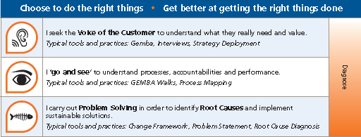

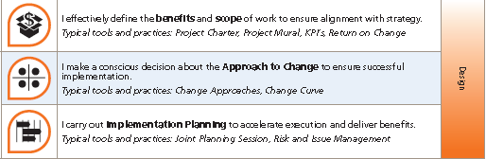

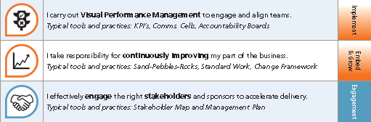

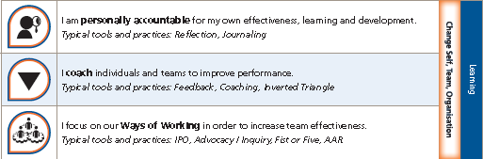

HOOPP SIMCORP, CIBC MELLON Financial System Renewal, CIBC SOX, AIA Harvester

Anecdotes: **🕮****Change Management** ⬩**Change management specialist** ⬩**FMEA Failure Modes Effect Analysis** ⬩**Orders of change** (1-Procedures 2-Policies 3-Values most difficult) ⬩**Effective change process** ⬩**Change Management Life Cycle** (1-Initiate 2-Plan 3-Implement 4-Manage Transition 5- Sustain Change) ⬩**Kotter’s Heart of Change** (1-Increasing urgency 2-Build guiding teams 3-Get vision right 4-Communicate for buy-in 5-Enable action 6-Create short-term wins 7- Don’t let up 8-Make it stick) ⬩**Change and OPM Organizational Project Management** (portfolio mgt tactical or strategic to define & value results of change initiative)

#### RUP Rational Unified Process

##### RUP Large Project (IBM)

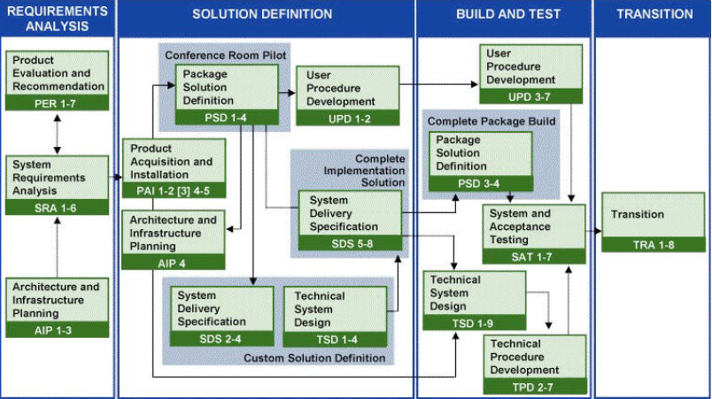

##### RUP and PMBOK

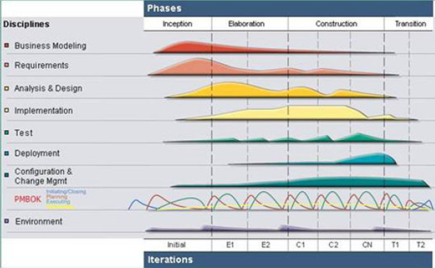

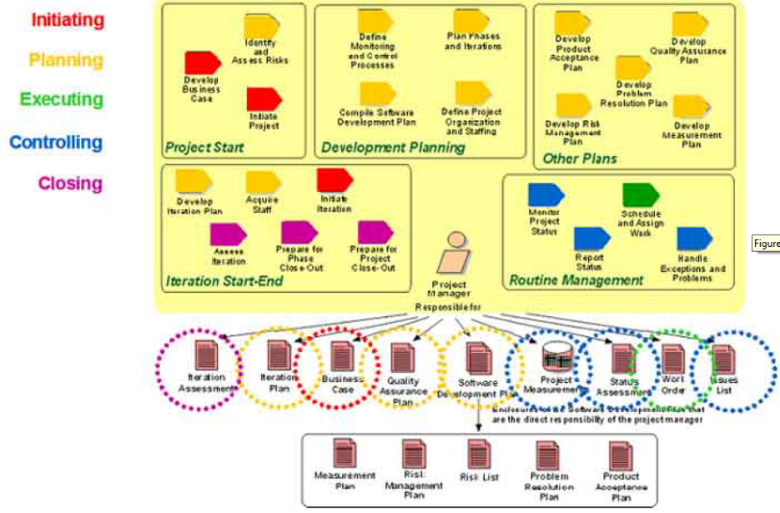

#### UML Diagram

❶**Structure diagrams** (Class diagram, Component diagram, Composite structure diagram, Deployment diagram, Object diagram, Package diagram) emphasize what things must be in the system being modeled ❷**Behaviour diagrams** (Activity diagram, State Machine diagram, Use case diagram) emphasize what must happen in the system being modeled ❸ **Interaction diagrams** (Communication, Interaction overview, Sequence, Timing)

##### Workflow modelling

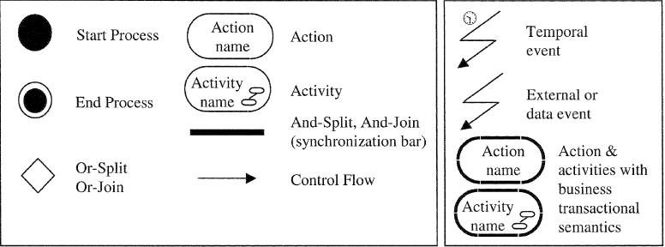

**Extensions**: Deadlines, Business transactions, terminations

##### UML documentation

➊**USE CASE VIEW** ➋**LOGICAL VIEW** ➀**Conceptual** (Internal Portal Subsystem, External Portal Subsystem, Business Subsystems, Business Rules Subsystem, Database Services Subsystem Reporting Services Subsystem, Batch Job Scheduling Services Subsystem) ➁**Layer** (Client, Presentation, Automation, Application, Services) ➂**Components** (applications assemblies, framework assemblies, SQL Server Database instances) ➃**Packages** ➌**PROCESS VIEW** ➀**Applications, Processes, Application** Domains ➁**Threads** (ASP.NET Threading, Windows Service Threading, Inter-process Communication) ➍**DEPLOYMENT VIEW** ➀**Deployment Nodes** (Web NLB Cluster, Application NLB Cluster, Database Failover Cluster, Internal/External Active Directory ➁ **System Software** (Windows Server, IIS, .Net Framework, SQL Server, SQL Reporting Services, Active Directory, Active Directory Application Mode (ADAM), 3rd Party Software) ➎**IMPLEMENTATION VIEW** ➀**Framework Classes & Components** (Web Control Class, Director Class, Workflow Class, Business Object Class, Quick Rule Class, Data Accessor Class, Stored Procedure) ➁**Utility Classes and Data Containers** (Db Proxy Class, Typed Data Set, Web/Application Boundary, Data Retrieval, Data Persistence, Exception Handling) ➂**Constants** ➏**DATA VIEW** ➀**Database Stores** (LPS Database, External/Internal Portal Configuration Database) ➁**File Store** (Business Rule Store, Document Store) ➂**Active Directory stores** (Active Directory for Internal users, Active Directory Application Mode (ADAM) for External Users) 🕮**UML Notation**

#### OO Analysis & Design

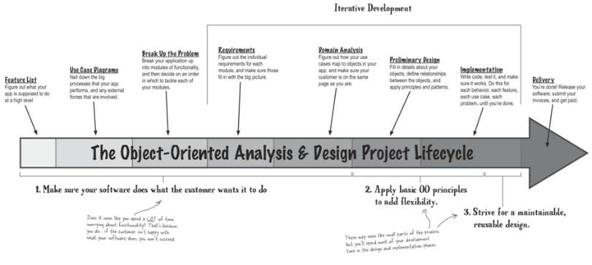

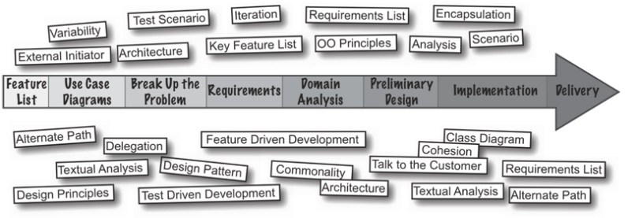

#### AGILE

##### AGILE Project Phases

➊**Project kick-off** ➋**Agile Preparation** creates ***Initial Solution Backlog*** (initial subset of requirements for solution to begin the development process) ➌**Agile Execution** - ***Sprint cycle*** or ***Scrum*** up to 4 weeks in duration to develop the solution on an identified set of backlog items. 2 Sprint cycles (**a**) ***Daily Sprint Cycle*** encompassed within (**b**) ***30-Day Sprint Cycle***. Development activities on daily basis, including planning, analyzing, designing, developing, and testing against ***Sprint Backlog*** – a compiled list of requirements from ***Solution Backlog*** that is broken down into smaller increments of product features. The requirements in the Sprint Backlog are then further broken down into manageable tasks during a ***Sprint Planning Meeting***. At end of Sprint Cycle, ***Sprint Technical Preview*** activity wherein the requirements are approved, or rejected, and fed back into the Solution Backlog for possible inclusion in a future Sprint Cycle. ***Sprint* *Post Mortem***to evaluate team's performance & discuss opportunities for improvement. After the final Sprint Cycle, an overall solution testing is performed, and the specification for the customer's production environment is finalized ➍**Deployment** and ➎**Operation** phases, including ➏**User Training** & **User Acceptance Testing**

##### PBI Vs Task

**⬩Product Backlog Item** (or “PBI,” “Backlog Item,” or sometimes simply “Item”) = all work to complete (however, since Scrum utilizes an incremental and iterative approach to development, only a handful of PBIs are tackled by in a given sprint) ⬩**Product Owner** (responsible for determining business value of work) *prioritize* the PBIs - Product Owner dictating the “what” (i.e. what is to be delivered by the end of the sprint), team decides “how” to complete PBIs—in what order, who will work on specific Items, etc. ⬩During sprint, **Tasks** are defined for each PBI (Product Owner do not monitor progress at the Task level - Tasks simply more granular versions of work entailed to complete PBI - Tasks created for team to size up PBIs and to know what everyone is doing to complete Sprint goals ⬩PBIs estimated in **Story Points** (abstracted estimates of difficulty), Tasks estimated with **hours** (Since these two forms of estimation are completely unrelated, PBIs and Tasks should not be compared; they are separate entities) ⬩**PBIs** always estimated using consistent ***scale of Story Points*** (Factors of two, t-shirt sizes, dog breeds, headaches, etc.—but what is important is for the team to agree upon their scale, the approximate values of each estimate within the scale, and use them consistently ⬩**Tasks** estimated in hours. Most developers are comfortable estimating the number of hours they believe it will require to complete a given Task. However, some advanced Scrum teams prefer not to assign hour estimates to their Tasks. Instead, they simply mark their Tasks as “done” or “not done,” which means the corresponding report would track Tasks remaining, rather than hours ⬩In ScrumWorks Pro, all meaningful, long-term metrics rely on PBI estimates, not those associated with Tasks

##### AGILE leadership Behaviors (9)

➊Satisfy customer ➋Harness change ➌Be incremental ➍Get business & IT together ➎Create trust through leadership & process ‘**Light-Tight’ discipline[4]** ➏Encourage face-to-face conversations ➐Set targets & reward real progress towards working solution ➑Pursue simplicity, not complexity ➒Give team space to excel

##### AGILE at HOOPP

**LDI Stress Testing (LST)** ⬩**Liability Driven Investment (LDI)** approach in managing plan ⬩LST = foundation for and initiating ALM calculation & reporting framework ⬩In-house built system utilizing FinCAD and Ortec PALM **Project Objectives** ⬩Calculate Plan sensitivities to pre-defined risk factors ⬩Provide overnight and ad-hoc sensitivity testing results including risk attribution results ⬩Provide robust user interface to manage & run risk factor scenarios **Instruments in scope (SPRINTS)** ⬩IRS, bonds, MBS, Non-standard IRS ⬩Equity options, Equity Futures, TRS ⬩CDS Single name, CDX, Tranches, CDX swaptions ⬩Ortec PALM results ⬩Barrier options, Price shocking instruments ⬩CCY forwards ⬩CCY Options ⬩Bond futures, Loans, IRS Swaptions **Risk factors in scope** ⬩Equity prices ⬩Real Estate Prices ⬩Private Equity valuations ⬩Risk free rate curve (swap curve) ⬩Currency basis curve ⬩Credit spreads ⬩Volatility (equity, interest rate) ⬩Inflation rate ⬩Spot FX rates ⬩Default recovery rate for default bonds ⬩Tenor basis curve for non-standard swaps **AGILE** ⬩Small, frequent, overlapping releases called Sprints ⬩Structured framework for code development ⬩Architecture for implementation of packages ⬩Collaboration & open communication facilitated by *daily Scrums, Wiki board, electronic issue tracking, automatic alerts, team calendar, team physical co-location* ⬩Open architectural framework that enables parallel work

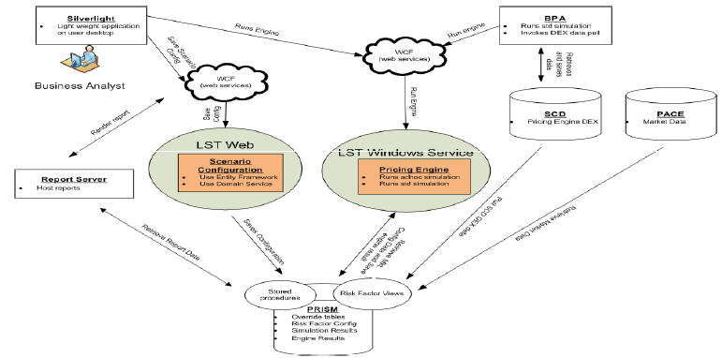

**Windows Communication Foundation (WCF)** framework for service-oriented applications

#### Rapid Application Development (RAD)

##### TIMEBOX Management

➊Well-defined project plan deliverable, resources, deliverable scope, scope flexibility ➋PM authorized to prevent increase in requirements, system specification or ongoing, unproductive discussion ➌Procedures to limit amount of time taken for decision-making e.g. *problems and issues list for items that cannot be solved in predefined period*

|  |  |
| --- | --- |
|  |  |

**Issues (7)** ➊RAD tool used more for development than modeling ➋Less requirements planning & modeling ➌Emphasize system construction, less domain analysis ➍Not seeking out errors/ misspecifications early ➎Benefits of reusability not obtained with shrinking analysis phase ➏Unrealistic management expectations about RAD delivery speed ➐Developers with linear C experience must adjust to object-based RAD tools **Approach (10)** ➊**Requirements** ⬩RAD Joint requirements ⬩Business requirements planning ⬩Deliverables vision statement ⬩**SOC** (strategy, objectives, constraints) ➋**Use standard methodology** ➌**Planning** by deliverables+ milestones using TIMEBOX ➍**Team Building** Team Contract, Roles & Responsibilities Matrix, “open” Issue Log ➎**Quality** ➏**Metrics** value earned vs. % complete, $budget, error rates, deliverables produced ➐**Reuse** ➑**Documentation** requirements, specification ➒**System Testing** ➓**Production Good Practices** ➊Solid communications ➋Well-planned project ➌Change Management ➍Requirements Traceability ➎High quality products ➏Low cost ➐Fast cycle time ➑Rigorous methodology

#### SDLC and Payment

##### Technical Research, Design, and Implementation

⬩**Emerging technology**: understand industry direction, features, challenges, and impact to solutions and business strategy and communicate this information to senior management ⬩Evaluate third-party products and exercises due diligence as required as part of vendor selection ⬩Identifies opportunities to leverage cross-project knowledge, best practices and reusability to expedite projects ⬩Responsible for the end-to-end technical solution once a direction is established ⬩Ensures proposed solution is compatible and lines up with strategic direction of RBC infrastructure ⬩Presents the application solution for review with business or IT parties as needed ⬩Provide technical leadership, expert counsel and guidance to the integration and development teams, adhering to solution design and best practices ⬩Contributes to successful project completion by identifying risks and developing/recommending mitigation strategies ⬩Designs solution so that it reuses existing RBC systems where applicable (i.e. **Mobile Banking/Secure Cloud**) to reduce complexity and time to market) ⬩Work with PM to create module level work effort estimates and task lists for each project by identifying requirements, roles and responsibilities ⬩Participate walkthroughs of technical documentation + code delivered by RBC and vendor resources

##### Testing, Documentation & Support

⬩Document end to end solution at a high level while ensuring all third party or RBC components have sufficient documentation for understanding when transitioned to delivery

Reviews vendor and third party work estimates using understanding of overall solution to ensure accuracy in the estimates ⬩Responsible for validation of the solution within the RBC environment and proving that it can be successfully transitioned into a full scale project ⬩Document any risk to RBC systems, policies, or procedures ⬩Participate in project closure and transition to appropriate delivery channel (provide handover documentation, participate in meetings, provide support and training as required)

##### Relationships & Communication

⬩Acts as liaison with multiple interfacing applications, third-party vendors, and project managers ⬩Manages the detailed aspects of day-to-day operations with third party vendors ⬩Effectively communicates and builds rapport with team members, stakeholders and interface groups using a variety of techniques and collaboration from initiation to close ⬩Leads complex group meetings (including business partners) for technical design, decision making, problem solving, implementation and strategic planning ⬩Prepares and delivers presentations to business and technology partners, senior management selecting the appropriate approach based on the audience ⬩Lead a technical team comprised of FTE and vendor resources. Oversee the development of code and documentation in-line with project deliverables

##### Development & Coaching

⬩Provides direction, expertise, feedback, coaching and development to build the capability of junior technical integration staff ⬩Continually enhances skills and builds knowledge in all aspects of the organization, the business and information systems ⬩Continually enhances skills and builds knowledge in all aspects of the payments field with a focus on emerging technology ⬩Will be required to organize and lead a team ⬩Conducts interviews and provides feedback on candidates.

##### Education/Experience (to enter position)

⬩Experience on large projects or programs interfacing with multiple applications and/or third-parties in a senior technical role ⬩Experience integrating complex end to end solutions spanning multiple technologies and platforms with multiple unknowns ⬩Experience in the mobile payments infrastructure space and knowledge of the **interactions between the various systems** (SP TSM, Root TSM, Mobile gateways device secure element, etc.) ⬩Experience working with card based payment technology with a focus on mobile payments

##### Process Knowledge

⬩Software research, analysis, and design ⬩Application infrastructure integration ⬩Application development ⬩Risk assessment & quantification ⬩Conflict and issue resolution ⬩Strong interpersonal and consulting skills ⬩Oral, written communication and presentation skills ⬩Innovation

##### Business Knowledge

⬩Business line(s)' business strategy, needs and technology

##### Systems Knowledge

⬩**Mainframe/distributed platform** z/OS, Linux, AIX ⬩**Mobile banking core**  HTML5, CSS, mobile SDK ⬩**IT Standards, Methodologies, CMM & audit requirements** ⬩**Middleware technologies** MQSeries, HTTP, Tomcat, Jboss, DataPower, Oracle (Database) ⬩**SVN for RBC Source code management** ⬩**Payment industry standards** (Global Platform standards, EMV, MSD) ⬩**Payment transactional  flows** (Credit/Debit authorization and validation flows) ⬩**Contactless Payment Specifications** (Visa Paywave, Mastercard Paypass, Interac Flash) ⬩**Trusted Service Manager** (TSM) and mobile gateway integration for provisioning credentials to secure element ⬩**Cryptographic operations** including use of hardware security module (HSM) and management of keys involved in payment credential provisioning and authorization ⬩**Card creation and embossing flow** from RBC systems through to plastic/mobile device

#### Microsoft Excel

⬩**Interactive Benchmark Analysis model** by combining features/functions: Ratios, VLOOKUP, Data validation ⬩Advanced Charting techniques ⬩Scenario Manager with business model for sensitivity analysis on multiple variables to determine business sensitivity ⬩Goal Seek to determine an input value for a desired endpoint result ⬩Solver Add-in for arriving at decisions on allocations where opportunities exist, factoring in multiple constraints ⬩**SUMPRODUCT** function and its use in calculations or support tools like **weighted factor analysis** ⬩Dynamic linking between Excel, Word and PowerPoint

#### Microsoft Visio

**Diagram Project Phases** (Planning, Design, Engineering, Implementation) **Types** (Gantt Chart, Project timeline, Project status, Processes Work Breakdown, Responsibility Matrix)

#### Microsoft Access

<CONTENT Here>

#### Microsoft Sharepoint

|  |  |  |  |
| --- | --- | --- | --- |
| HOOPP: No infrastructure to manage and communicate requests, reqrmts, changes | Problem: excel + outlook only provided one-to-one comm.. No archiving | - Bus. Case, Plan, Acquisition  - Standardize project team site, 'MySites' (profiles e.g. skills mgt, search tools), enterprise wikis, org. hierarchy, tags, notes | Standardize PM  tooling and compliance for PM document & record management |

*•Supports the generation of project charter, schedule & budget (workflow) •Facilitates communication & feedback •Monitors project activities •Controls project changes •Analyzes & forecasts project performance •Disseminates project status to relevant stakeholders*

*•Provides R-T information for initiating, planning, executing, controlling, and closing*

*•SharePoint Services 3.0 (free) - plus SharePoint Server 2007 (commercial extension)*

*•SharePoint Foundation 2010 (free) - plus SharePoint Server 2010 (commercial extension for Foundation), and SharePoint Enterprise 2010 (commercial extension for Server)*

*•SharePoint Foundation 2013 - plus SharePoint Server 2013 (extension on Foundation)*

⬩Business Process & Forms ⬩Business Intelligence ⬩Collaboration ⬩CRM ⬩Enterprise Content Management & Portals ⬩Configure & maintain document libraries, lists, WSS site collections ⬩Programming with .NET ⬩Web Forms front end Enterprise integration tech (MS BizTalk, MSMQ, Web Services, Remoting) ⬩MS Enterprise Content Management & Collaboration technologies (SharePoint Portal Server / Windows SharePoint Services ⬩Content Management Server ⬩Office SharePoint Server 2007 ⬩Office Live Communications Server ⬩MS Groove Server 2007) ⬩MS SQL Server, Analysis, Integration & Reporting Services ASP .NET & client web development (XML, XSL, ASP .NET, AJAX, HTML, Java Script) ⬩Agile methodologies Enterprise integration, SW development patterns

|  |  |
| --- | --- |
| **PMIS component** | **Purpose** |
| **Project Calendar** | Stores common project events such as meetings, deadlines, and resource availability |
| **Project Tasks** | Stores project task information, assignments, and status |
| **Project Risks** | Stores project risk information, priority, and status |
| **Project Contacts** | Stores common project contacts |
| **Project Resources** | Stores project resource information, skill sets, and rates |
| **Project Documents** | Stores relevant project documents, templates, checklists, and reports |
| **Change request system** | Stores change request information, decisions, and actions |
| **Project Announcements** | Stores relevant project announcements |
| **Project Milestones** | Stores project milestone information with baseline dates and actual dates |

🕮**Project Artifacts** 🕮**MS SHAREPOINT**

#### Microsoft Project

⬩Set up a new project ⬩Set up/ use global, project, resource calendars ⬩Enter project tasks, define appropriate work breakdown structures ⬩Define major & minor milestones ⬩Define task dependencies ⬩Define resource pool & allocate resources to tasks ⬩Set task constraints ⬩Manage risk and identify/quantify risk actions ⬩Identify and resolve resource conflicts ⬩Identify tasks on the critical path ⬩Develop strategies for reducing project duration ⬩Create/modify/review views, tables and filters ⬩Identify and apply project management activities ⬩Update the plan with actual ⬩Use the printing and reporting facilities of MS Project ⬩Use project groups ⬩Create and maintain inter-project dependencies ⬩Share resources across multiple projects

🕮**MS Project**

#### CA Clarity

➊**Project Management** Basic & Detailed project planning (**capture/control costs, resource scheduling, manage tasks against a timeline, track/complete deliverables**), Best practices methodologies, Project templates, WBS creation, resource assignments, Multiple project baselines, Task guidelines, Integration with Open Workbench and MS Project ➋**Time Tracking** Timesheets, Auto-populating timesheets, Timesheet approval

➌**Risk, Issue and Change Management** PMBOK-compliant **risk scoring** (probability, impact and category weighting), **Risk sorting**, Risk-issue- task-action item associations, Audit trail, Portfolio risk assessment, Risk issue change progression (convert risks into issues into change requests) ➍**Budgeting and Forecasting** Project budgets and forecasts, Budget and forecast **revisions** (base lined, tracked and compared), Budget and forecast **approvals**, Automatic financial plan creation ➎**Program Management** Project **roll-up** into programs, Program and project level planning, Program dashboard, Program **drill-down**, Benefit realization graph ➏**Reporting** •Budget/Forecast Analysis •Key Tasks & Milestone Status •Project Analysis & Profitability •Resource Assignments •Resource Bench •Timesheet Detail Stoplights

#### CIBC PLANVIEW

**PLANVIEW Support of AGILE**

**Support collaboration** •**Product Owners** document product vision, develop user stories, and prioritize features •**Customers** provide input during sprint demos that can be captured as new user stories for product backlog prioritization •**SCRUM Masters and Development Managers** populate sprint backlog from product backlog, create sub-tasks for stories, update story points based on sprint planning, and add developers to stories •**Developers** testing notes against stories or sub-tasks, report effort for costing purposes •**Resource Managers** – optimize resource utilization across multiple projects or products and ensure resource availability on critical initiatives **Project communities** •Per project community page that includes project documentation, multi-threaded discussions, a message board for project team updates, polling functions, and project analytics in support of **velocity and burn down charts**. •Integrated with **SharePoint**. Integration with Agile software development tools **Rally Software**, **IBM Rational Team Concert** and **Atlassian JIRA**.

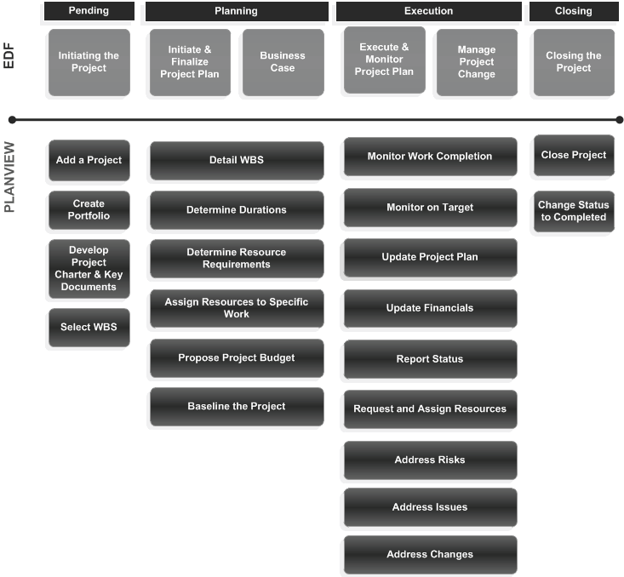

#### On ERP Implementation Methodology

**⬩** **Generic ERP (Oracle) Methodology**

**⬩** **Microsoft SureStep**

#### On MICROSOFT ERP

|  |  |
| --- | --- |
| Implementation methodology  Associated technologies  Plan system topology  Plan h/w and s/w infrastructure | Plan for data  Plan security in an implementation  Plan business intelligence  Plan for product-wide features  Plan maintenance |

#### On Microsoft Dynamics SURE STEP Methodology

#### On SCOTIA RLP Retail Loan, Adjudication

**Objectives** ⬩Enhance **RLP** (Retail Lending Platform)’s **PCA** (Personal Credit Agreement) system to support **SPL** (Scotia Plan Loans Variable & Fixed Rate) from 2 channels: ➊Indirect originated from the Automotive Channel via dealer web portals with an integrated adjudication platform (ALS COM). (Indirect SPLs migrated in phase 1) ➋Direct originated from Branch Channel, using **ReCApp** (Branch Retail Credit Application system) to adjudicate loans and include sub products only available in Branch Channel, such as *Direct Real Estate Secured* and *Unsecured SPLs* **EDW’s perspective** ⬩Data elements required for pricing optimization to produce *Pricing Models* and input for *Pricing Engine* ⬩Monitor performance of Pricing Models, refine them into a better booking rate and increased profitability **Logical Process Flow** •**ReCApp** captures credit application details [*customer information, security type, purpose code, insurance type, etc.*] and send to **OM** (Origination Management) for adjudication ⮚if failed, application sent to **ACE** (Adjudication Centre of Excellence) for manual adjudication ⮚if successful, ReCapp sends details to **POP** (Product Origination Platform) for [*Rate decision, Insurance capture, Payment frequency selection etc*] •To obtain rates, POP calls **Pricing Engine** to use application data to search in **Pricing Table** database for *Regular, Sales Officer discretionary rates* and *Branch Manager Override rates* ⮚branch staff may discuss with the customer to select a rate ⮚POP can use *direct key (for pre-approved loans*) to retrieve specific rates (works for adjudicated and non-adjudicated (Pre-Approved) applications – but only adjudicated work flow sends adjudication details to pricing engine) •Selected rates held for period of time as indicated by response from Pricing Engine. Past that window, new rate based on current application and pricing strategy **In Scope Business Activities**  **1** SALES OFFICER PROCESSES A LOAN APPLICATION **2** SAM ADJUDICATES LOAN **3** SPL INTEREST RATE DETERMINATION  **4** CSR SETS UP AND FUNDS LOAN **5** DDA/SAV SYSTEM CHARGES NSF FEE **6** DELINQUENT LOANS **7** RLP RENEWS LOAN AT MATURITY

**8** MANUAL LOAN RENEWALS **9** MAINTENANCE ON SCOTIA PLAN LOANS **10** PPSA REGISTRATION EXPIRY **11** PAYOUT AT AMORTIZATION MATURITY **12** EARLY PAYOUT **13** PRE-PAYMENTS **14** PAYMENT EXTENSION **15** PAYMENT ADJUSTMENT **16** CHANGE PRE-AUTHORIZED DEBIT INFORMATION **17** TRANSFER A LOAN TO A DIFFERENT BRANCH **18** MISS-A-PAYMENT **19** TRANSACTION REVERSALS **20** LIFE AND/OR DISABILTY INSURANCE CANCELLATION **21** DISABILITY INSURANCE PAYMENTS **22** TAX REFUND FOR STATUS INDIGENOUS – NATIVE CANADIANS **23** ONLINE BANKING **24** CUSTOMER CONTACT CENTRE **25** SCOTIABANK.COM

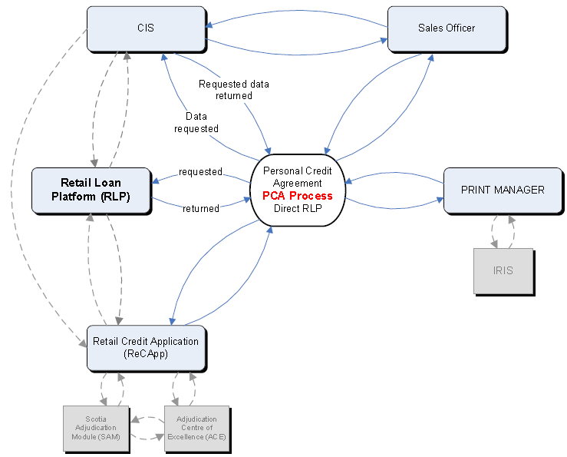

#### On SCOTIA Credit Card generic platform

Credit card growth strategy; partner with 3rd parties; offer new credit card products;target customer’s needs; objective = add **24** spare products and Cards with basic functionalities (un-branded) to be tested in QAT and turn them off in production until required including 3 products for a potential partnership with a company “Steel”. **Basic functionalities: ⬩**Account Application Set up (All Channels) **⬩**Adjudication **⬩**Transactions Authorization (Visa, INTERAC, FFT) **⬩**Transactions processing (Settlement, clearing, posting) **⬩**Disputes **⬩**Charge-backs/ retrievals **⬩**Fraud management **⬩**Reconciliation **⬩** Account Maintenance & Servicing **⬩**IVR **⬩**SOL, Mobile (Servicing) **⬩**Epost **⬩**InfoAlert **⬩**Bill Payment **⬩ D&H** Cheques ordering **⬩SYMCOR** Cheques Processing **⬩**Card Activation **⬩**Statements, Letters, Disclosures as existing **⬩G&D** plastic files **⬩**Reporting **⬩**VbyV **Out-of-scope** **⬩**Sales Builder **⬩**Sales Tools **⬩**PAL Pre-approved leads, SPOT **⬩**Interfaces with Partners if applicable; Development for New Features i.e. installment, or new rewards model **⬩**New Websites if applicable **⬩**Item Processing (SYMCOR) if new transit required **⬩**Cash Back or Rewards **⬩**Telephony (Skills, new 1-800, Recording) **⬩**New GLs **⬩**HB RU

Process 1: Credit Account Application and Adjudication Process

Process 2: Credit Card Operations – Maintaining the Account

Process 3: Credit Card Account Setup and Fulfillment

Process 4: Credit Card Operations – Servicing the Account

#### On SCOTIA Pre-paid Card

**Reloadable prepaid VISA cards**: ➊Scene branded card in addition to our current suite of Scene Debit and Credit Cards; ➋General Purpose card for customers not participating in the Scene program; Operate under **Visa DPS**. **Future**: expand to one-time Gift Cards, including: •Government Disbursements •Travel Spend •Payroll •Insurance •Western Union Receive cards for Canada and International **In scope ⬩**Prepaid VISA cards - Mag stripe only - issued & settled in C$ **⬩**2 new VISA Credit BINs with prepaid subtype (for General Purpose card + for SCENE branded Pre Paid card) **⬩**Prepaid Information Form (PIF) defining prepaid program type as general purpose reloadable **⬩**New PRC (Processor identification number) for DPS platform processing **⬩**Bill Payment for VISA Prepaid through Scotia alternate delivery channels and OFI’s **⬩**New e-Form and supporting workflow processes to set up Customer **⬩**Card Order File (COF) batch reloads in branch / Scotia OnLine / Mobile Banking / TeleScotia /IVR / Contact Centre (via bill payment) **⬩**Basic cardholder support: balance inquiry, card activation, reviewing transaction history, and reporting the card lost or stolen via VISA DPS VRU (Voice Response Unit) Application **⬩**Scotia-sponsored VISA DPS Consumer Website for basic cardholder support: balance inquiry, card activation, card registration, reviewing transaction history, suspending their card and maintaining their cardholder information (name/address, etc) **⬩**VISA Prepaid Terms and Conditions, FAQs for consumer website, card package **⬩**VISA DPS “full service” call center model to handle all Visa Prepaid customer inquiries **⬩**Set up prepaid cards and initial loading of cards via Scotia NBCAU utilizing the Prepaid Administrative System (PAS) **VISA DPS Deliverables ⬩**Consumer Website (English/Canadian French) **⬩**Visa DPS hosted websites configured to reflect BNS branding, messaging, and functionality **⬩**Visa DPS VRU for multiple language support plus menu options in VRU **⬩**Full Call Center Support **⬩**Exception Processing (Disputes/ Chargeback’s) **⬩**Negative Balance Management - Back Office Negative Balance Research accounts in -ve balance state; determine which transactions resulted in -ve balance; whether transactions can be charged back based on Visa Operating Regulations **⬩**Fraud Queue Management **Out of Scope** **⬩**ABM/ATM access for Cash Advances **⬩**Chip, Paywave or PIN functionality **⬩**US, Euro, International $ settlement **⬩**Issuance through Customer Contact Centre, Scotia Online, TeleScotia, IVR or the VISA external website **⬩**Card maintenance via Customer Contact Centre or Branch Network **⬩**Real time reloads for non Scotia customers

#### On SCOTIA Collection System

##### CSR Team

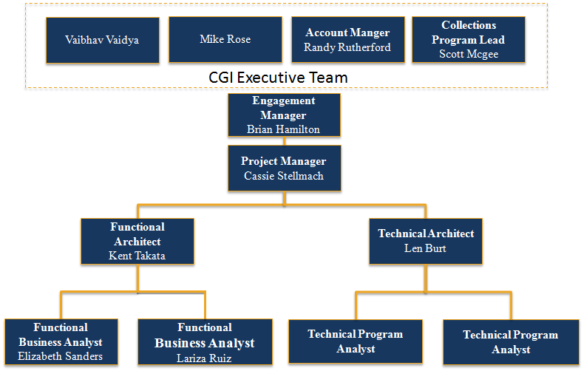

##### CACS Interface

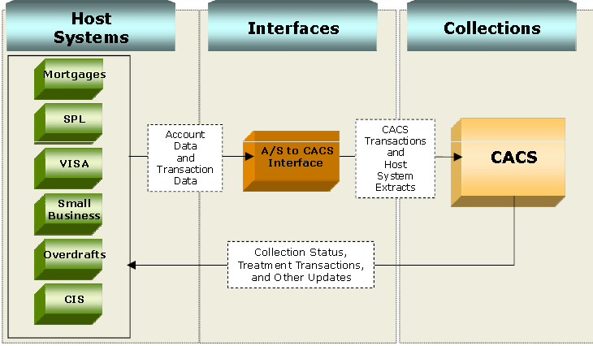

##### CSR Scope

**BNS Responsibilities ⬩**Replace current platform for consumer credit collections **Debt Manager DM 3.9.7** with **CGI CACS 9.0 ⬩**Convert Retail Collections products in DM (Credit Cards, ScotiaLine, Mortgages & Term Loans) plus 2 portfolios: Overdraft facilities (OPCS) + Small Business Collections (Collectlink) **⬩**Build DMZ Landing Zone (communication link between CGI and BNS) **⬩**Build internally hosted Collections Gateway (iWay) with feeds from all interfaces **⬩**Build conversion files from Debt Manager, OPCS and Collectlink (including D+H highway data) **⬩**Maintain connectivity with vendors Davis+Henderson, Adeptra **⬩C**onnectivity to online dialer to CGI Servers **⬩**Develop/test interfaces and modifications **⬩**Migrate, configure existing work flows into CACS **⬩**Provide CGI with daily batch files **⬩**Integrate CACS MIS file in Risk Data Mart in EDW **⬩**Trai-the-trainer 12 NCC staff (6 Ottawa + 6 Toronto staff) **⬩**Decommission Debt Manager **CGI Responsibilities** **⬩**CACS 9.0 hosted & managed solution installed at Montreal CGI Data Centre •CACS 9.0 Mon-Sat online availability for collections and recovery use (as defined in the SLA SOW) •Batch cycle six (6) days per week – Mon-Sat night execution •CGI to replicate current EDW feed received from DM Collection system •CGI responsible for SW + HW requirements to support operations •CGI connectivity with Dialer (Adeptra) to support ‘screen pop’ when customer contacted •CGI baseline ‘train-the-trainer’ sessions for key BNS functional team leaders •CGI functional training to Client core team members on CGI Software functionality •Responsible for Stress Testing

##### Risk EDW background

**Stakeholders** ***Credit Strategy and Execution (CS&E*)**, ***National Collection Center (NCC)*** **History** Since 2005, DM main collections system for NCC retail products ⬩Increased customization of DM ⇨ unable to upgrade to core system with vendor ceasing to support current version ⬩Needs integrate ***Collectlink/DRN*** for Small Business monitoring, ***Overdraft Protection Collection System (OPCS)*** (both manually intensive) ⬩ **EDW** collections data loaded to Risk Data Mart from Debt Manager only + extract files from Collectlink landed at staging + no files from OPCS

##### Risk EDW report

|  |  |
| --- | --- |
| **EXISTING REPORTS** | **Description** |
| **BCP - Greater than 150 Days & Still in Dialer** | Lists all **Bank Card Products** (Visas, Lines, Student Loans) which are 180 days in arrears or greater and in any of the following queues: *Acceptance, Standard, Deceased, Invalid Phone, Low Dollar or First Payment Missed* |
| **SPL - Greater than 120 Days & Still in Dialer** | Lists all **Scotia Plan Loans** which are 120 days in arrears or greater and in any of the following queues: *Acceptance, Standard, Deceased, Invalid Phone, Low Dollar or First Payment Missed* |
| **Credit Bureau Update Report** | Lists all records currently sitting in the ***Credit Bureau Update queue*** in order to key in the required amendments and provide completed report to ***Credit File Integrity*** **CFI** |
| **Approval to WOR** | Lists accounts which have been approved to be **written out of records** and are currently in the WOR queue with a status of C/O or BD. All products can be viewed or specific product sub-types can be viewed |
| **GAP Report** | Lists the number of accounts which are currently outside of the **GAP SLA** (specific number of days without being worked), broken down by product and severity code. Also displays the percentage of accounts outside of the GAP |
| **GAP Details Report** | Lists the account details to support the numbers listed in the GAP Report. Can be sorted by Product and/or Severity Code.. |
| **Mortgages 90+ Days - Not yet in Legal** | Lists Mortgages which are 90 days in arrears or greater and not in the **Legal queue** broken down by report section and district. |
| **CRC Loan Exception Report** | Lists **Scotia Plan Loans** which are 90 days in arrears or greater, have an account status of OD, and are in the following queues: *Acceptance, Standard, Deceased, Invalid Phone, Low Dollar, Promise to Pay, or First Payment Missed* |
| **Scotia Plan Loan (CLIP) - Arrears Advise for CMHC** | Lists all CMHC insured CLIP loans which are greater than 90 days delinquent broken down by report section and district. |
| **Arrears Advice for CMHC / GE Insurance / MICC** | Lists all mortgages insured with CMHC or Genworth which are 90 days in arrears or greater broken down by insurer and whether product is a STEP. |
| **Arrears Advise for GE Insurance > 30 days** | Lists all GE insured mortgages between *30-60 days in arrears, 61-90 days in arrears, or 91 days and greater* |
| **Other Existing BUNDL Queries** | |
| **EXISTING QUERIES & EXTRACTS** | **Description** |
| **Days to Cure Report** | Identify # accounts in ***Exit router***, based on #*days to cure* ( difference between collection entry date and cure date) grouped in 7: less, equal 10 days to cure/ between 10 to 20 days/ between 20 and 30 days/ between 30 and 40 days/ between 40 and 50 days/ between 50 and 60 days/ greater than 60 days. The credit card accounts are also grouped in secured/unsecured. |
| **Excuse Code Report** | Identify accounts in collections which have experienced an **Operational Risk Event** (i.e. *Grow Ops, Fraud, Documentation errors, etc*) |
| **Blast Report** | This report provides a count of accounts that have one of the 3 codes *'MBN','MBR','MBT'* within the reporting week and a count of cure, pay in the next 7 days from the blast |
| **MAS Report** | Lists all accounts which were MAS'd into the collection system over 60 days ago and remain active in the system |
| **Old 'As Of Date' Report** | Lists all accounts which are active in the collection system however have an 'As Of' date greater than 30 or 60 days in the past. *The 'As Of' date signifies the last date on which the collection system received an update from the Host system* |
| **NEW REPORTS REQUIRED** | **Description** |
| **Promise To Pay Detail Report** | Lists all accounts in the Collection System on which a ***Promise to Pay*** was input during the selected report period. PTP records are displayed based on the user that entered/changed/deleted the PTP instructions. This means that a given PTP record could appear on the report multiple times (i.e. under each user that maintained the record) |
| **Promise To Pay Summary Report** | Summary snapshot of Unit-wide PTP’s taken and Kept, broken down by product, strategy and signor type |
| **Right Party Contact Summary Report** | Summary snapshot of Unit-wide **Right Party Contacts (RPC)** broken down by product, strategy, RPC Type and signor type |
| **Inventory Movement Detail Report** | Details *movement (strategy & router) of accounts* for a given month. The report lists the *dialing strategy* to which the account belonged at the beginning of the month and the dialing strategy to which the account belonged at the end of the month. It also lists router information as well as whether or not payments were received and the account is up-to-date. |
| **Summary Router Inventory Movement Report** | Summary of *inventory roll rates (favorable vs. unfavorable vs. unchanged)* by Router. This report summarizes the inventory router movements for the month as favorable, unfavorable or unchanged, based on where the account originated at the start of the month (i.e., Customer Service or Receivables) and where it ended. |
| **Summary Strategy Inventory Movement Report** | Summary of *inventory roll rates (favorable vs. unfavorable vs. unchanged vs. manual) by Strategy* |

#### On Retail Banking

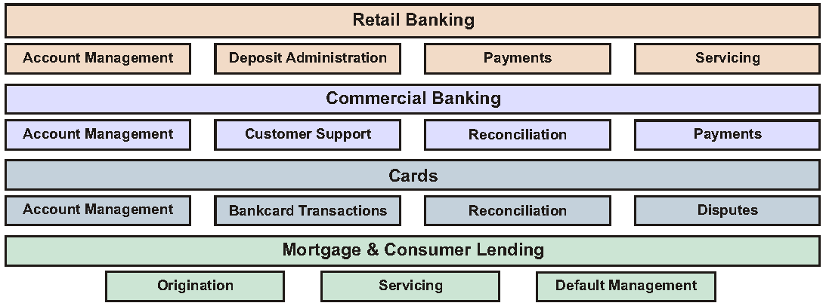

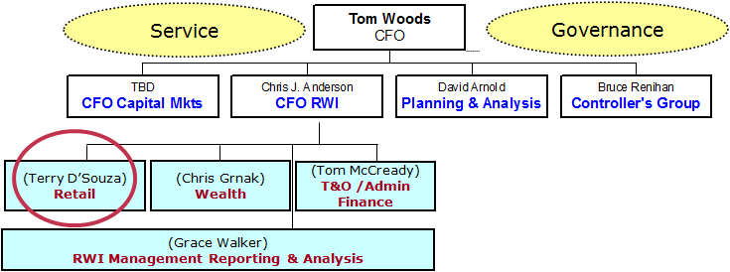

#### On Lending Systems

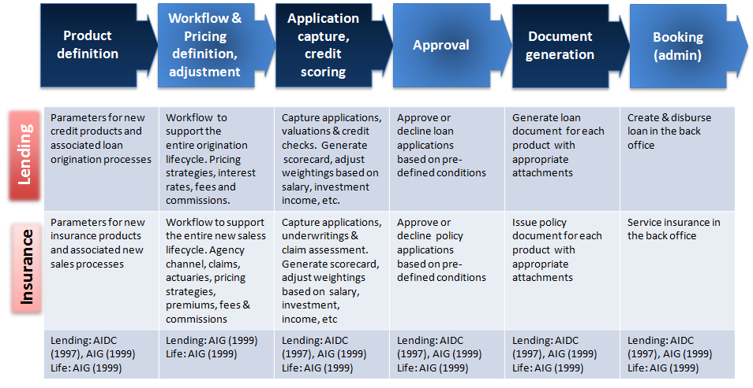

#### On Loan types

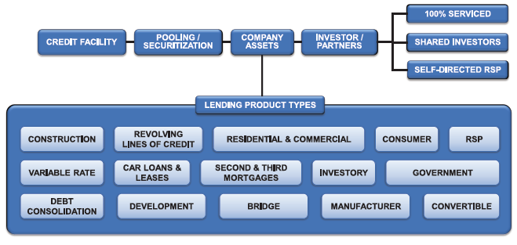

#### On Retail Strategy Planning and Analysis

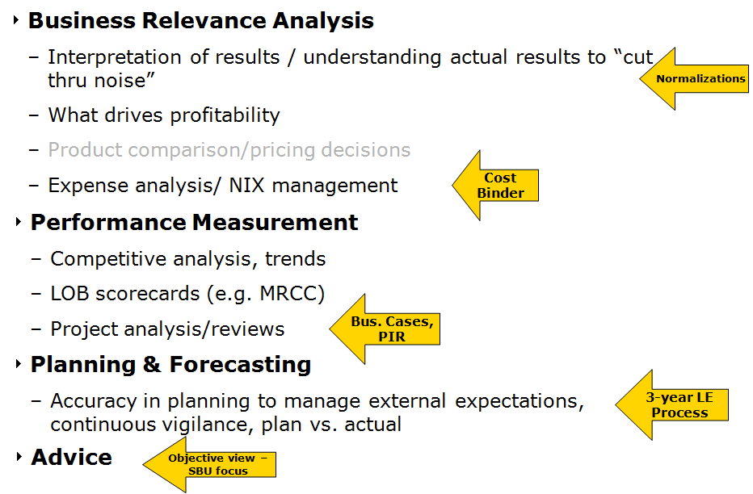

#### On Front Office

•**PV01 IR Report** - Amortization of government mortgage-backed securities factored into the DV01 where DV01 = (Market Value + Accrued Income) x Modified Duration / 10,000, Market Value = (Original Notional x Factor) x Price = Current Value x Price (yield) •**Duration** figures from Bloomberg that are comparable to SCD, change the “Yield” option to “Avg Life”. Otherwise, the results would be very different as both systems employ a different methodology when calculating the duration. **Example**: for ROFLP2.209 11/32 (CUSIP 780632AA3) SCD Modified Duration – 11.0149, Bond Man Duration – 11.02, Bloomberg Duration (yield option changed) – 11.2 •**Add benchmarks** DEX ALL GOVERNMENT index to FIUGAMCA portfolio and DEX LONG-TERM ALL GOVERNMENT INDEX to FILUAMCA •PV01 calculation for forex CDX adjust for FX •Asset Mix rebalancing (mid-term bond, Canadian and International equity) •Experience with trading and managing fixed income risks •Market data management (bootstrapping algorithm) •Curve generation techniques: bootstrapping/ enhanced methods •Trade capture •Pricing (Black-Scholes, Cox-Ross binomial model) •Risk (Monte Carlo, VAR)

#### On Back Office

⬩Settlements (SWIFT, ACH, FedWire) ⬩Documentation (confirmation, advices, reset advices, etc.) ⬩Accounting (general ledger, P/L accounting, etc)

#### On Treasury

|  |  |
| --- | --- |
| **CIBC-Mellon Treasury**  [**CIBC Processes (FCU)**](#_CIBC_Processes_(FCU))  **HOOPP** **Collateral****/****Treasury****/****SCLENDING**  **AIDC Treasury**  [**SCOTIA Collection**](#_SCOTIA_Collections_(jan14-feb14)) | **Treasury System**  **SWIFT**  **SIMCORP SWIFT**  **Treasury Overview** |

##### On Treasury system

⓿**Requirements** Enterprise-wide cash visibility, Real-time global risk management, Integration with GL, SWIFT integration and reconciliation ❶**FX** (base CCY, traded CCY, XCCY, Spot, Forwards, FWDS time options) ❷**Investments** (overnight, fixed deposit, call accounts, CP/CD, Eurobonds, MM funds) ❸**Funding** (intra-group loans, external funding, overdraft, loans (syndicated, fixed/floating), mortgages) ❹IR derivatives (options, caps, floors, collars, amortizing, XCCY) ❺**Commodities** ❻**Guarantees, fees** ❼**Cash management** (banking structure), cash pooling, cash forecasting, payments, net settlements, bank reconciliation, multi-lateral netting ❽**Decision support/Risk management** (what-if, modeling, stress test, mark-to-market, VaR, yield curve) ❾**Counterparties** internal, external, facilities management, credit risk ❿**Reporting** (position, maturity) **Security and audit**

#### SWIFT

##### SWIFT messages

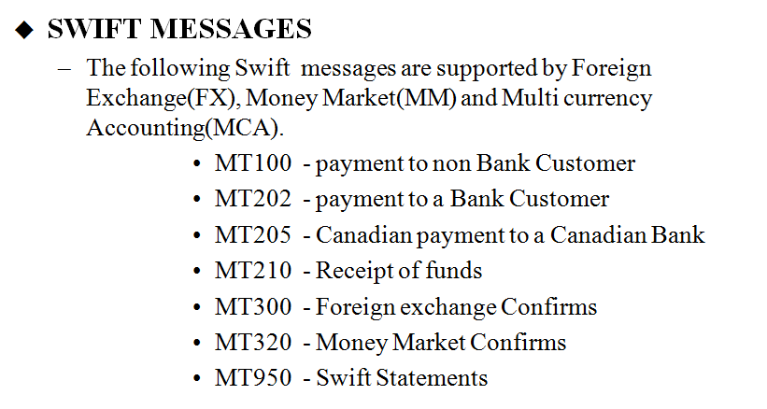

##### SIMCORP SWIFT

###### SWIFT BIC (Bank Identifier Code)

Code that identifies the receiver of the SWIFT message

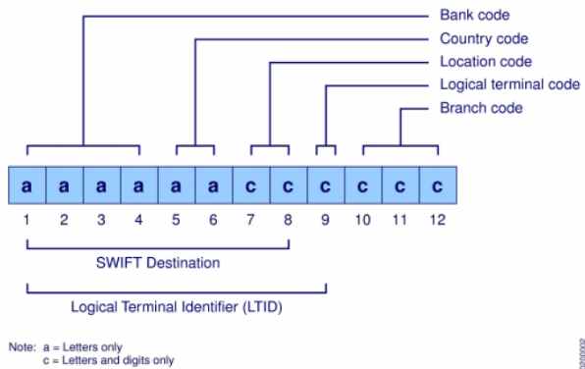

###### SWIFT Workflow

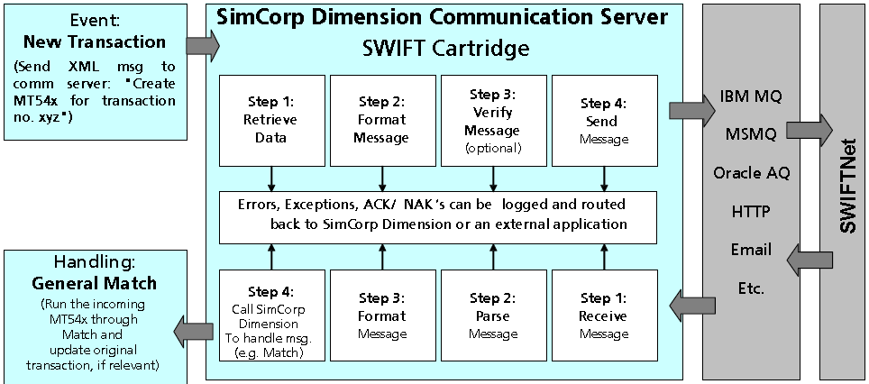

Example - Buy/Sell equity transaction ⇨ SWIFT MT541 - Auxiliary job defined for MT541

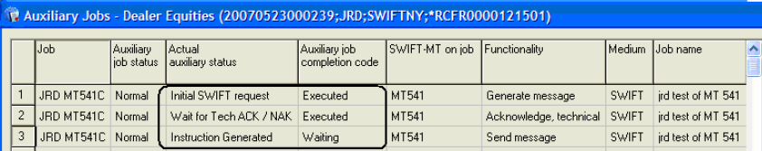

Match transaction: send MT541 receive MT545





#### On HOOPP Middle Office

**⮚7** project streams for *equity products*, *private equity* and *credit products*: ➊Financial accounting BI & data warehouse (map SCD logical schema + PACE pricing) ➋Fair value adjustment for equity swaps, equity basket options, credit default & interest rate swaps ➌Corporate actions workflow for accurate dividends and splits ➍Vanilla option and index option pricing integrity report ➎Accounting Analytics to reconcile sub-ledgers ➏Automation of securities lending in short sales-trading ➐Collateral management of trades subject to non-standard settlement periods

#### On HOOPP Treasury

**⮚Non-standard settlement periods** (trade date & settlement date between & inclusive ex- and record date) ➊Short Sell then Borrow ➋Borrow then Place on Collateral ➌Borrow then Lend ➍Receive in Collateral then Place on Collateral ➎Receive in Collateral then Lend ➏Receive in Collateral then Sell ⮚**Cover order** across multiple brokers ⮚Securities lending and manufactured dividend transactions

##### On Collateral Management

⬩Restructure collateral pool for transactions with Scotia ⬩New securities lending agreement ⇨ new configuration ⬩Future-dated transactions status (e.g. collateral going out in 2 weeks) for cash forecast reporting ⬩**Hair cut** on collateral based on original maturity, not on time to maturity ⬩Multiple custodians ⬩Collateral associated with model portfolios •Implementation 5-6 months for 1 pool (2 SME + 3 BA) •Trade entry, **DFS** – Interfaces - Collateral pool (threshold, haircut) - Custodian (settlement only) •Bloomberg -> FINCAD -> Pricing team -> Pricing engine -> Yield curves, marked data; price valued outside SCD

##### On Securities Lending and Collateral Administration

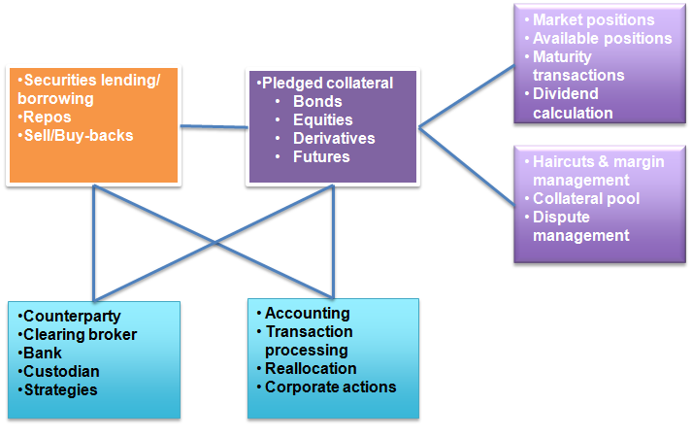

#### On workflow Equity, Derivatives, Fixed Income, FX

•Reconcile trade activity between system of record & trade-related documentation •Ensure trade activity confirmed & settled with counterparties •Drafting trade confirmations, amendments, terminations, researches, resolves trade issues, breaks & disputes

##### Commodity

Equity - trade interface, FX rates, dividend, splits/consolidations, prices

Derivatives – life cycle (deal entry, settlement, payment), futures price, S&P/TSX60 swap prices, <TR leg linked to reference equity, Non-TR leg funding to pay floating or fixed, interest fixing date, fee rate, interest ac cruel, dividend, swap reset>

FX– spot, forward, swap, P&L calculation (exchange, base, spread, amount)

##### On Fixed Incomes

•**Fixed income markets** trade interface (**TradeWeb**, **ICAP**), transaction interface SSCNET for post-trade communication (SCD 🡪custodian), **price** (IR risk, credit risk), indices market data (**LIBOR**, **CDOR**), **CPI factors**, **IR curve/basis risk**, **yield**, **implied volatility**, **credit spread** •**Variable spread** for bonds, IRS, bonds with embedded cap/floor, call/put features where fixing frequency <> payment frequency (Coupon Dates, Fixing Dates) •Fair value adjustment **with irregular redemptions** for CDS and IRS •**Swaps geography** (Upfront fee posted to ‘Swaps Receivable, Cost’ if Clean Value >0 otherwise to ‘Swaps Payable, Cost’ - Mark-to-market posted to ‘Swaps Receivable, Mkt Val Adj’ if Clean Value >0 otherwise to ‘Swaps Payable, Mkt Val Adj’) •HOOPP Bond (Corporate, Sovereign, Supra-National)

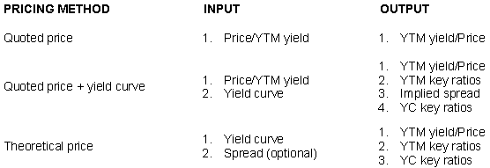

Trade settlement workflow controls and effects of operational breakdowns

•Understanding full front-to-back process within a trading environment •Cash (domestic/ international) & physical securities •Depository Trust & Clearing DTC settlements •Understanding U.S. commodity, equity, interest rate markets

##### Order management workflow

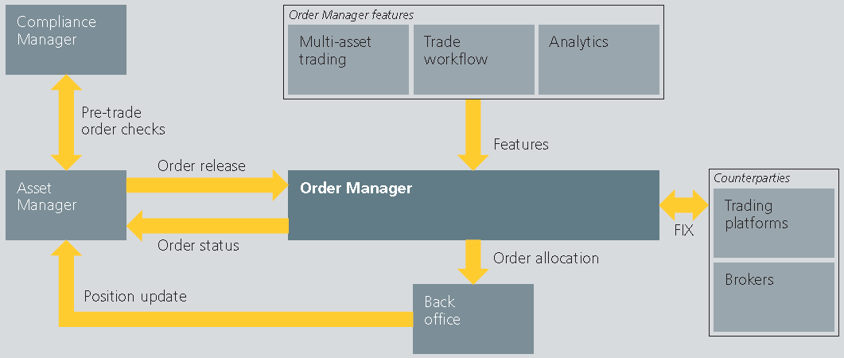

##### Asset management workflow

|  |  |  |  |  |  |
| --- | --- | --- | --- | --- | --- |
| **Start of Period** | | **Portfolio Management** | | | |
| Corporate Actions | | Fund Management | | Investment management strategies | |
| Back Office transactions | | Benchmarking | | Pre-check compliance | |
| Reports | | Rebalancing | | Trading | |
|  | | Orders | |  | |
| **Reconciliation Control** | **Data Quality** | | **Valuation Process** | | **End-of-Period** |
| Matching | Market data validation | | Distribution | | Post check compliance |
| Settlement |  | | Fee Management | | Performance |
| Reconciliation |  | | Tax figures | | Risk analysis |
| Cash management |  | | Legal reporting | | End-of-period |
| Collateral management & Securities Lending |  | |  | | Management reporting |
|  |  | |  | | Client reporting |

##### Investment Book of Record

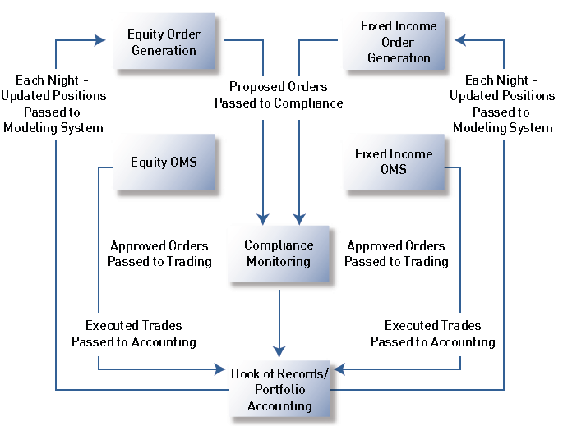

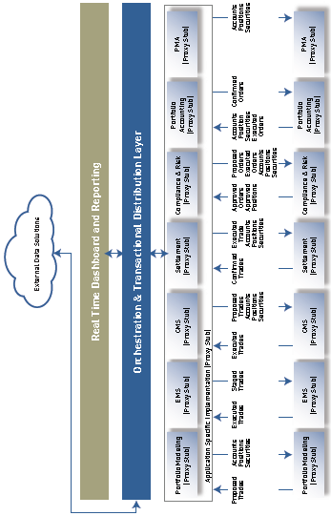

🕮**Trade Workflow** 🕮**Payment System** 🕮**Special Credit**

# STAR Assignments

|  |  |  |  |
| --- | --- | --- | --- |
| Situation | Task | Action | Result |

#### LITCOM SR. Consultant IT BEST PRACTICES/ PM (Jul14 – Now)

⬩**Continental Bank of Canada CBOC** Coached CIO for **OSFI certification**; comprehensively reviewed the **IT strategic plan,** **IT budgeting****,** **project management**, **vendor management,** **application management**, **system and data architecture**, **security management**, **IT services management** and **disaster recovery planning**; defined roadmap and mentored the team in establishing key policies, processes and procedures; structured the IT capabilities according to **COBIT**, **PCI-DSS**, **ITIL** and **SANS**

CBOC 7 products (Continental Bank of Canada) ➊Retail FOREX ➋Cards & deposit ➌Metals ➍LCBS ➎Secured Loans ➏Deposit A/C ➐Referrals

*CBOC CIO needs demonstrate to OSFI the maturity of his IT organization, while leery of wasted effort in documentation. As a demonstration, I built through the weekend a generic yet comprehensive COBIT-based control matrix – that helped him capture his key IT capabilities from governance to vendor management. As a result, he became the champion of a 3-month exercise to design and test the relevant controls – which subsequently convinced OSFI of the readiness of hi IT operations.*

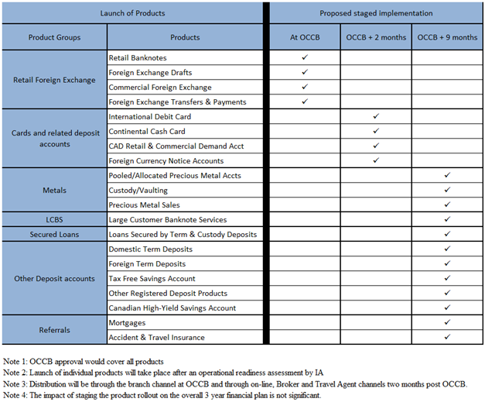

#### EVOQ PROJECT ENGAGEMENT (Apr14 – Now)

⬩**National Commercial Bank Jamaica NCB** in Caribbean Sea time-sensitive program for **EMV** (“Europay- MasterCard- Visa” standard) compliance to 2 payment systems VISA /MasterCard 3 streams: replace **3M** credit, debit, prepaid cards; replace/ certify **20K** POS terminals + **300** ABMs; develop EMV-related functionalities, reporting and interfaces for **TSYS PRIME 4**, **Oracle GL**, **CRM**, **FINACLE** –budget +**$20M** payback period **1.5 years** **80%** fraud reduction, Visa/ MasterCard incentives: **liability shift avoidance** and **Interchange Reimbursement Fee (IRF)** reductions

*NCB’s card business faced penalties from VISA and MasterCard, due to their tardiness in adopting the EMV standard. I performed an in-depth financial and operational analysis of the roll-out of 3M credit, debit, pre-paid cards; replace/ certify 20K POS terminals + 300 ABMs. As a result, I successfully helped business challenge IT, who agreed to reduce the deployment timeframe – through aggressive managing of card manufacturer while speeding up the integration of TSYS to support the acquiring business.*

⬩Designed EVOQ proprietary **project methodology** with 9 core competencies for integration, scope, time, cost, quality, staffing, communication, risk and acquisition then trained 10 project managers to be deployed across North America ⬩Completed evaluation of opportunities in FINTECH **specialty credit** **and** **payment**; deep dive analysis of **ALGORITHMICS** capability in financial risk and enterprise risk

#### SCOTIA Backfilling NFF (oct13-apr14)

|  |  |  |  |
| --- | --- | --- | --- |
| NFF (online, call centre, finance, branch) ranked last among banks  Catch up ING | Identify, analyze, Improve, redesign system and non-system related NFF | Facilitate **2 month** 2/week Joint application design (JAD) – **40** team leads biz + IT; govern., comm., escalation | Signed off charter, BRD and Detailed Design **within 2** months |
| **SCOTIA Methodology project handbook, status report, financials, Business Case/Funding, PAR** Project Authorization Request ⇨ **PFR** Project Funding Request**, Governance, Charter, GPS** Get Properly Started [**TPR** Tech Project Review, **SAO** Solution Architecture Overview, Business Risk, Operational Risk]**, RAMP** Risk Assessment & Management Plan**, Portal, BRD** Business Requirement Document + Traceability Matrix**, EDD** External Design (Analysis)**, GDD** General Design**, WireFrame, IST, QAT, Release RFC, RCA, RCS, Firewall Port Requests 🕮****SCOTIA online** | | | |
| Non Face to Face Account opening process launched in 2008 to increase accessibility of D2D account opening to areas with less SCOTIA branch presence and to allow flexibility to open accounts from home; **Federal Bill C25** > new methods of identification > new alternatives for on-boarding customers. Instead of requiring branch visit to provide 2 pieces of standard identification for KYC purposes, a credit bureau authentication and a cleared cheque from another financial institution, sufficed 🕮**System Overview** | | | |
| **Ontario Bill 152, TRANSUNION** (consumer protection legislation for identity theft and related fraud), Wireframe, marketing, online, data warehouse (org change), 🕮click-to-chat | | | |
| **BRD** Dec14 **EDD/GDD** Jan14 **IST** Mar14 **QAT** May14 **LIVE** Jul14 | | | |

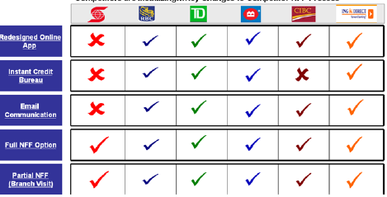

#### SCOTIA Collections (jan14-feb14)

|  |  |  |  |
| --- | --- | --- | --- |
| Replace domestic credit collections **DEBT MGR** with CGI CACS – New credit risk/ debt mgt Credit+ Collections | New feeds -> 30% incr. load for DMZ landing zone + Collections iWay | Facilitate 2 weeks negotiation vendor IT- batch, IF, processing; governance, CR analysis, sizing | Project /budget baseline for CGI’s + **16 IT** (Visa/ SCOTIALINE, Scotia Plan Loan, Mortgage, etc.) |
| 🕮**Collection project**, Change request, financial | | | |

#### SCOTIA Retail Loan (jan14-feb14)

|  |  |  |  |
| --- | --- | --- | --- |
| Enhance **Retail lendng plfrm** for direct var/fixed from branches – POP coupling with Retail Insurance | **100+** L1 test problems in POP compromised APR release; **12 CRs** raise 20% scope 3 biz (unsec. retail lending, insurance, finance) + **15 IT** (retail loan, ins., sales, risk, etc.) | Capture, analyze, cost, prioritize CR  Negotiate, plan new release; escalation, build consensus, wkly report to sr mgt | Sr Mgt approved 3 months extension of QAT APR -> JUL release |
| 🕮**Retail Loan project**, 🕮**Scotia Direct Loan**, 🕮**Scotia Retail Glossary** | | | |

#### SCOTIA Family of Cards (nov13-feb14)

|  |  |  |  |
| --- | --- | --- | --- |
| Growth branded card – generic platform for **24** products/ cards– applicat, adjudicat, cheque order D&H, cheque process SYMCOR, G&D | Project-**2-**program, productivity, plug-in project for new cards, products | Facilitate director’s meetings to capture broader requirements; Coord. IT + biz for roadmap + project plan/budget | Roadmap, Charter, projects and templates |
| 🕮**FOC Scope**, 🕮**FOC System Interfaces**, 🕮**Time2Market**, 🕮**Program org**  **Campaign Launch material** (DYK Do-You-Know, scripts, talking points, E.O Circulars, FYI’s, Job Aids, Manuals) | | | |

#### AGNICO-EAGLE JD Edward (may13-oct13)

|  |
| --- |
| **80+ SOX** controls for financial reporting processes on **JD Edwards** G/L, A/P and A/R, fixed assets, procurement and payroll |

#### AGNICO-EAGLE C3 (may13-oct13)

|  |
| --- |
| Centralized to **TOR + Rouyn-Noranda** (Quebec), **20 IT** operations to Q9 data centre, ing guidance on IT Cyber security, IT governance, Testing & management of **50 key vendors** |

#### HOOPP Back office Product Backlog (nov10-dec12)

|  |  |  |  |
| --- | --- | --- | --- |
| SCD in production for 2 months – **800+** Sharepoint requests captured during **3** years of SCD impl. | If not implemented, **40%** manual/work in Collateral mgt, Investmt accntng, treasury operation | Categorize, analyze, prioritize, negotiated into product backlog of **300+** initiatives | Streamlined/ delivered **20K man-hour (5 BA*2 yrs)** - integrated back office, portfolio mgt, trading, risk mgt. |
| Anecdotes: **SCRUM/Agile** organization | | | |

#### HOOPP Fair Value Continuity (jan11-jun12)

|  |  |  |  |
| --- | --- | --- | --- |
| Accounting explains changes at security level wrt price, trading, forex | Muti dims Recon sub2ledger Schema not avail **6** bus stkehldrs **Level 3** F/S | Charter, Prototype,  Iterative planning,  Roadmap delivery, RAD, Test tools | Map **70+** sec types  Frmwk future sec  On-time L3 for FY11 |
| **🕮****Project Overview** - Personalized communication (email, face2face, report) **Challenges** [•G/L mapping •XCCY exchange of principals •Upfront fee •Income statement •MtM pending trades •Unwind] | | | |

#### HOOPP Upgrade (jan11-dec11)

|  |  |  |  |
| --- | --- | --- | --- |
| SCD in production for **10 months**. Upgrade necessary because major changes mandated by European regulatory bodies | New technology  Staff <2yr exp  **7 bizIT** streams  SCD 90% trading act. | Facilitation (test rqrmt + process review)// **3xSprint (1 mth**), **daily scrum**// Quick issue escalation •Visual process /plan •empowerment •shield from org. pressures | Completed **2** months before FY  Identified **30+** improvement opportunities  Template for future upgrades |
| 🕮**Project Overview** - End-to-end test case > Voice of Process, voice of customer  **Phases** [Pilot > I/F upgrade > Business learning adoption > Production] **Systems** [•SCD •Bloomberg •Warehouse •MARKIT for tranche CDS •Derivative Pricing] **QA Elements** [•architecture •security •tool •process •efficiency •performance] **Test work package** [•Exec summary •Overview BOSCARD •Approach feeds-automation-timelines-gating •Details UT-DIT-SIT-UAT-PAT •Test environment •Staffing •Training •Reporting •Milestones] **🕮****CEMLI****,** **SDLC** | | | |

#### CIBC RSI (jun09-oct10)

|  |  |  |  |
| --- | --- | --- | --- |
| OSFI mandates  Competition  Replace FR tech  **5** streams MR, CR, OR, Analytics, Data | $80M 3 years  ASP model  **10** PMs **100** BA  Report to **2** CFOs (Risk + Wholesale) | **3** phases: POC, vendor selection/ order-of-magnitude OOM, execution  Plan-resource-budget  Wkly reprt progress, finance (actual, accruals, f-casts) | Finance integrated to plan – explain progress, challenges |
| ⮚Personalized communication CFO (budget template, closed working)  ⮚**Market Risk** ⮚**Analytics** ⮚**Credit Risk** ⮚**Risk Data** ⮚**Operational Risk**⮚**Legacy Risk System** ⮚[**TRACS**](#_TRACS_(Credit_Risk)) ⮚[**Voyager**](#_Voyager_(Market_Risk))  ⮚🕮**CIBC EDF**, 🕮**RSI Future State**, 🕮**RSI Phase A**  ⮚**System components** [•Reporting •Trade position •Reference data •Backdated corrections •Downstream feeds •Analytics Hist. snapshots •Trade data •Limit management •Market data •Model parameters •Time Series •Credit Measures •MC VAR •HS VAR •Stress VAR •KRI monitoring]  ⮚**Data Blocks** [•Transactions (booking, position) •Counterparty •FO Measures •Accounting •Risks Measures] | | | |

#### CIBC OSFI Initiatives (nov09-jun10)

|  |  |  |  |
| --- | --- | --- | --- |
| OSFI mandated Basel II revisions VAR methodologies 🕮**IRC** **+ MRA** (M Risk Amendment) Ready before SUNGARD Monte-Carlo full evaluation | **Incremental Risk Charge IRC** (default+ credit migration risk incr. to current VaR) 🕮**MRA/Stressed VAR**  🕮**MRA/Enhanced VAR** (new measures IR Basis Risk, Skew Vega, Customer Behavior) | Plan **5 work** streams: IRC, 2MRA, Capital impact, OSFI approval packages)  Set up dev team  Budget, Requirements | **IRC UAT** (Feb 10) Stressed VaR Dev (May 10)  Enhanced VaR SIT (Mar 10) |
| **DELIVERABLES** 🕮**Business Case**, 🕮**Work Streams**, 🕮**Project Plan, Project Governance** ⬩High Level Cost Estimate for SW + HW (OOM Estimate)  ➊Incremental Risk Charge Methodology (Phase 1) ➋IRC High Level Requirements ➌IRC High Level SW Design ➍IRC Market & Reference Data Inputs ➎IRC Database Tables ➏IRC Pre-Processor Design ➐Position Inputs for IRC ➑Exponential Weighting for DSR Methodology ➒Exponential Weighting for DSR ➓Volatility Scaling Factor for DSR ➊Stressed VaR Methodology ➋Enhanced VaR Sensitivities Methodology ➌Volatility Scaling Factor & Exponential Weighting for DGVT ➍Concentration Factor Estimation (calibration) ➎Fixed Rate Bond & Floating Rate Note Valuation ➏Credit Default Swap Valuation ➐Market Data & Position Data Gap Analysis ➑IRC Pre-App ➒MRA Pre-application Package ➓RWA-Market-Risk-Multiplier ➊VaR Manual | | | |

#### CIBC Control (jan08-nov08), (jan05 – dec06)

|  |
| --- |
| **4,000 SOX** controls and legislative library into OpenText Internal Control Repository (ICR)  UAT **4 streams**: fin. reporting, operation control, legislative & general entity compliance  5 profs to design/develop SQL Server-based SOX reporting for **200-plus** lines of business |

#### [MANULIFE Derivatives Accounting (jan09-jun09)](#_Manulife_OTTI_(Other)

|  |
| --- |
| Completed development of GAAP "**Other Than Temporary Impaired" (OTTI)** - report fair value, amortized cost, unrealized gains/losses with disclosure on nature of impairments for various fixed-income securities including government issues and private placements - **Activity-Based Costing (ABC)** |

#### CIBC SOX Secure End User Computing SEUC (jan08-dec08)

|  |
| --- |
| Planned then coordinated the vendor’s proof-of-concept that showcased solutions to secure high-risk financial processes (**loss > $5 billion**) at **3** targeted lines of business: Risk Management (model vetting); Middle Office (calculation of OTC derivatives); Retail Wealth Management (pricing/cash flow calculation) |

#### 🕮CIBC Mellon (ERP, Vendor) (jan07-dec07)

|  |
| --- |
| PMO procedures and reporting structures; requirements for Treasury and MIS, evaluation of **7** vendors of ERP and Business Intelligence solutions **Activity-Based Costing (ABC)** |

#### AIG/AIA (sep96-apr00)

|  |
| --- |
| **Regional PMO (96-97):** **15** direct reports -portfolio of **$100M**-**100** initiatives-**15** countries  **Harvester Program (96-99)**: **5** regional IT teams with **110** IT resources and **20** strategic vendors program of 10 core streams  **Market Entry India, Vietnam (99-00)**: **20** IT managers- launching platform for endowment, group pension, casualty and property in **40** cities in India and  **Marketing Campaign (Global Advertisers for India, BBDO NY for VN)**: to purchase media; update flyers / direct mail pieces, conduct internet-based marketing/advertising; manage, coordinate, track, and quantify results using pre-existing concepts and themes |

#### AIDC (oct93-aug96)

|  |
| --- |
| **Financial risk and Treasury (94-96):** FR for debt & equity a multi-dimensional analytics  Managed treasury **6** functions: cash management sub ledger, bank reconc, disbursement authorization, banking relationship, pay-base cheque printing, daily bank transmissions  **Financial Systems Decommissioning (93-95):** Decommissioned legacy treasury and corporate lending in **2** years to expand customer service capability by **20%** |

#### PWC (oct90-aug93)

|  |
| --- |
| **WESTPAC DCPK (90-92):** Team of **5 traders, 20 testers** and **7 vendors** to complete the UAT of key processes of pricing, trading, settlement and General Ledger posting  **Home Care Services (92-93):** business process reengineering team, budgeting and roster application for **5,000** staff, state-wide **56** branches and **84** service outlets; **15,000** individual accounts of a statewide chart of account hosted in the PROPHECY/SAP Financial Systems |

#### SIERRA Rescue (jan07-may09)

Jan08: **Russell-Mellon** Enterprise Investment Platform RFP (Wealth)

Oct07: Balanced Scorecard**/BI BC Corporate Accounting Services** (public sector)

Mar08: migration of **MTO Road User Safety Revenue Mgt System**from legacy (public)

Jan09: Travel Insurance Coordinators TIC + Trent Health (P&C)

##### TIC system integration - merger

|  |  |  |
| --- | --- | --- |
| **Project** | **Objective** | **Target State** |
| **Applications** |  |  |
| Retire Policy Management System and switch to IBIS | Retire UNIX Platform | Single system for customer and policy management |
| Consolidate Agency Management functionality to Agency Maintenance | Retire UNIX Platform | Single system for management of agents and brokers |
| Retire Group Management System and switch to Rosters Database | Retire UNIX Platform | Single system for processing of group lists |
| Point e-TIC, GM, RMR, IMT to IBIS Database | Retire UNIX Platform | Data from partner applications will be loaded in IBIS database |
| Migrate TICNet, TICWeb to MS Windows Hosting | Retire UNIX Platform | LAMP applications will run on Windows web servers and databases |
| Migrate TICNet and TICWeb to Microsoft Sharepoint Server | Align TIC with Co-operators Standards and industry best practices in architecture, technology and process | Off the shelf (MS Sharepoint Server) content management software for management of Intranet and Company's website |
| Enterprise Architecture Redesign | Consolidated Enterprise Computing Platform | Platform that adheres to Co-operators technology standards |
| CRM Solution | Align TIC with best practices in architecture, technology and process | Consolidated information about all interactions with agents and customers |
| **Technology Infrastructure** |  |  |
| Augment Current Testing/UAT Environment | Align TIC with Co-operators standards and industry best practices in architecture, technology and process | Testing/UAT environment that is a replica of a production environment is created for all in scope applications |
| IT Change Management Process and Tools | Develop standardized TIC-wide approach to IT Change Management (adopt Co-operators standards as appropriate) | IT Change Management tool is created, organizational controls (e.g. deployment approval) are put in place, and it is followed both by IS organization and business users |
| Standardize Code Management and Promotion Practices | Align TIC with Co-operators standards and industry best practices in architecture, technology and process | Well established set of code management practices is implemented and followed by all TIC IS organization |
| Upgrade servers to Windows 2003 | Alignment with CLIC standards | Server OS software is standardized |
| Upgrade database servers to SQL 2005 | Alignment with CLIC standards | Database Server software is standardized, MS Reporting Services are rolled out |
| Consolidate Reporting and utilize Microsoft Reporting Services | Provide integrated corporate reporting across TIC | Consolidated Reporting |
| Security Enhancements | Align TIC with Co-operators standards and industry best practices in architecture, technology and process | Customer sensitive data is stored in encrypted format |
| Identity Management | Align TIC with Co-operators standards and industry best practices in architecture, technology and process | Identity for external and internal users is centrally managed, and signle sign on is present for major TIC applications |
| Consolidate and archive UNIX Data, retire UNIX I/F | Retire UNIX Platform | UNIX and IBIS data are fully synchronized |
| Infrastructure Consolidation | Consolidate Toronto and Vancouver Inftastructure, integrate with GroupNet | GroupNet compliance |
| Data Warehouse and Ad Hoc Data Mining | Elimination of organizational and operational inefficiencies | Easy to use set of tools for custom data mining |
| Migrate critical applications to Q9 hosting environment and institute measures for high availability | High Availability | Production and UAT servers are hosted in highly available and redundant Q9 Data Centre |

# CIBC RSI

## RSI Overview Deliverables

❶**Market Risk** General MR, IRC, Equity & Debt Specific Risk, Stressed VaR, Stress Testing ❷**Trading Credit Risk** CVA, Limits Monitoring, Stress Testing, Master Agreement Details, Pre-Deal Check, Ratings Maintenance ❸**Trading Operational Risk** Product Authorization, Limit Breaches, KRIs, Reporting❹**Analytics** VaR Methodology, Stress Testing, Model Calibration, Exposure Modeling❺**Economic & regulatory capital** IRC enhancement❻**Data/ reporting** Data quality, Master data management, Derived historical data, Unstructured data management, Standard/ad hoc reporting/analysis, Meta data

#### Risk Model & Sensitivities

❶**DGVRT** assumed MR factors log-normally distributed; statistical parameters based on 250 days of history; inputs (risk factor sensitivities, correlations, volatilities, average returns, market prices of risk factors) ❷**HistSimm** based on historical distribution of rolling 500 dailychanges in risk factors ❸**Debt Specific Risk** **DSR** default + idiosyncratic spread risk - MC model with 4 components: 1 *Marginal distribution calibration* to estimate/ calibrate spread return for each credit group 2 *Correlation calculation* 3 *Preprocessing* *4 Core* ❹**Approach** Use *spread simulation model;* small spread moves 🢧 spread *volatility risk*, larger moves 🢧 *migrations and defaults*; models **total credit spread** of individual bond as general spread + specific component; **general spread** from bond index given by observable index or inferred as average credit spread of basket of bonds comprising a Credit Group; **specific spread** component = difference between total credit spread inferred from bond’s observable price and sectorial spread; use 90 Credit Groups of bond indices, baskets of traded bonds, spanning markets, economic sectors, credit qualities maturities; use MC simulation to compute specific risk; join marginal distributions using copulae to model tail dependence embedded within credit spread data; model sector and specific spread distributions using Student’s t-distributions; calibrate historical bond index data to obtain distribution parameters via moment matching **Risk sensitivities** (45) equity/ metal/ oil/ FX DGVRT, duration e.g. *base metal vega risk*, *CS idiosyncratic risk*

#### Interest Rate Risk

❶**IR Outright and Curve risk** portfolio sensitivity to changes in yield curve (Frontier/ Voyager zero rate yield curves for sensitivity, VaR generation) ❷**IR Swap Spread risk** portfolio sensitivity to changes in spread between govt yields and swap yields ❸**IR Vega risk** sensitivity to changes in IR volatilities ❹**Total IR risk all IR risks + IR Theta** with correlations between IR components (zeroes, swap spreads, volatilities)

#### Credit Spread Risk

Due to change in spreads (bond index, government yields) ❶**Generic CS risk** change in spread (Treasuries, mapped bond index) ❷**Idiosyncratic CS risk** change in spread (specific issuer, mapped index)❸**Total CS risk** = Generic CS risk + Idiosyncratic CS risk assuming zero correlation

## Analytics

#### Analytics OLSM

(Optimized Least-Squares Monte Carlo) simulation to compute **potential future exposure (PFE)** **profile** of derivatives with complex optionality for which no analytic approximation exists; relies on **Least-Squares approximation** by Longstaff & Schwartz; traditionally **nested Monte Carlo MC** or **approx surrogate structured deal** computationally expensive & approximate **work streams** *IR & FX basis risk*, *Equity Dividend*, *Volatility Skew*, *Monte Carlo on Monte Carlo* **correlation risk** *equity-equity*, *commodity-commodity*, *commodity-FX* assets classes **dividend risk** measured through sensitivity based variance-covariance; *calculated for 1 bp change in dividend yield, applied to shocks based on dividend yield volatilities; dividend yield volatilities for indices based on time series of forward dividend yields and dividend yield volatilities for single stocks*

🕮**Analytics Model gaps**

## Market Risk

#### Market Risk Data

❶**Data groups IR market data** Yield/zero curves for bonds, swaps (zero curves bootstrapped from corresponding yield curves), spread curves, volatility cubes or surfaces, basis spread curves **Trading credit** CDS spreads, CDS indices **FX related** FX spot rates, FX volatility surface **EQ related** equity indices, common stock prices; equity volatility surfaces **Commodity related** commodity spot prices, commodity forward/future price curves, commodity price volatility surfaces ❷**Data structures** **Scalar asset spot prices** FX spot prices, equity spot prices, commodity spot prices bond prices **1-dim term structure curves** (1-dim vector data) IR yield/zero curves, IR spread curves, CDS spread curves, commodity forward/futures curves, ATM FX implied volatilities, commodity price volatilities, ATM equity implied volatilities **2-dim surfaces** ATM IR implied volatility surfaces, equity implied volatility skews, FX implied volatility skews **3-dim cubes** IR implied volatility skew cubes **Matrix market data** correlation metrics, transition probability metrics❸**Trade data** **Instrument** (security term & conditions, Security, Debt, Option, Future, Forward) **Instrument Type** (product type) **Trade** (daily trade position information) **Structured Product**, **Cash Flow**, **Schedule** (average rate schedule, payment Schedule, reset schedule, amortizing schedule, exercise schedule) **Instrument state** (daily basis ‘NEW’, ‘SG_DONE’, ‘SG_RESULTS_LOADED’) ❹**CIBC MHS (market data store)** central repository for Voyager (market risk minus specific risk), Euclid (specific risk), TRACS (credit risk) ❺**Types** 1-market data 2-variance/ covariance (derived market data) 3-statistical parameters (derived market data) ❻**Feeds** generates 76 market data feeds (34 feeds in MR) 30+ FO systems (1 feed 1 system)

#### Incremental Risk Charge (IRC)

⓿**What?** Loss due to default/changes in quality at 99.9% CI over 1 year ❶**Phase 1** MC simulation of *Merton structural model* for default/credit migration **Phase 2** MC simulation of credit/equity states based on *Stochastic Volatility model* (stochastic price + variance process driven by Brownian motions with constant linear correlation) ❷**Phase 1 design** **①**Parameterize correlation with concentration parameter to couple issuer/ market concentrations to migrations and defaults **②**Constant level of risk (same loss distribution over liquidity horizon 3 months liquid within 1 year horizon) **③**Aggregation/liquidity horizon correlation – use hedge for sub-portfolios with multiple liquidity horizons **④**Valuation – principles (full valuation; same valuation by front and risk); for equities no model needed (prices simulated directly) ❸**Credit Spread & Mark-To-Market Adjustment** - 2 credit spread types: **①**CDS spread: bond spread, can differ in magnitude for technical reason; **②**Bond spreads: yield spread, asset swap spread, option adjusted spread (OAS or Z-spread), interpolated spread (I-spread) available on Bloomberg ❹**Plan** **⓪**Contingency (standardized approach) **①**Risk model (requirement, development, unit test) **②**Market data (requirement, document, unit test) **③**Trade position data (requirement, development, unit test, SIT, UAT, Regression) ❺**Gap analysis** **①**Products (structured credit run-off portfolio) **②**Position data (instrument type, business entity for aggregation -- insufficient id of securitized position, parallel effort to standardize DSR treatment, banking book/ securitization treatment) **③**Market data (credit spreads per currency/sector/rating - insufficient sector coverage, better granularity)

#### Regulatory changes

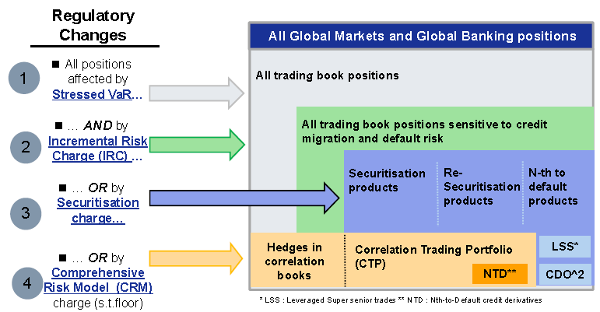

#### Metrics to calculate regulatory capital for market risks

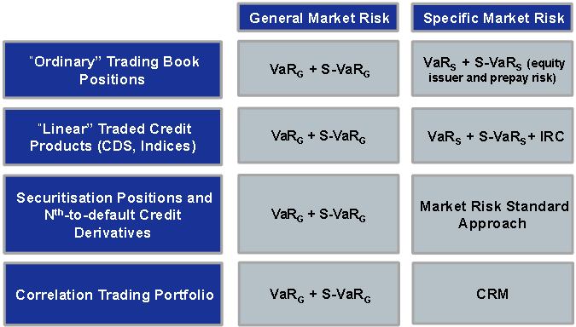

# TOUGH INTERVIEW QUESTIONS

**GENERAL**

1. Tell me about a time where you had to manage change. How did you do it, and what was the outcome?
2. How would you describe your management style?
3. How would you describe your ability to communicate with senior management?
4. What qualities make a good boss or manager?
5. What are your greatest attributes as an employee?
6. What are your career goals?
7. In your last performance evaluation, where were your areas for improvement?
8. Why did you leave your previous employer, or why are you leaving your present job?
9. Where do you hope to be in five years?
10. Which of your past jobs was the most interesting?
11. Which of your past jobs was the least interesting?

**BEHAVIORAL**

1. Describe a recent situation in which you imparted your key points to a group with varying verbal skills?
2. Describe a time when you communicated something unpleasant or difficult to say to your manager. How did you assert yourself?
3. Give me an example of a time when you confronted a negative attitude successfully, which then resulted in building teamwork and morale.
4. Tell me when you had to “stand up” for a decision you made even though it made you unpopular.
5. Tell me about a time when you showed high enthusiasm and energy in order to create a positive energy in others. Give a specific example.
6. What is your viewpoint about co-workers that never speak their mind?
7. What sources of information have provided you with the best data for decision making?

**PERFORMANCE-BASED**

1. What are you looking for in a new job?
2. Why is having “x” and “y” important to you, and why do you think that this job meets that criterion?
3. Tell me about your schooling and advanced training.
4. What is your major project or accomplishment ?
5. Tell me about a major team accomplishment; consider one where you led a team and one when you were a key member of a team.
6. One major problem we are now facing is “xyz”. How would you go about addressing this? a. What would you need to know, and how would you plan it out? b. What have done that is most similar to this?
7. While I’ve seen a few other strong candidates, I’m impressed with some of the work you’ve done. What are your thoughts now about this job? Is this something that you’d consider further? Why or why not?

**FACT FINDING**

1. Describe a significant work challenge that you’ve had to overcome. Why was it significant?
2. What were the actual results?
3. When did this take place and at what company?
4. How long did it take you to complete the task?
5. What was the situation when you took on the project?
6. Why were you chosen for this role? Did you volunteer?
7. What was your actual title?
8. Who were the people on the team?
9. What was your supervisor’s title?
10. What technical skills were needed for the task?
11. What skills were learned? Describe the planning process, your role in it, and whether the plan was met. Provide details of what went wrong and how you overcame them. What was your role in this project?
12. Give me 3 examples of where you took the initiative?
13. What were the biggest changes or improvements?
14. What was the toughest decision you had to make? How did you make it? Was it the right decision? Would you make it differently looking back?
15. Describe the environment – the pace, the resources available, your boss, the level of professionalism.
16. What was the biggest conflict you faced? Who was it with and how did you resolve it?
17. Give me some examples of helping or coaching others.
18. Give me some examples of where you really had to influence or persuade others to change their opinion.
19. How did you personally grow as a result of this effort?
20. What did you like the most and least?
21. In retrospect, what would you do differently?
22. What type of recognition did you receive for this project? Was it appropriate in your mind?

**INTERPERSONAL SKILL**

1. **Emotional Self-Awareness** – the ability to recognize and understand one’s feelings and emotions, differentiate between them and know what caused them and why.

•Benefit in the Workplace? Good emotional self-awareness promotes conflict resolution and leads to improved interaction between staff. Is it easy for you to know when you are getting anxious, scared, annoyed, or angry? Can you give me an example or explain to me how you know this? What things do you feel really happy about? Why? What things do you feel really sad about? Why?

**2. Assertiveness** – ability to express feelings, beliefs and thoughts and defend one’s rights in non-destructive manner.

•Benefit in the Workplace? Proper assertiveness helps individuals to work more cohesively and to share ideas effectively. When you disagree with someone, what do you typically do? Give me an example of when you did that? Do you have difficulty standing up for your rights? Give me an example of when you did. When someone’s behavior consistently bothers you, how do you usually react? Can you give me an example of when you dealt with this situation and how you handled it?

**3. Self-Regard** – To respect and accept oneself as good.

•Benefit in the Workplace? Employees who have a high self-regard have better work attitudes and behaviors. Better self-confidence means better performance. What are your strengths, and how do you use them to your advantage? Can you give me an example? What are your weaknesses and what are you doing to improve them? Can you give me an example? Describe what kind of person others would say you are. Why?

**INSIGHT INTO BEHAVIORAL-BASED QUESTIONS**

4. **Self-Actualization** – To realize potential capabilities and to strive to do that which one wants to do and enjoys doing.

•Benefit in the Workplace? High self-actualization is connected with good motivation + team performance. What are your short-term goals and long-term goals? What are you doing to accomplish these goals? How actualized do you feel you are? Why? What things interest you and why?

5. **Independence** – The ability to be self-reliant and self-directed in one’s thinking and actions and to be free of emotional dependency.

•Benefit in the Workplace? Independence increases productivity and efficiency in work flow and the ability to meet milestones + goals in a timely manner. How do you make difficult decisions? Give me an example of a difficult decision that you had to make and the process you used for making it? Do you need people more than they need you, or the opposite? Why? What interest you and why?

6. **Empathy** – the ability to be aware of, to understand, and to appreciate the feelings of others. It is “tuning in” to what, how and why people feel the way they do.

•Benefit in the Workplace? This creates a more cohesive, functioning team and better team players. How difficult or easy is it for you to understand how people feel? Do you usually know when you have said or done something that has offended someone? How do you know? What do you do about it? Can you give me an example of a time when you felt you might have offended someone? What did you do?

7. **Interpersonal Relationships** – to establish and maintain mutually satisfying relationships that are characterized by intimacy and by giving and receiving kind gestures.

•Benefit in the Workplace? Good interpersonal relations translate into effective communication within and between departments and groups. When you are in a social situation with people you don’t know, what do you typically do? What is the basis for a good relationship in your opinion? What are the ingredients that go into it? Tell me about a relationship that is meaningful to you and what do you do to try and maintain it?

8. **Social Responsibility** – To demonstrate oneself as a cooperative, contributing, and constructive member of one’s social group. This involves acting in a responsible manner although one may not benefit personally.

•Benefit in the Workplace? Social responsibility means recognizing departmental and company goals and contributing to these goals. Can you give me an example of a situation where you considered the needs of others, possible to your own detriment? Give me an example of how you behave as a team member?

**ADAPTABILITY SKILLS**

9. **Problem Solving** – to identify & define problems as well as to generate and implement potentially effective solutions.

•Benefit in the Workplace? The method used for problem solving is critical: viable alternative solutions must be considered, including cost / benefit analysis and long term implications, as examples. Can you give me a step-by-step example of a difficult situation that you handled at work or at home? Is it generally easy or difficult for you to come up with a number of possibilities for approaching a problem? How easy or difficult is it for you to decide on the best solution and implement it? Can you give me an example?

10. **Reality Testing** – the ability to assess the correspondence between what is experienced (the subjective) and what in the reality exists (the objective).

•Benefit in the Workplace? It is important to focus on practicality and not on unrealistic expectations. Do you usually assume things and jump to conclusions, or do you check things out before acting? Can you give me an example? Would others say you are realistic or idealistic and why? Can you give me an example of that?

11. **Flexibility** – to adjust one’s emotions, thoughts and behavior to changing situations and conditions.

•**Benefit in the Workplace?** Employees perform better in positions where tasks are dynamic and changing. Low flexibility resources perform better in more well-defined tasks requiring reliability and consistency. Can you give me an example of when your opinion about a person or situation was clearly wrong and what you did? Give me an example of how well you deal with change in general? If you were forced to leave your home, how would handle it?

**STRESS MANAGEMENT SKILLS**

12. **Stress Tolerance** – the ability to withstand adverse events and stressful situations without “falling apart” by actively and positively coping with stress; the ability to weather difficult situations without getting too overwhelmed.

•Benefit in the Workplace? Effective stress tolerance has to do with managing reasonable workloads, establishing clear priorities and meeting realistic deadlines. What tactics do you use to cope with everyday stress? Give me an example of a stressful situation that you coped with effectively?

13. **Impulse Control** – the ability to resist or delay an impulse, drive, or temptation to act. It entails the capacity for accepting one’s aggressive impulses, being composed, and controlling aggression, hostility and irresponsible behavior.

•Benefit in the Workplace? Rash actions can be costly. Mistakes can often be avoided simply taking the time to stop and think things through. Can you give me an example of a situation in which you were very angry and what you did in that situation? How do you typically deal with an impulse or temptation to act prematurely?

**GENERAL MOOD**

14. **Happiness** – the ability to feel satisfied with one’s life, to enjoy oneself and others and to have fun.

• Benefit in the Workplace? Positive moods lift spirits, create resonance and help overall performance of individuals and teams. If I were to ask your friends how you make them feel when they are around you, what would they say? Why? Are you generally satisfied with the way things are presently going in your life? Why?

15. **Optimism** – to look at the bright side of life and to maintain a positive attitude, even in the face of adversity.

•Benefit in the Workplace? An optimistic attitude helps ward off stress while creating resonance that increases one’s productivity. How do you typically deal with failure? Can you give me an example of a time where, in your opinion, you failed? How did you deal with the situation? How do you cope with your pessimistic feelings?

# PROJECT Contact Names

**CBOC** Scott Penfound, Mike Menezes, Vince Carrere, Denise Cross **SCOTIA B1**-Brian McCabe (VP, Core Deposits & Payments), B2-Paul Akey (VP, Credit Strategy and Execution), B3-Yvonne Zeabin (VP, Centralized Accounting & Administration), B4-Marie-Josee Vinet (VP, Channel Marketing & Services), B5-Shawn Goddard (VP, Toronto Contact Centre), B6-Todd Anderson (Branch Customer Experience), B7-Mike Henry (SVP & Head, Retail Payments, Deposits and Lending), B8-Elizabeth Ross (SVP Credit Strategy & Execution), B9-Michele Ramos (VP Integrated Business Solutions, Retail Products & Services Canada), B10-Francis Power (SVP Lending Support) **T1**-Donna Whittacker (VP, Quality Assurance), **T2**-Martine Lamoureux (SVP, Banking Technology), T3-Herve Loc (VP, Banking Operations), T4-Gene Kosmyna (VP, Online Banking Technology), T5-Neil Freyke (VP, Information Management), T6-Glenn Anderson (VP, Service Integration Technology), T7-Robert Rosatelli (VP, Banking Solutions), T8-Richard Lawrence (VP, Contact Center Technology), **P1**-Uma Jayaram (BTO-PMO),**C1**-Canadian Banking Compliance, C2-Global Anti-Money Laundering Unit, C3-Legal Counsel, C4-Fraud Management, C5-Business Conduct & Privacy, C6-Change Management **CGI** Cassie Stellmach (PM) **NFF-Team** Peter Geer, Andrew Redding (On-Line Sales Mgmt), Paul Russell (Marketing), Emily Labro (CCC), Helly Howard (CA&A), Diana Nasr, Daishen Wen, Eddie Rambharack, Edison Wai, Paul Crangle, Rita Chauhan (QAT) **Vendor** Critical Mass, TRANSUNION, I4C, Tech Mahindra, DawnInfo Tech, CGI, Davis& Henderson (Cheque manufacturer), Giesecke & Devrient (Plastics manufacturer) **CIBC RSI** – Neil Oswald (CFO), Rand Thomson, Armen Vanayan (Risk IT), Matt Willis, Melody Glover (Lily Leung), Greg Frank, Pankaj Agarwal (Finance-Reporting Division), Robert Kowara (Internal Audit), Spiro Daoussis (Risk Management - Credit Risk Analytics), Milo Rado, Laurie Russell (Risk Management —RSI Project), Brian O’Donnell, Paul Duffy, Liam Mason, Murray McIntosh, David Podrebarack, Zubair Ramzanali, Mike Swan, Steve Kiss, **FIRST DERIVATIVES, MOSAIC, KPMG** **SGD** Andrew Williams (VP Professional Services), Simon O’Neil (Project Director), Josie Palazzo (SVP Product Management), Tony Daly (Director, Adaptiv ASP Service Delivery), Jon Pendergast (Professional Services Manager), Steve Shipp (Client Services Manager, Adaptiv ASP Service Delivery), David Togstead (Manager, Infrastructure Services, Adaptiv) **CIBC Control** – Jackie Beaurivage, Joel Frankel, Bill Austin, Karen Miske, Don Mc Cartney, Sanjiv Talwar **Sierra** – Steve Matthews **CIBC Mellon** STEERING Helen Polatajko, Brian Naish, Harold Keller BUSINESS DEV Claire Johnson (Client Technology), Gloria McCormick (Relationship management), Alkarim Daya (Calgary), Philip Chao (Investment Management Relations) CAPITAL MARKETS Po Chu Fong (Accounting), David Wells (Treasury), Rob Ferguson (Product & Client Service) FINANCE George Wong (Finance planning) INTERNAL AUDIT Kenneth Wong, Nathanael Mathi (IS Audit) IS Sanjeev Drego (IS, Technology purchasing specialist), Kenneth Osmond (IS Architecture), Abdool Rohoman (IS Infrastructure) FSRP MIS Team Carl Griffiths (Customer & Product Profitability stream), Nayyar Shabbar (MIS) **Manulife** Jeannie Collins-Arderne, Mike Zalanyi, Branimir Kralj, Ken Mcdonald (*John Hancock*, Boston), Leticia Mayol-Wong **HOOPP** John Crocker, Reno Bugiardini, Jim Keohane, John Riviere, Barbara Thomson, Ken Rahl, Nancy Borges, Ashley Tuner, John To, Barbara Thomas, Albert Dieleman, Gideon Ong, Ray Singh, Simon Moore, David Chmelnitsky, Chris Gobbo, Jake Dunat, Nan Samaroo, Juliana Duray Kikuchi, Allan Bisessar, Marco Drummond **AGNICO-EAGLES** Allen Lum (Control), Lino Cafazzo (VP IT), Christopher Ferguson (I&A), Marc Rivard (Manager IT), Daryl Land (Manager network), (E&Y)

# KELLOGG SCHOOL OF MANAGEMENT

⬩Full-Time/ Executive MBA facilities at **Allen Center** along picturesque shores of Lake Michigan in Evanston, Illinois on Chicago’s North Shore, access to private beach, extensive sports and aquatic facilities, bike paths, playing fields and a sailing and windsurfing ⬩***The Keg***, popular bar closed in 2013 ⬩Pioneered group projects and evaluations, importance of “teamwork” and “team leadership” ⬩**Deans**: Don P. Jacobs, Dipak C. Jain, Sunil Chopra ⬩**Professors**: Philip Kotler (marketing), Keith Murnighan (Risk Management), Mohanbir Sawhney (technology management), Dean Sally Blount (Leadership)

# Great Tips

## STAR Techniques

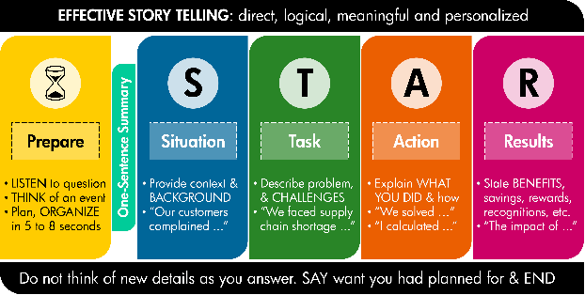

**Question (Jack & Suzy Welch):** “Have you ever had to define yourself in the midst of criticism, and did you succeed?”

•**‘S’ for Situation:** “My first job was to lead a product development team at ABC Corporation. My responsibilities involved participating in weekly product planning meetings that decided on product features. After the meeting, I would meet with my staff and delegate the programming tasks. Since I am an experienced programmer, I would explain details of how each feature needed to be programmed. I expected my staff to write the programs in C++, test and debug. We seemed to work very well as a team.”

•**‘T’ for Task:** My manager observed that I could improve my delegation skills. I had believed that I was good at delegating given that I would detail my expectations of each staff-member and list every step he/she needed to work on. It believed my staff was productive and continually gained knowledge from my coaching. I thanked my manager for the feedback and promised to reflect on my delegating style and consider a change.”

•**‘A’ for Action:** “I reflected on my delegation approach and realized two problems. Firstly, I assigned work to my staff only in terms of steps to take. I had habitually failed to describe the background of product features we wanted to develop and explain how their work would improve the overall product. My staff would do just what I had asked them to do. Secondly, in telling my staff how to complete each assignment, I was micromanaging. This may have tended to limit my staff’s initiative and reduced opportunities to advance their programming skills. During the next staff meeting, I thanked my staff for the feedback and acknowledged I would change. Then, each week, I explained the context to every product feature we wanted to develop, described the task in terms of outcomes and asked my staff how we could approach each task.”

•**‘R’ for Results**: “My staff was very excited about the opportunity to propose ideas, brainstorm and choose a preferred way of going about their work. It was no longer my idea they would work on; it was their own idea and their own approach. They were more enthusiastic about their work and realized they were an integral part of something bigger than themselves. During the next quarterly meeting, my manager praised me for empowering my team.”

## Crucial Conversations

|  |  |
| --- | --- |
| **1-Start With The Heart**  • Work on me first  • Focus on what you really want  – What do I want for myself? For others? For the relationship? – How would I behave if this were what I really wanted?  • Refuse the sucker’s choice  – Choose between peace & honesty; winning & losing – Look for the “and”; the win-win  **2-Learn To Look**  • Content and conditions  • When things become crucial  • Watch for safety problems  • Do others move toward silence or violence  • Look for outbreaks of ***Style Under Stress***  **3-Make It Safe**  • Step out  • Decide which condition of safety is at risk  – Mutual purpose or mutual respect  • Apologize when appropriate  • Contrast to fix misunderstanding  • CRIB (commit, recognize, invent, brainstorm) to get to mutual purpose | **4-Master My Stories**  • Retrace your path  – Get in touch with your feelings  – Analyze your stories  – Get back to the facts  – Watch for clever stories  • Tell the rest of the story  – Am I pretending? What would a reasonable person do? What do I really want to have happen here?  **5-STATE My Path**  • Share your facts • Tell your story • Ask for others’ paths • Talk tentatively  • Encourage testing  **6-Explore Others’ Path**  • Ask • Mirror • Paraphrase • Prime • Agree  • Build • Compare  **7-Move To Action**  • Decide how to decide  – Command – Consult – Vote – Consensus  • Finish clearly  – Determine who does what by when |

## Make Ideas Stick

**SIMPLICITY** – Eat subs and lose weight.

**UNEXPECTEDNESS** – A guy lost a lot of weight by eating fast food.

**CONCRETENESS** – Think of the oversized pants, the massive loss of girth, the diet composed of particular sandwiches.

**CREDIBILITY** – The guy who wore 60-inch pants is giving us diet advice.

**EMOTIONS** – You root for an ordinary guy, not a celebrity.

**STORIES** – It’s an inspiring tale to make us want to do the same.

## How to succeed in life

**1. Realize that people don't care as much as you think they might.**

Most people won't notice that you bought a new car or got a promotion, and you shouldn't be basing your happiness on their judgments anyway. On the flip side, if they're showering you with attention, don't let it go to your head.

**2. The people who truly care about you aren't interested in your accomplishments and possessions; they're interested in you.**

It's called love, and you'll know when someone congratulating you on your new job is jealous or truly happy for you. When you find people who love you, do everything you can to hold onto them, because they'll be your foundation.

**3. Arranging your life around money won't make you happy.**

Focus on your passion, not your paycheck. Freeman says he knew a man who spent his career amassing six figures in savings, but died of cancer before he could even touch it.

**4. Debt is not a necessary burden of adulthood.**

If you're making an investment in your career by going to school, then your student debt is something you'll need to manage. But just because it's become normative, do not consider debt a rite of passage into adulthood. It can dangerously imbalance your finances.

**5. Rhetoric is powerful.**

Figure out what elicits certain responses from people, and you'll be better able to influence others. "When you know how to speak in order to change someone's mind, to instill confidence in someone, to quiet the fears of a child, then you will know this power firsthand," writes Freeman.

**6. You have a responsibility to everyone, and a responsibility for only yourself.**

Freeman thinks that by merely existing we have a responsibility to recognize the humanity in everyone and offer help to those in need. Ultimately, however, you have control over only yourself, and it's on to you to find success and happiness.

**7. Prepare for the unexpected.**

Do all that you can to understand the way things work, whether how your company functions or how your government is operating. But understand that no amount of knowledge can prepare you for chaos that will inevitably hit you. Always have a Plan B.

**8. You can't let others define you.**

While humans are built to be part of communities, don't let other people or ideologies tell you who you are.

**9. You must always go beyond what is required.**

To become successful, outperform the other guy. And at the top, compete with yourself.

**10. Self-awareness is endlessly valuable.**

If you can see yourself the way others see you, you will be able to work with and get along with others more easily.

**11. Biases affect everything you do.**

Your worldview works its way into every decision you make. If you know your biases, you can minimize acting selfishly and do what is right for the situation.

**12. Living in the present will keep you focused.**

Accept that the past can't be changed, and make the most of what's in front of you.

**13. People who are very different from you can enrich your life.**

Surrounding yourself with like-minded people can limit your creativity, but if you seek out new perspectives, you grow faster and learn more.

**14. Travel. Travel more.**

Not only will being exposed to other ways of living give you a new perspective on life, it will take your brain off autopilot and allow you to return to work refreshed.

**15. It's important to keep taking risks until you find your passion.**

If you haven't found a job that makes you happy, don't settle.

**16. You must take care of your health.**

You can't focus on your career if you're continually set back by indulging your vices or ignoring health problems.

**17. Your reputation must be protected.**

Guard your reputation with all that you have. Make habits of being honest, reliable, and kind, and others will notice.

**18. Emotions should not guide decision-making**.

A knee-jerk reaction influenced by anger or panic can destroy a lifetime of work in one moment. Wait until you are calm before making a big decision.

**19. Forgive others and yourself.**

Strangers and loved ones alike will hurt and disappoint you. React accordingly, but do not hold grudges. It takes a tremendous amount of energy to fuel hatred.

**20. Seek a greater purpose.**

You live in a world much bigger than yourself. Figure out how you'd like to give back.

**21. Life is short.**

Use a sense of urgency to make the most of your time.

**22. There's a lot you don't know.**

If there's a task you can delegate to someone better suited for it, do it. If there's a discussion about something you're not knowledgeable about, resist the urge to jump in.

**23. You need to be honest with yourself.**

To grow as a person, it's important to see unpleasant things for what they are.

**24. Happiness is a choice.**

Your attitude is a decision. Choosing to be happy and optimistic, regardless of the situation, yields more success than negativity.

**25. Confidence will take you places.**

When you believe in yourself, others tend to believe what you have to say.

**26. Everyone is afraid.**

Realize that everyone is afraid of failing. The successful ones know how to accept their fears and keep anxiety from restraining them.

**27. Everyone hurts.**

That's why it's important to be kind to everyone. Small kindness can have a big impact.

**28. Nothing is perfect.**

Unlike in the movies, the good guys don't always win. Appreciate what you have, and you'll be stronger and happier because of it.

**29. You can learn from the countless successes before you.**

It's good to have heroes. Borrow liberally from their advice, and find what works for you.

**30. Luck is the most elusive aspect of success.**

It can be easy to give up when you're talented and work hard but aren't getting a break. Remember that you find good fortune by constantly moving forward.

## NASA Shared Voyage

•Projects usually present a bundled set of challenges demanding that people operate in both known and new domains at the same time. The known domains are amenable to technical expertise and managerial authority. The new challenges - ***adaptive challenges -*** require leadership that can handle the conflict and messiness of ongoing structural tensions across different organizations and groups as they strive for collective innovation.

➊Adaptive leadership is active and reflective: constantly alternate between participating and observing; be part of the action and yet also rise above it to analyze more clearly changing landscapes requiring ongoing corrective action; be able to “get off the dance floor and get on the balcony.” •**Adaptive processes in evolutionary biology are experimental**. Rather than investing the knowledge in high authority, which makes sense for technical problems, adaptation is more likely to succeed with a distributed intelligence.

➋Adaptive work generates tough trade-offs between legitimately competing claims, “the difference between ‘desirements’ and requirements.” •Discovering which trade-offs to make requires drawing out divergent perspectives, orchestrating conflicting views and interests, and listening for the crystallization of a good idea rather than reaching too quickly for decision. •But trade-offs are painful. Jobs are lost, people are let go. Casualties are often necessary. Have the stomach to deliver bad news, and the heart to deliver it well.

➌Leadership is a political activity, even in projects. When people make the classic leadership error of treating adaptive challenges like technical problems, they end up assuming too much about the relevant stakeholders and then step on toes unwittingly. Everybody has a piece of the turf, and you’d best respect that. You never know how much your lack of respect may cost you.

➍Leadership is about challenging people to take far-reaching responsibility**.** The task is to put the creative work back in people’s laps when parochial views inhibit new thinking and necessary collaboration. “I don’t know how you’re going to figure this out, but I have confidence that you will, and if you don’t, we all fail.”

➎Adaptive work takes time. Within days, we can complete the analysis that was the technical part of the problem-solving. The implementation, on the other hand, took months because implementation consists of changing people’s hearts, minds, and habits of behavior. People will either sustain the direct loss of their own job, the indirect loss associated with a friend or colleague losing their job, or the loss of competence for a period of time during which they must learn new competencies. Closer to where the tire hits the road, implementation is more than execution, it demands of people that they face some losses and learn new ways.

➎Leadership infuses the work with meaning. People are willing to take risks, and even pay dearly, if the stakes are sufficiently meaningful. Money is only part of it

1. **Pro-forma** - Assumed, forecasted, or informal information presented in advance of the actual or formal
2. **Standardized Corporate Environment (SCORE)** based on closed user group, one-to-many open model where SWIFT dictates what message standards can be exchanged with any bank that supports SCORE. Advantage administrative relationship to reach all your bank networks that are SCORE members (ca. 1,000 banks)
3. **MA-CUG (Member Administered Closed User Group)** - One-to-one model where the messages and/or formats that will be exchanged are agreed on between the corporate and the bank. This model is most suited for use as a complement to SCORE in those cases where a message is not permissible over SCORE
4. **Light-Tight** = lightly defined process for management, tightly defined process i.e. effective project governance while enough freedom for development and expertise